Pass: Enterprise Report - MCC Capture Report > Result Description: Test Passed for Report: Enterprise Report - MCC Capture Report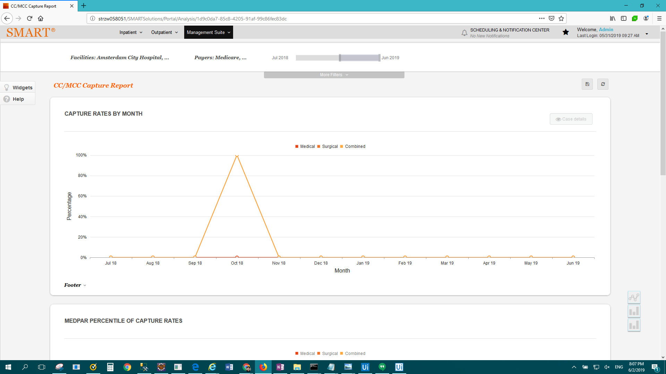

Pass: Enterprise Report - CMI by Payer by Month - Enterprise Version > Result Description: Test Passed for Report: Enterprise Report - CMI by Payer by Month - Enterprise Version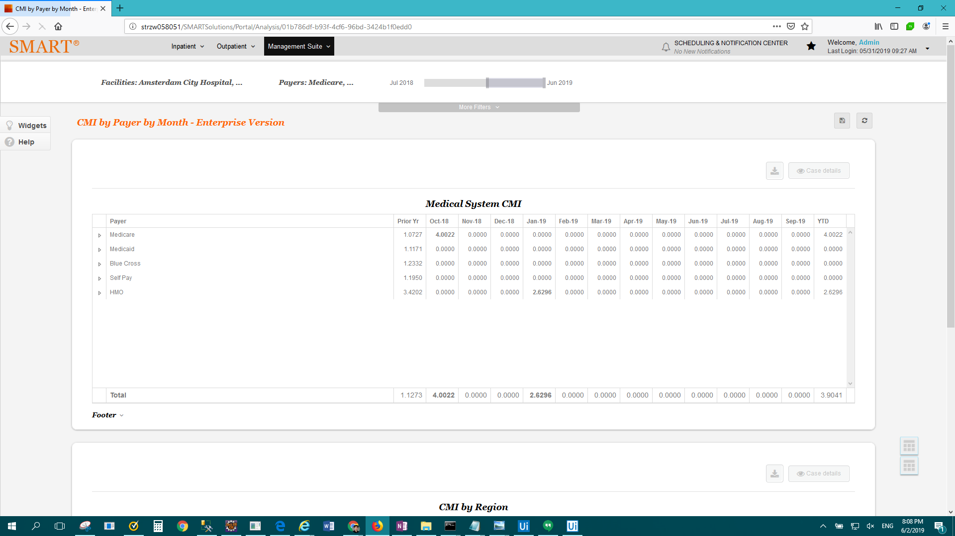

Pass: Enterprise Report - Data Validation Report > Result Description: Test Passed for Report: Enterprise Report - Data Validation Report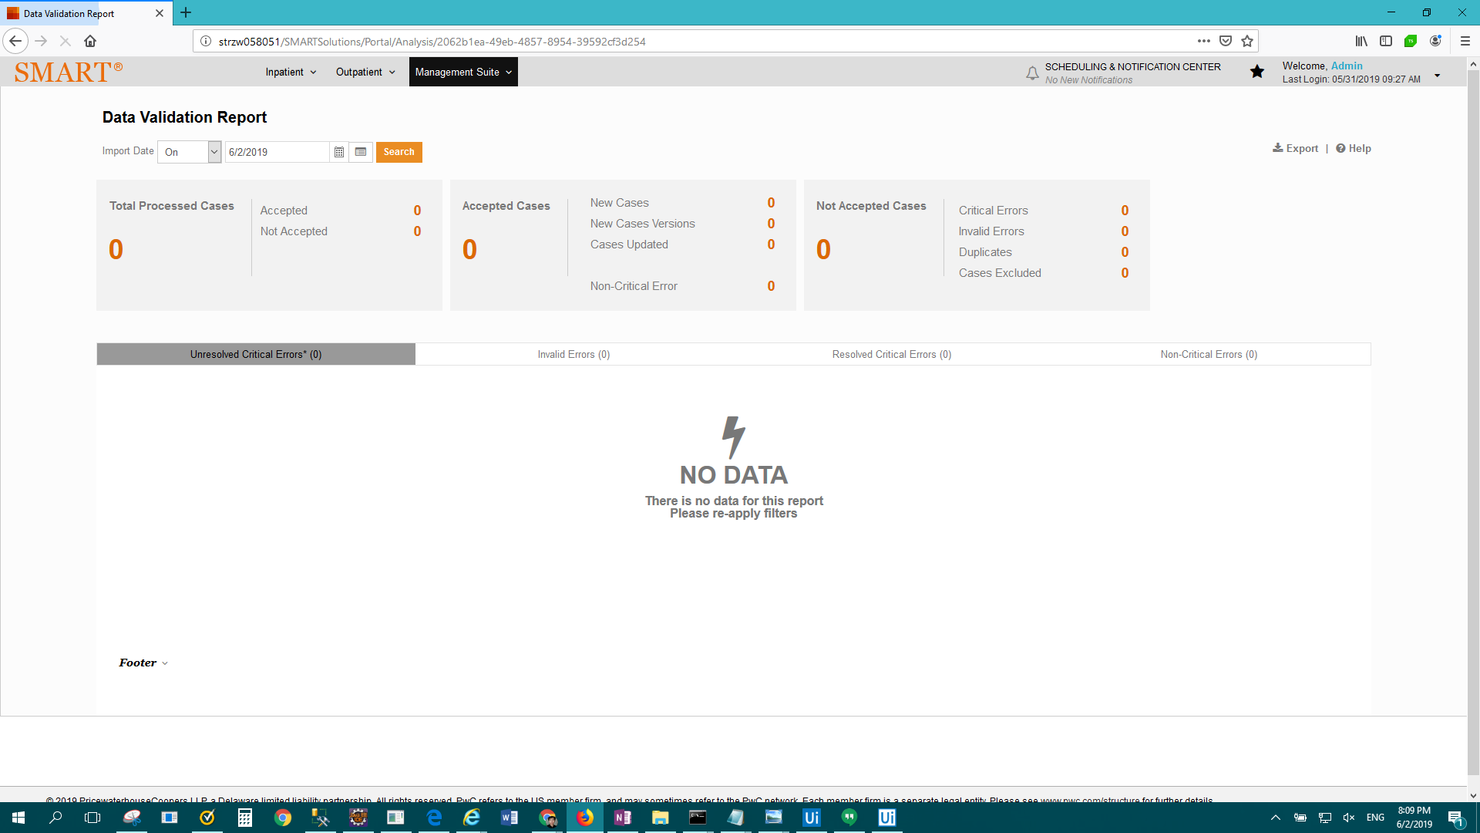

FAIL: Enterprise Report - Discharge Status of Observation Cases > Result Description: Test Failed For: Enterprise Report - Discharge Status of Observation Cases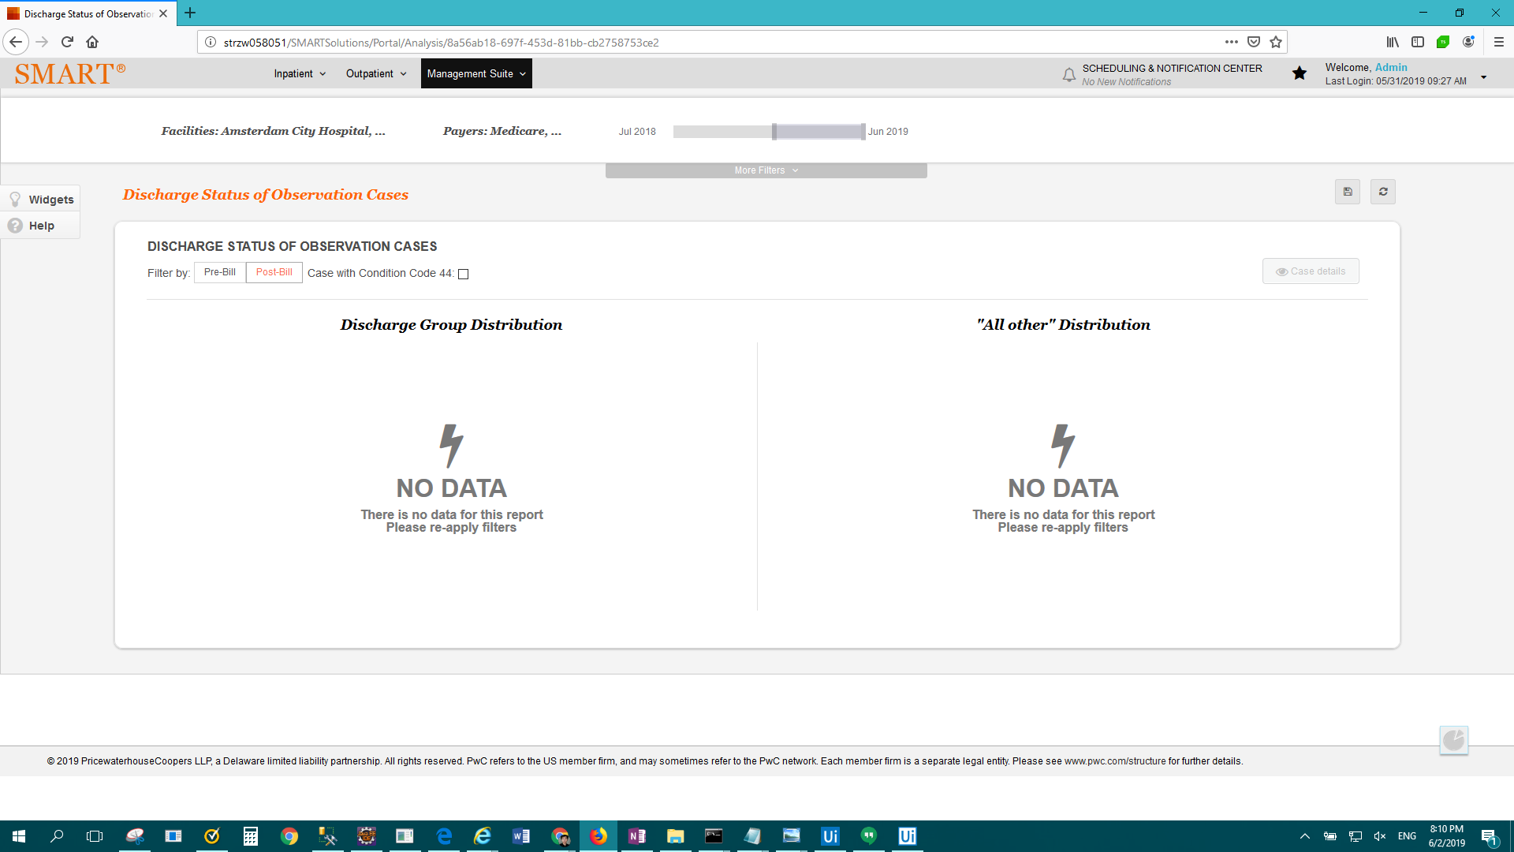

FAIL: Enterprise Report - DRG Payment Window > Result Description: Test Passed for Report: Enterprise Report - DRG Payment Window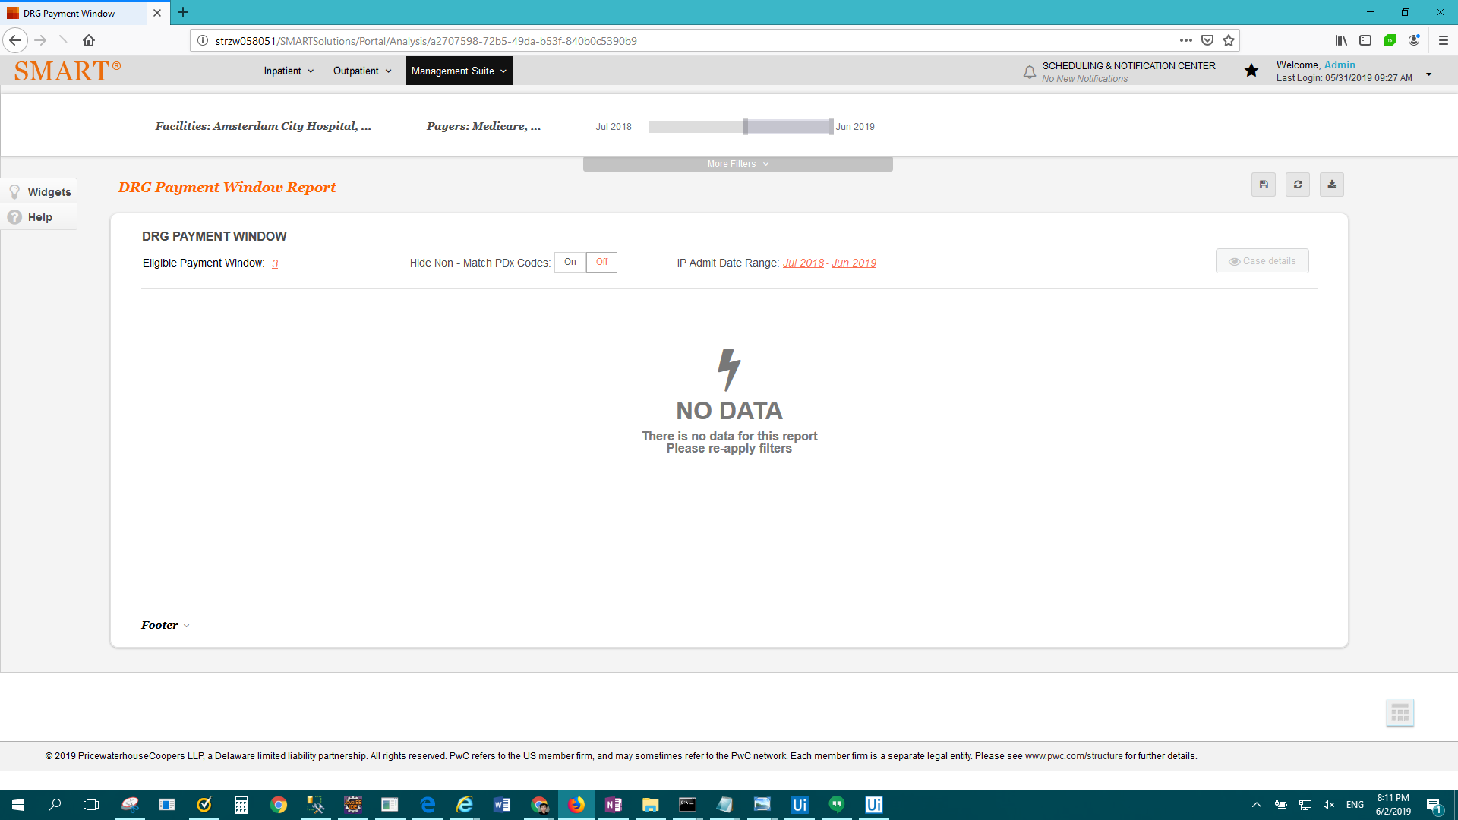

FAIL: Enterprise Report - E&M Distribution Report > Result Description: Test Failed For: Enterprise Report - E&M Distribution Report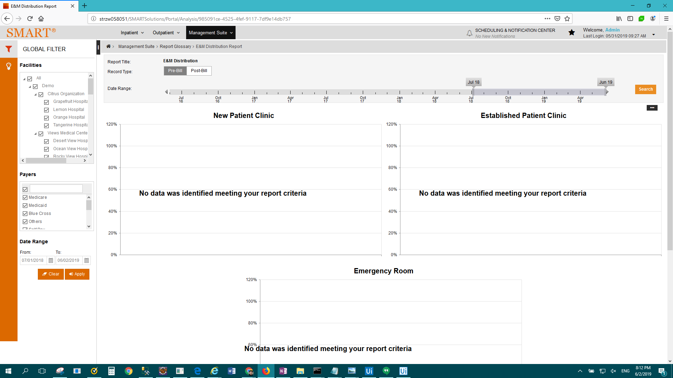

FAIL: Enterprise Report - Evaluation & Management Clinical Profile > Result Description: Test Passed for Report: Enterprise Report - Evaluation & Management Clinical Profile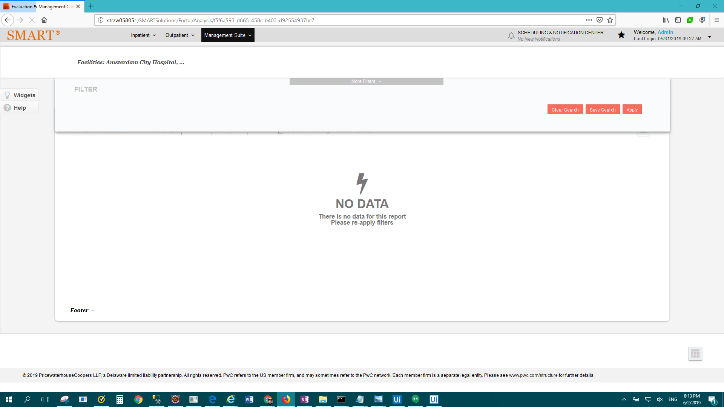

FAIL: Enterprise Report - ICD-10 Dashboard Report > Result Description: Test Failed For: Enterprise Report - ICD-10 Dashboard Report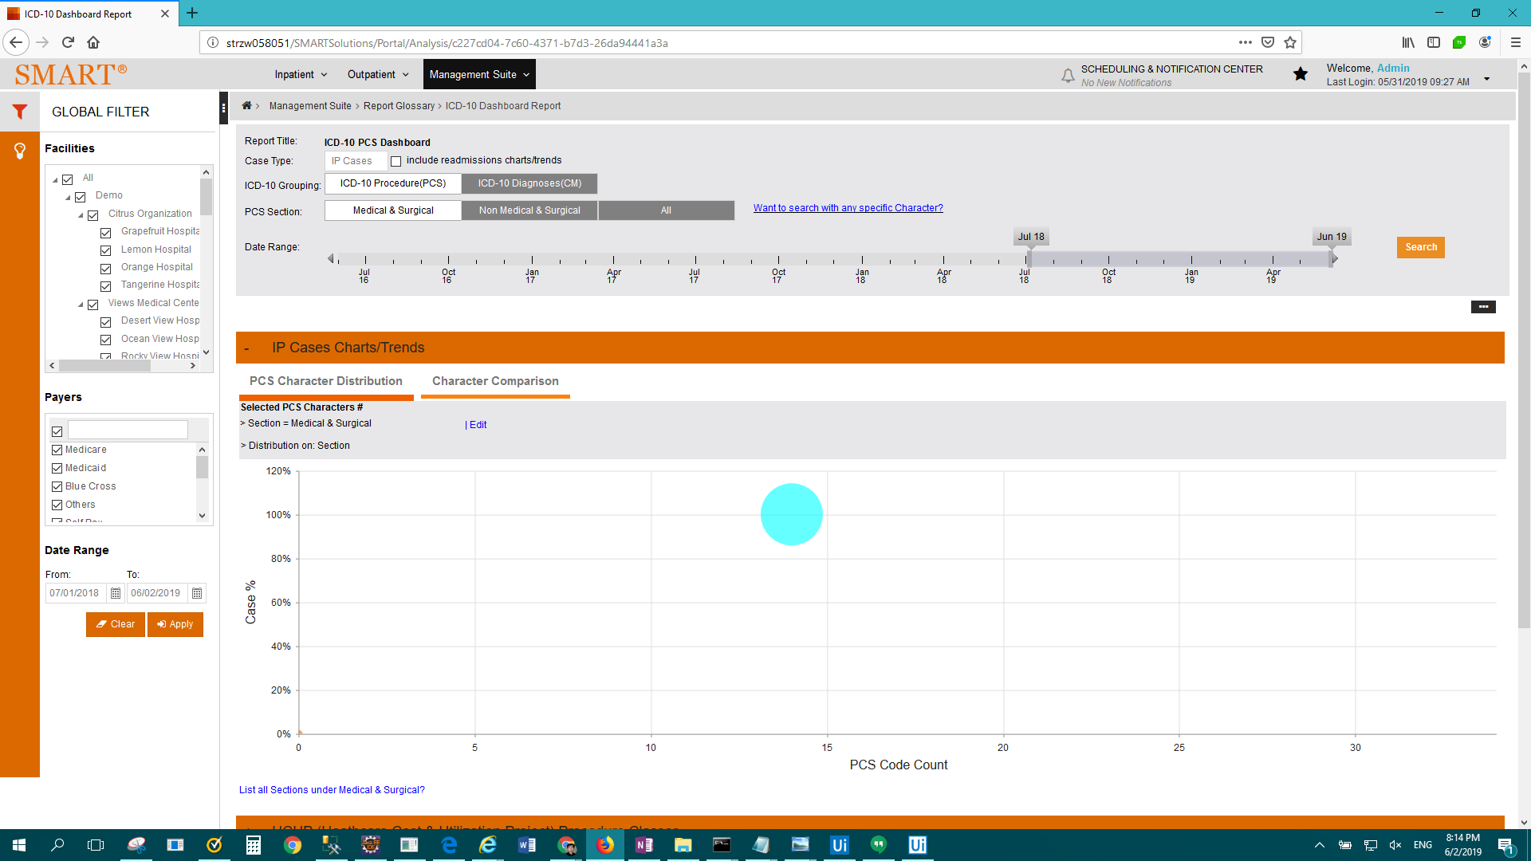

FAIL: Enterprise Report - ICD-10 Fracture Analysis > Result Description: Test Passed for Report: Enterprise Report - ICD-10 Fracture Analysis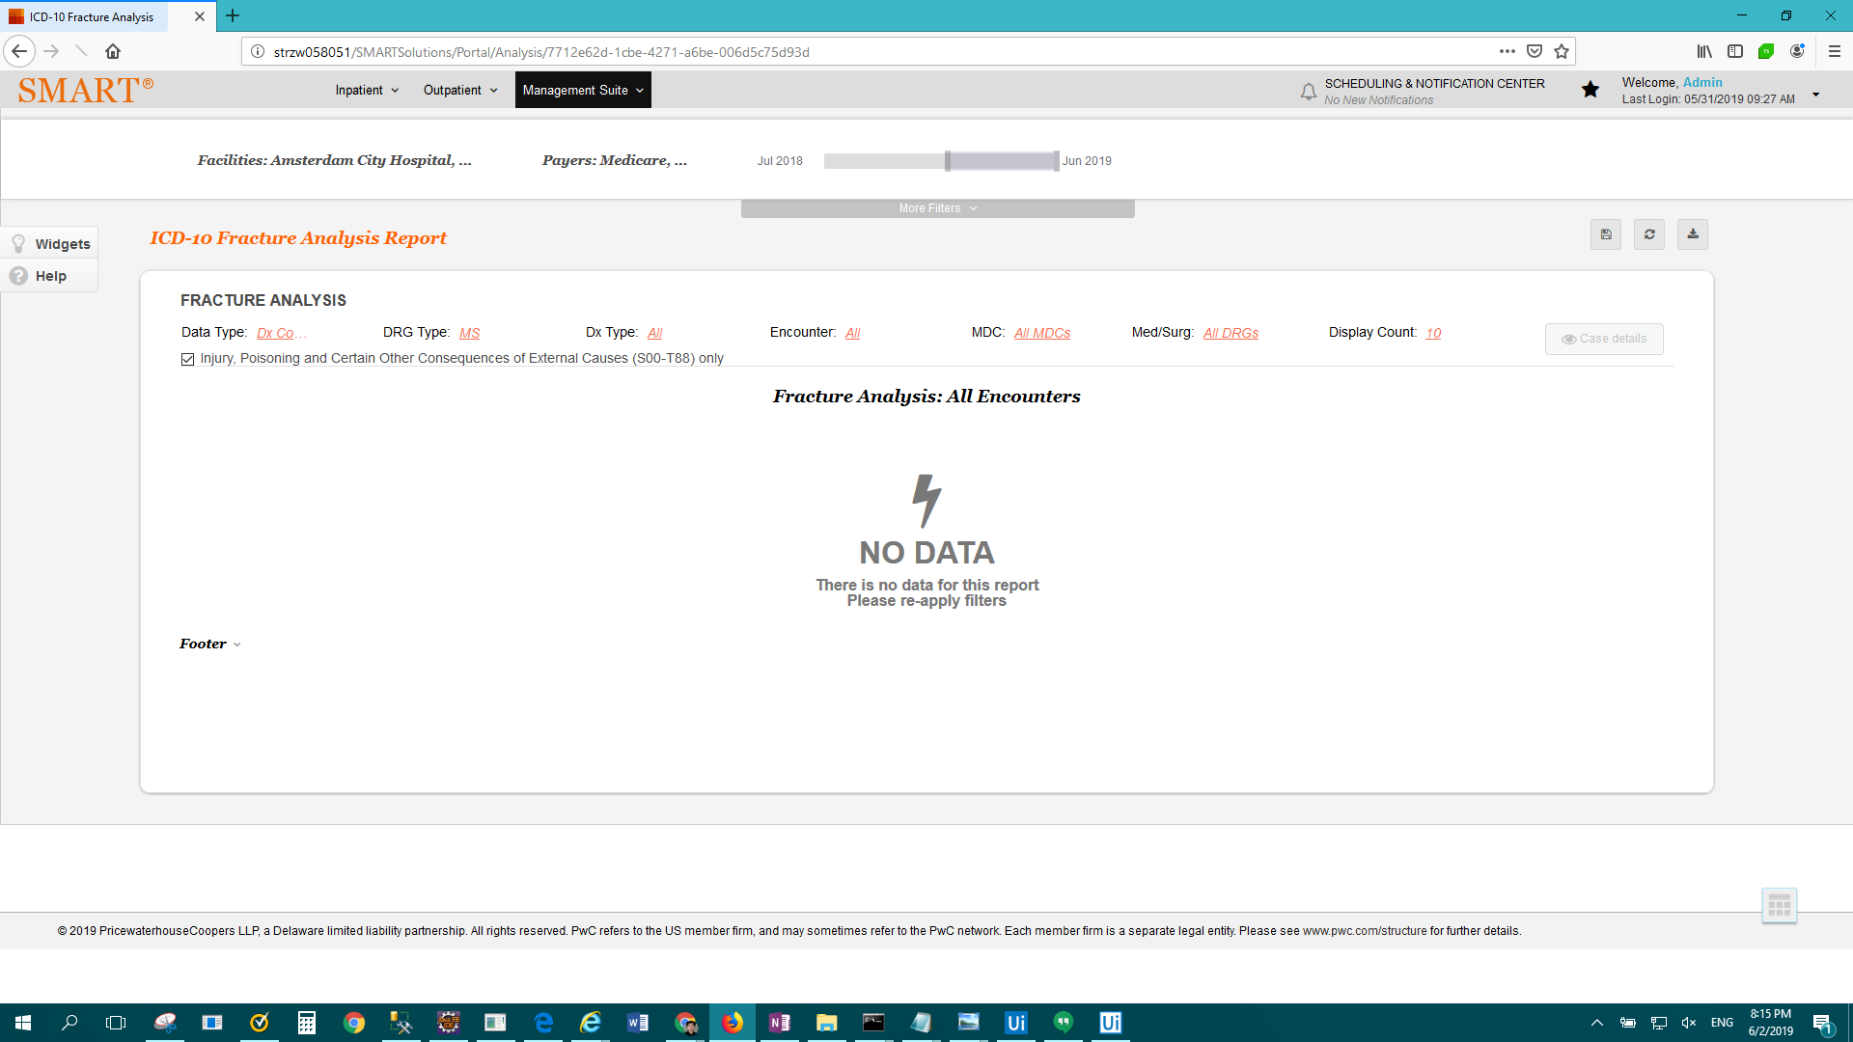

FAIL: Enterprise Report - ICD-10 Unspecified Codes Report > Result Description: Test Passed for Report: Enterprise Report - ICD-10 Unspecified Codes Report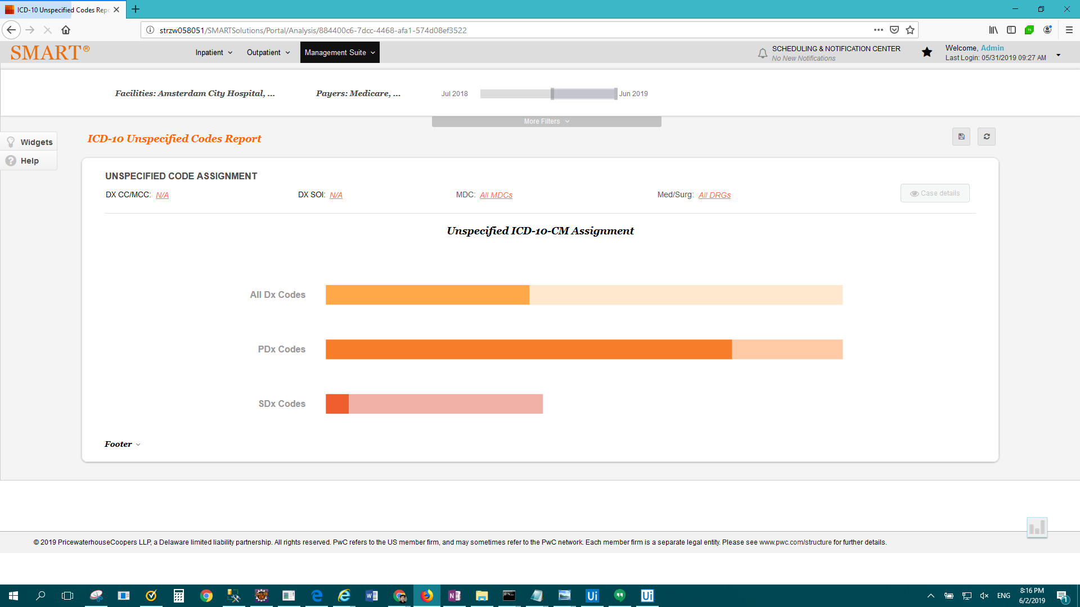

FAIL: Enterprise Report - Inpatient Coding Accuracy and Results > Result Description: Test Failed For: Enterprise Report - Inpatient Coding Accuracy and Results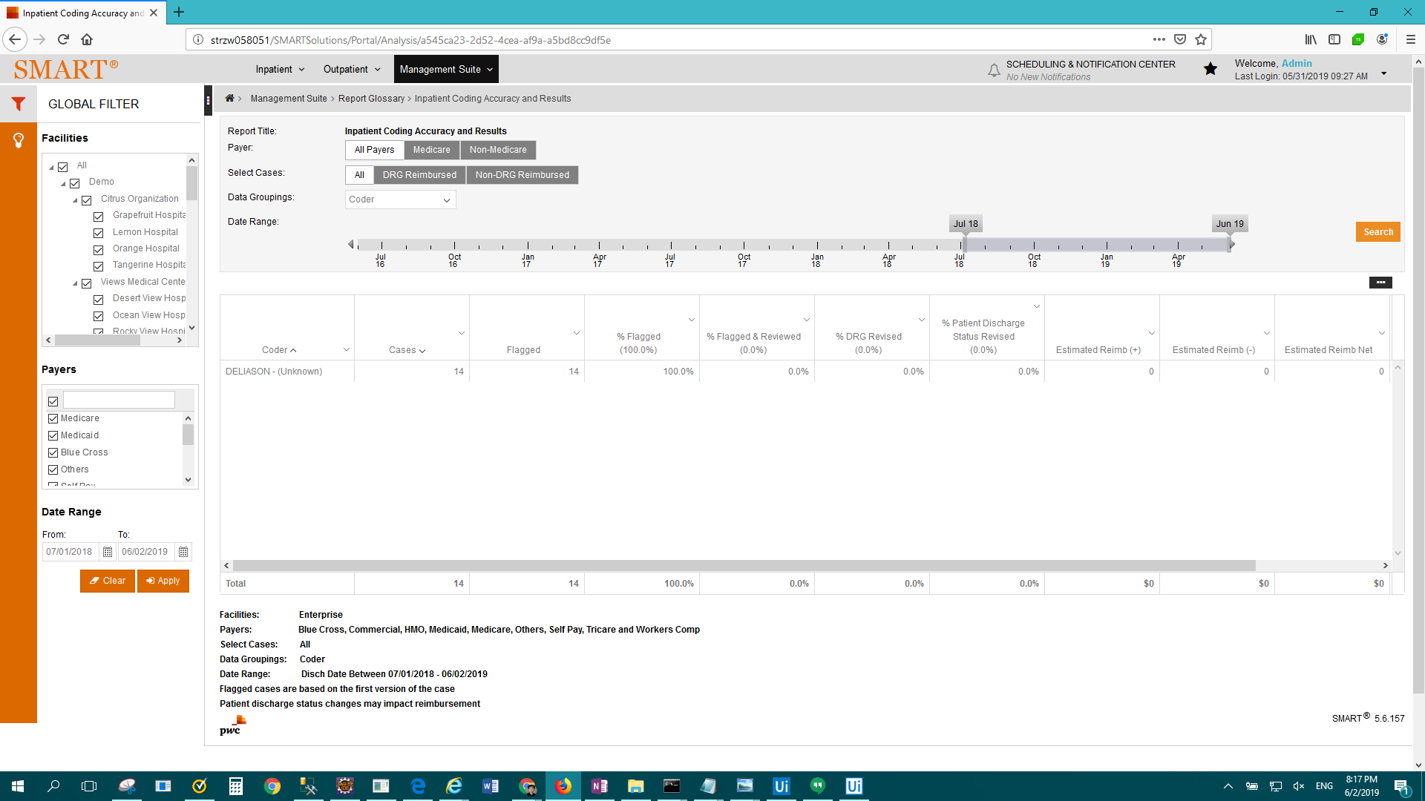

FAIL: Enterprise Report - Medicare short-stay cases by DRG > Result Description: Test Passed for Report: Enterprise Report - Medicare short-stay cases by DRG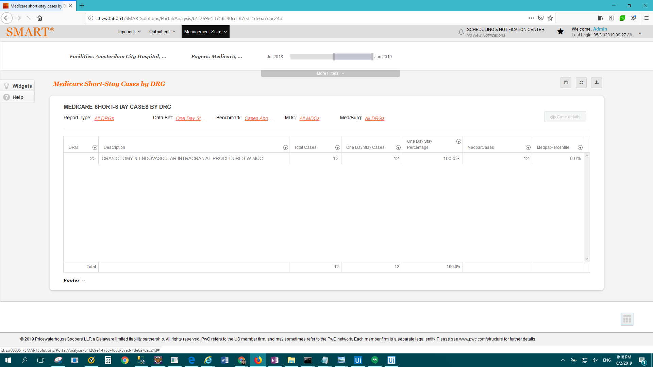

FAIL: Enterprise Report - Medicare short-stay comparison to MedPAR > Result Description: Test Failed For: Enterprise Report - Medicare short-stay comparison to MedPAR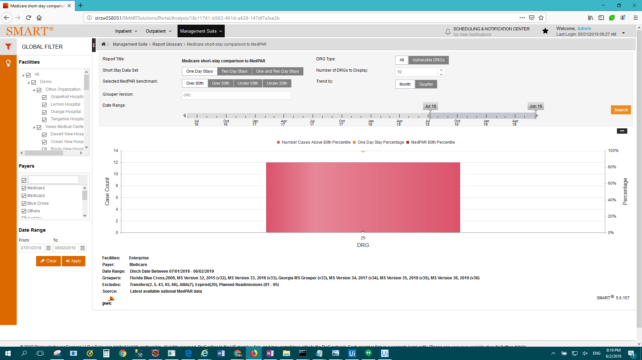

FAIL: Enterprise Report - Normalized CMI > Result Description: Test Passed for Report: Enterprise Report - Normalized CMI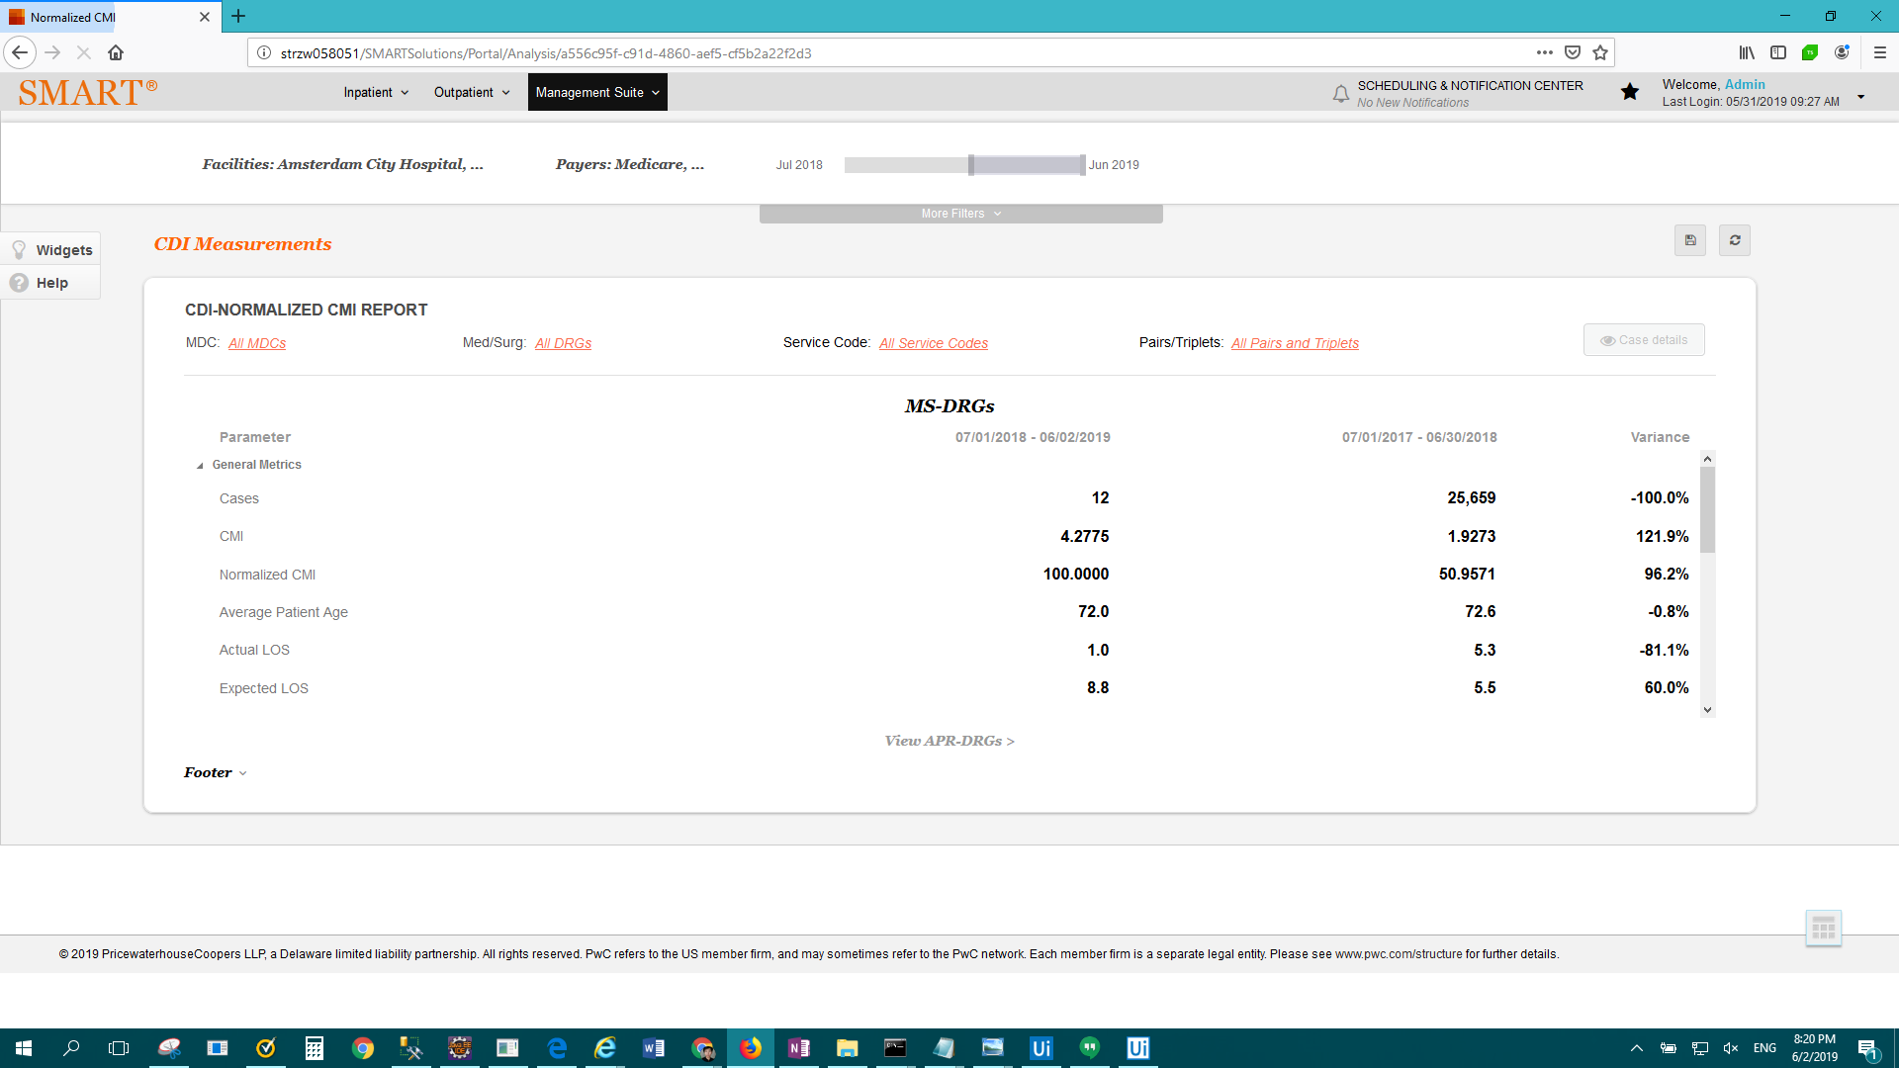

FAIL: Enterprise Report - Observation Case Profile > Result Description: Test Failed For: Enterprise Report - Observation Case Profile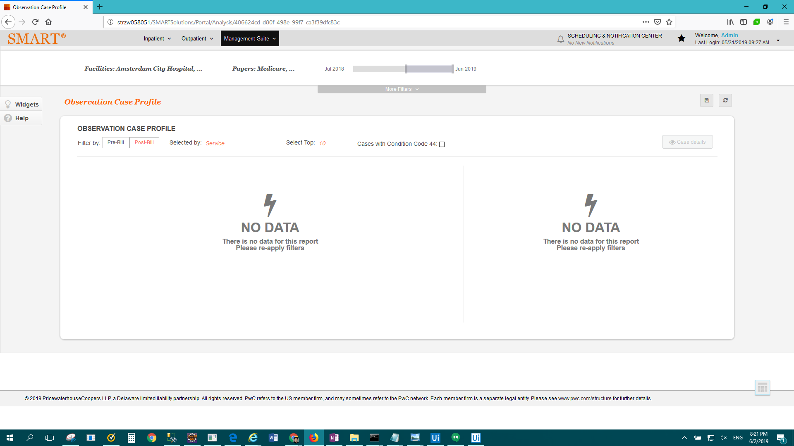

FAIL: Enterprise Report - Patient Discharge Status Trending > Result Description: Test Failed For: Enterprise Report - Patient Discharge Status Trending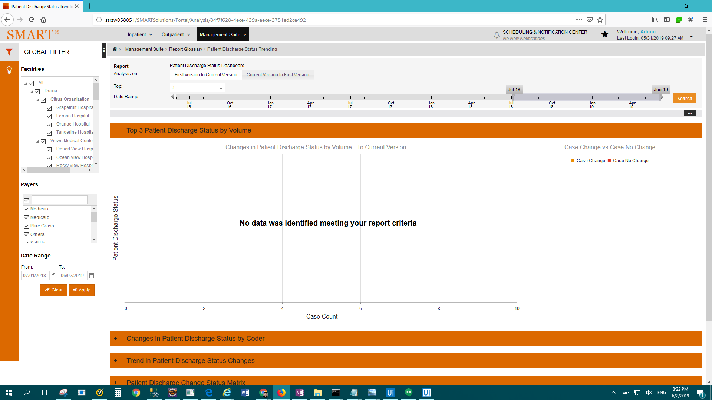

FAIL: Enterprise Report - PEPPER Outlier > Result Description: Test Passed for Report: Enterprise Report - PEPPER Outlier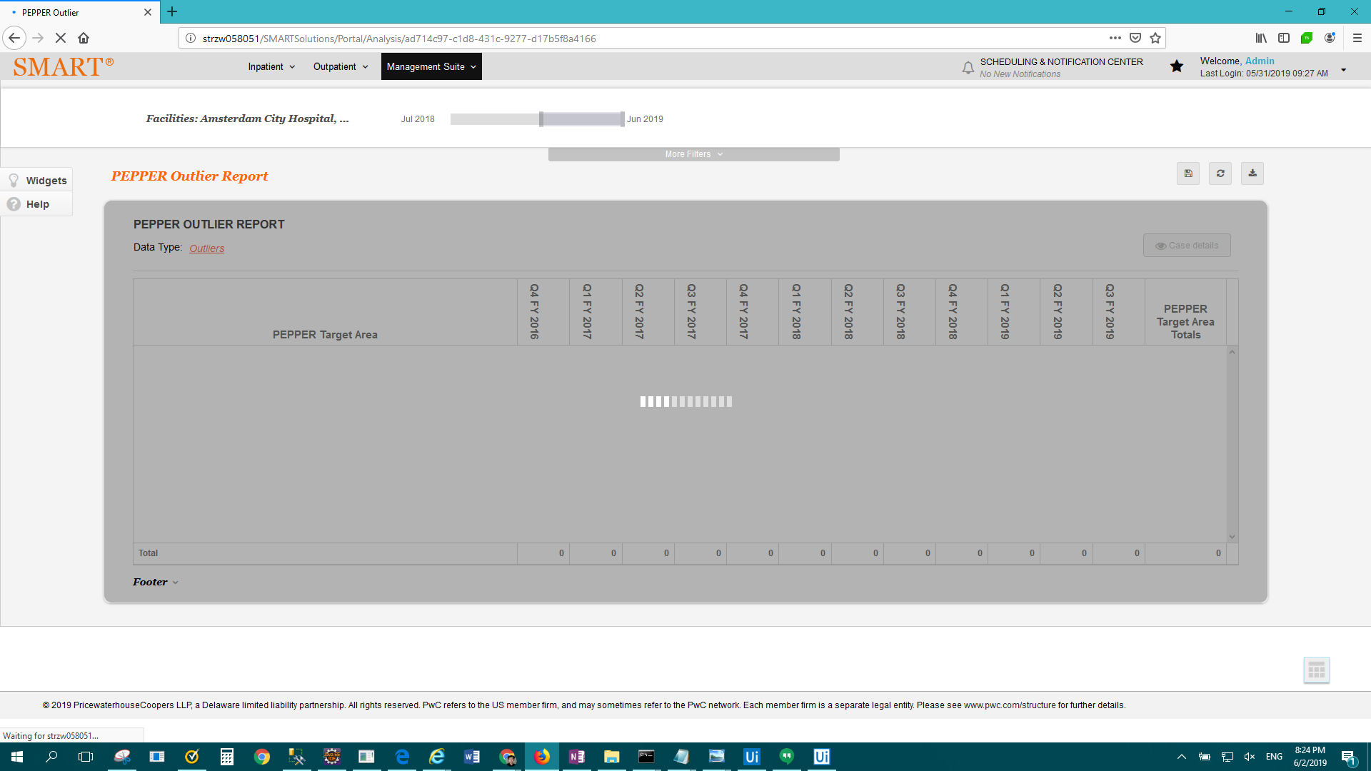

FAIL: Enterprise Report - PEPPER Target Areas > Result Description: Test Passed for Report: Enterprise Report - PEPPER Target Areas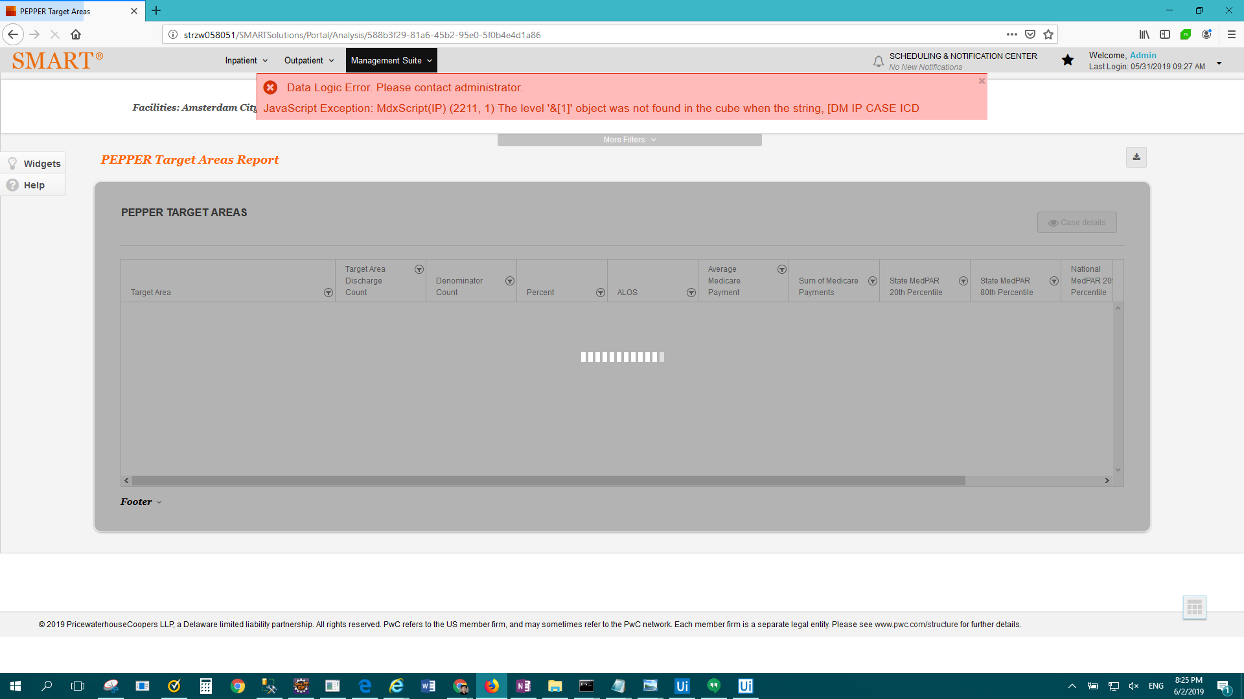

FAIL: Enterprise Report - PEPPER Top Medical DRGs > Result Description: Test Passed for Report: Enterprise Report - PEPPER Top Medical DRGs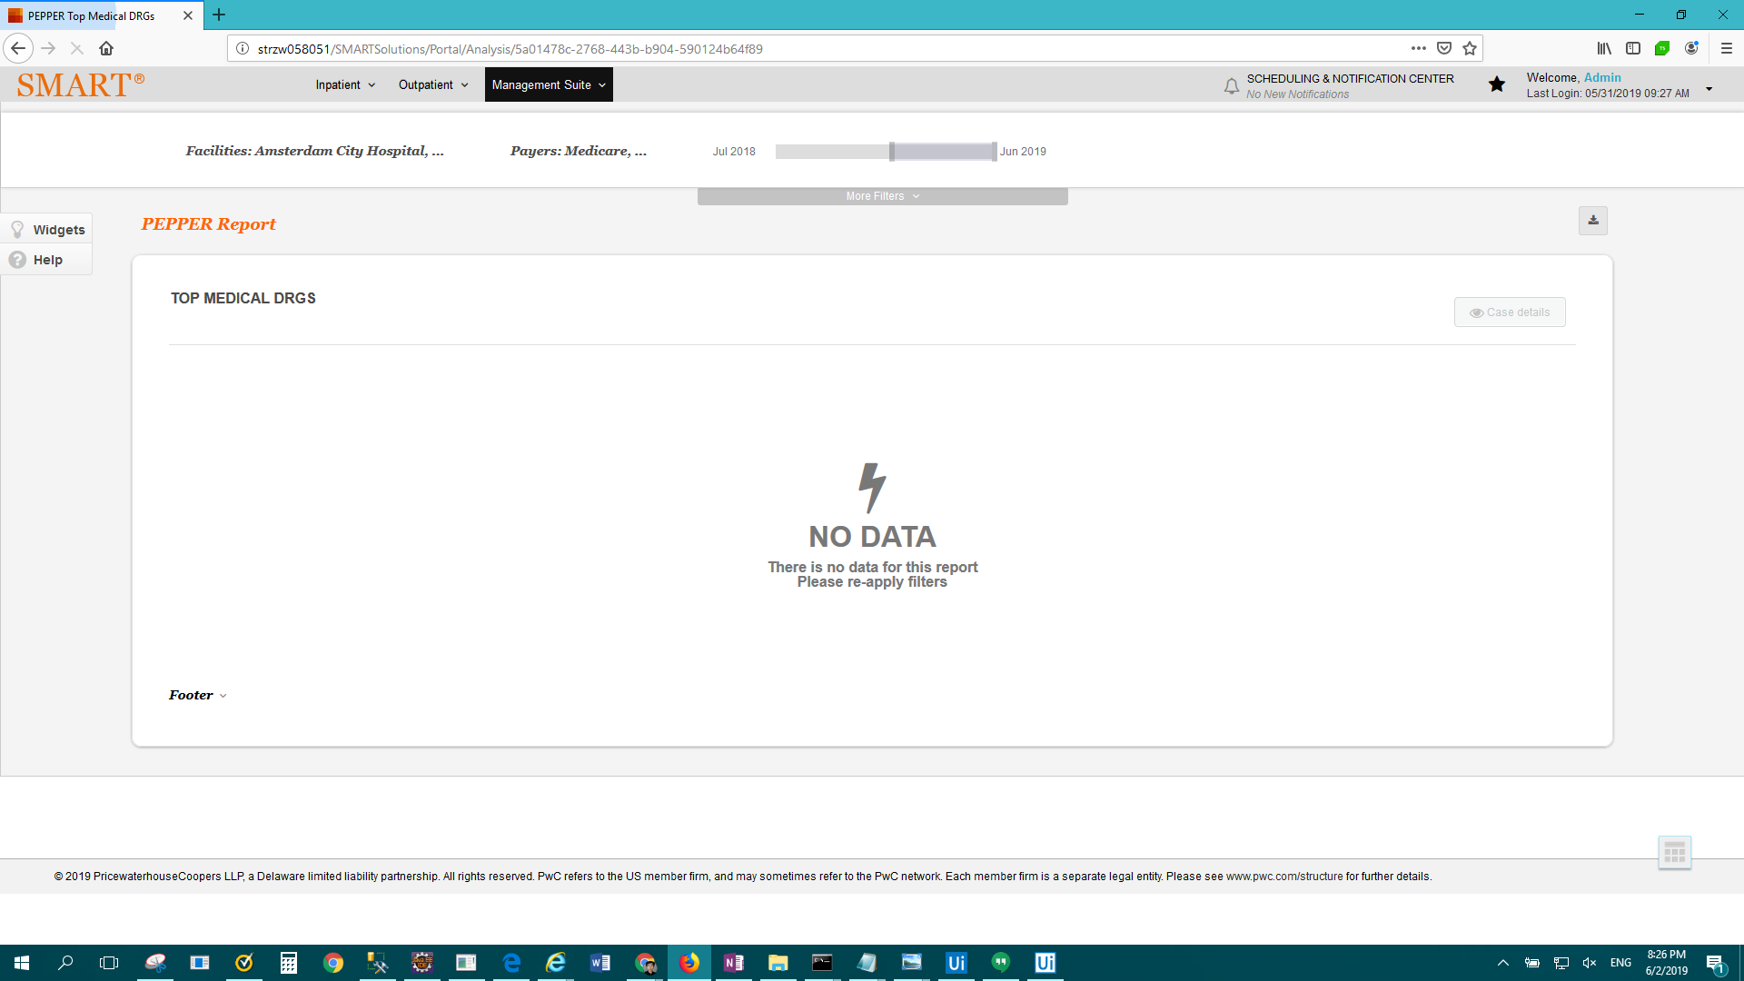

FAIL: Enterprise Report - PEPPER Top Surgical DRGs > Result Description: Test Passed for Report: Enterprise Report - PEPPER Top Surgical DRGs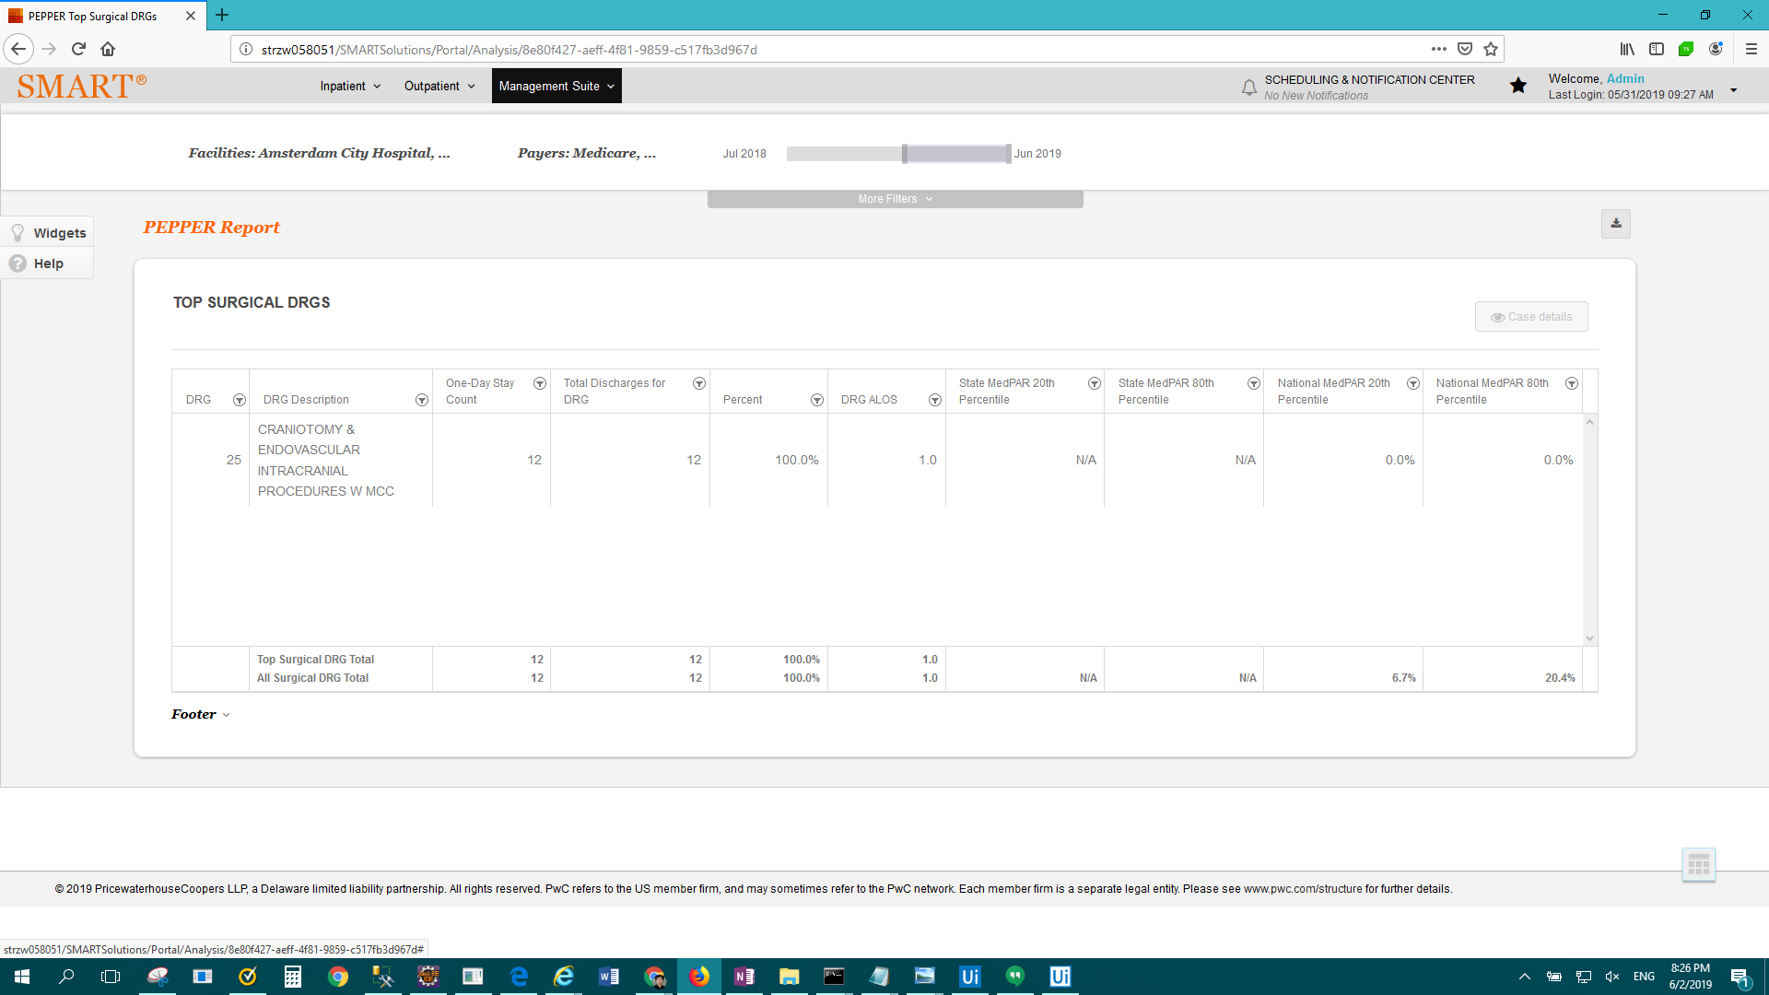

FAIL: Enterprise Report - Physician Profile > Result Description: Test Failed For: Enterprise Report - Physician Profile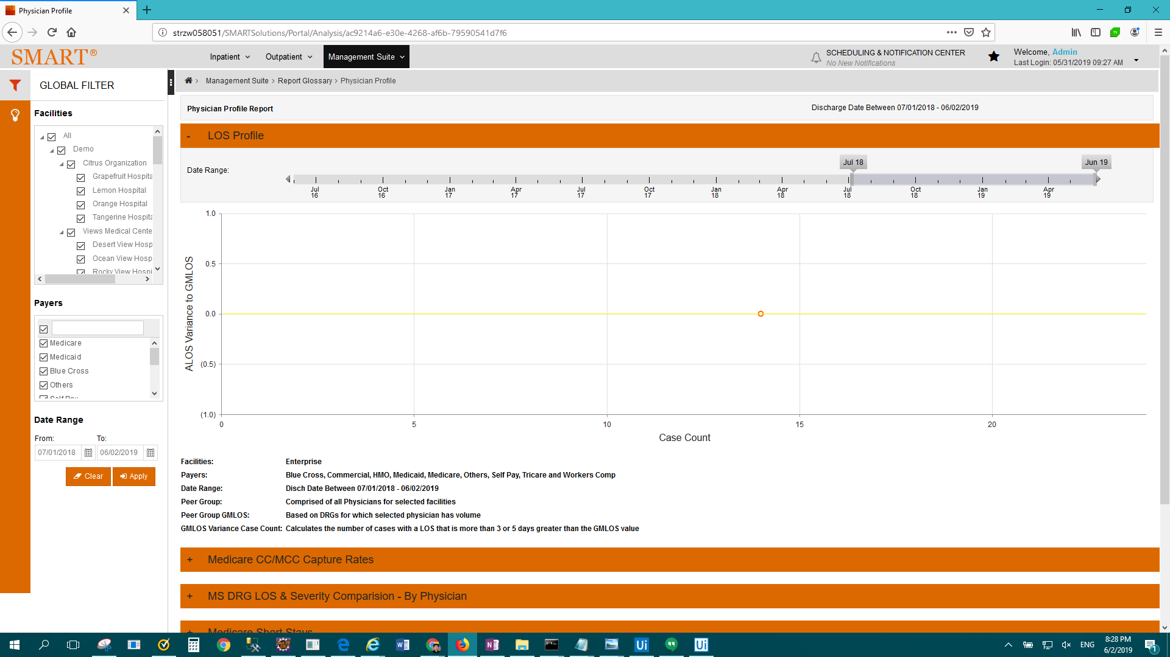

FAIL: Enterprise Report - PSI #90 Report > Result Description: Test Passed for Report: Enterprise Report - PSI #90 Report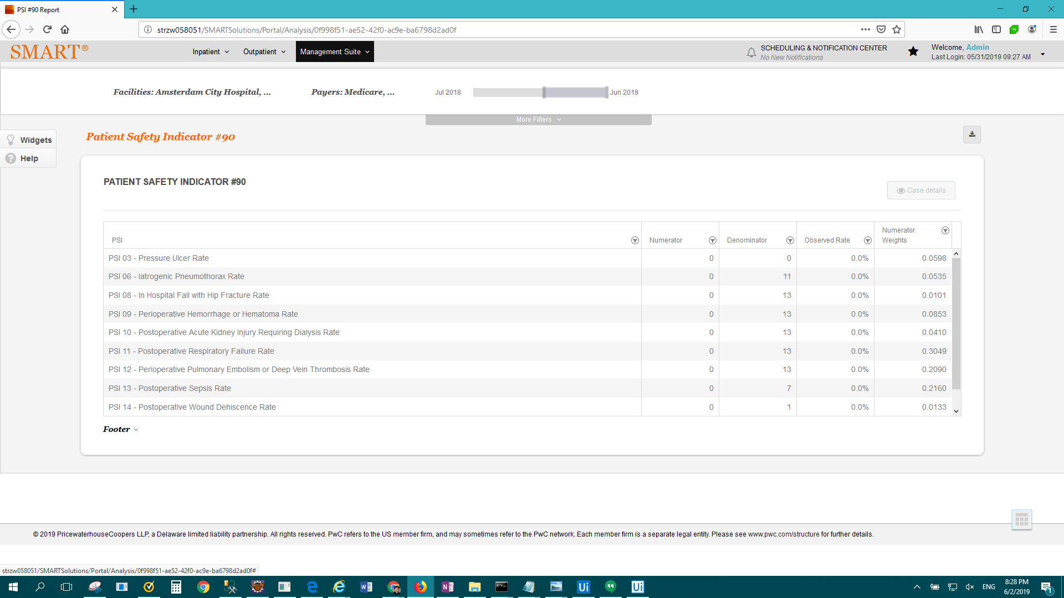

FAIL: Enterprise Report - PSI Case Count > Result Description: Test Passed for Report: Enterprise Report - PSI Case Count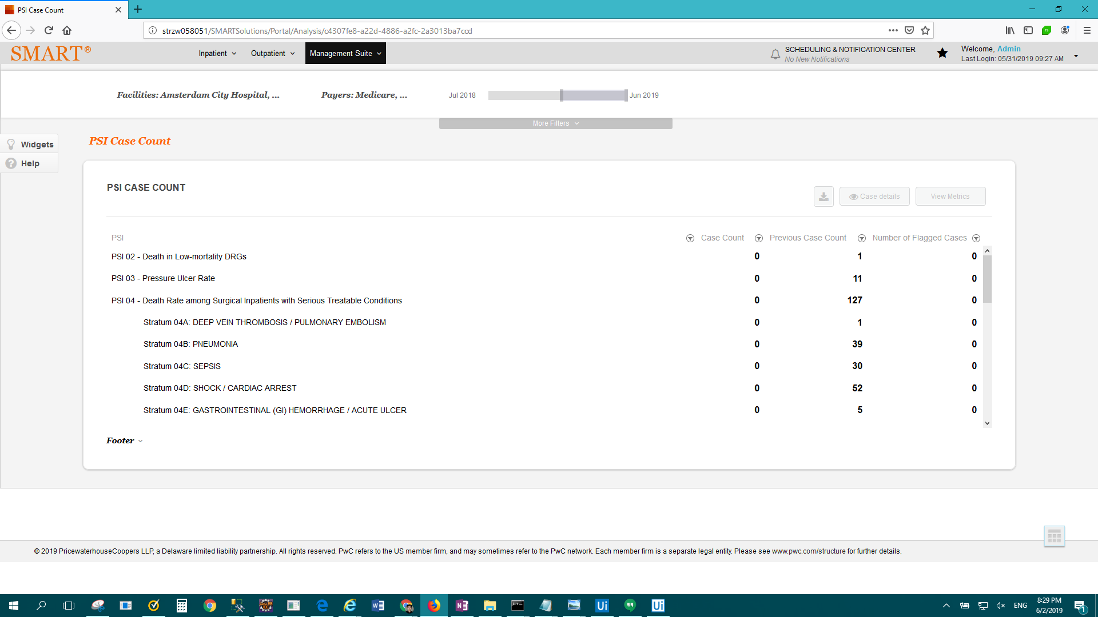

FAIL: Enterprise Report - Readmissions by Facility > Result Description: Test Passed for Report: Enterprise Report - Readmissions by Facility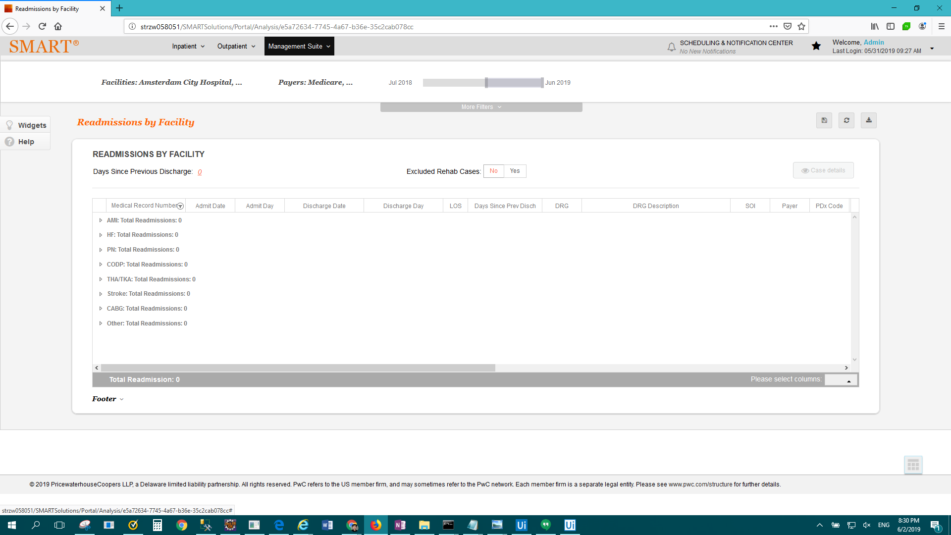

FAIL: Enterprise Report - Revision Metrics > Result Description: Test Passed for Report: Enterprise Report - Revision Metrics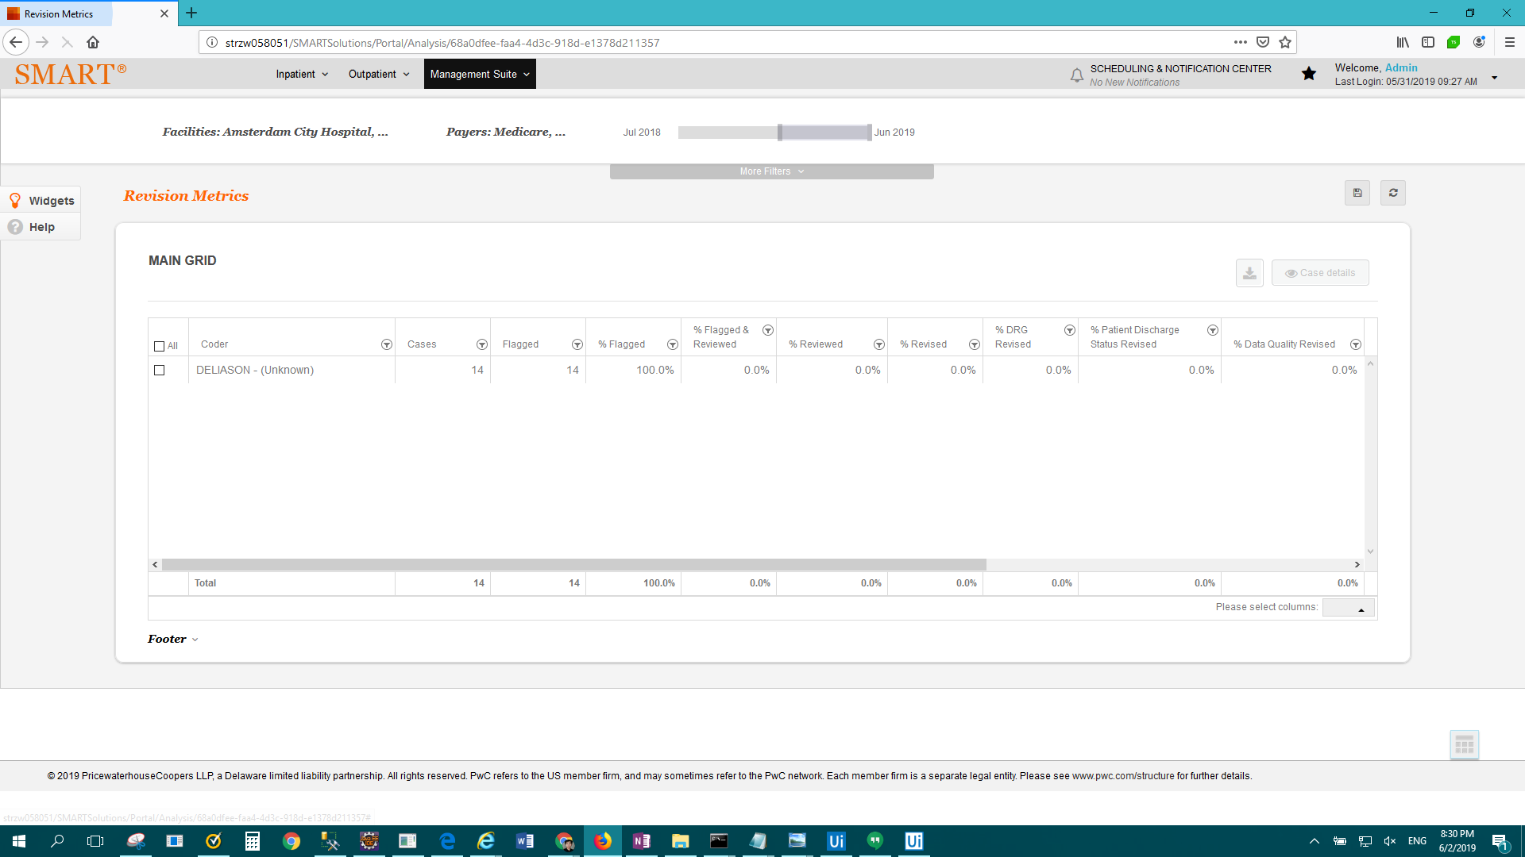

FAIL: Enterprise Report - Short-stay cases by DRG > Result Description: Test Passed for Report: Enterprise Report - Short-stay cases by DRG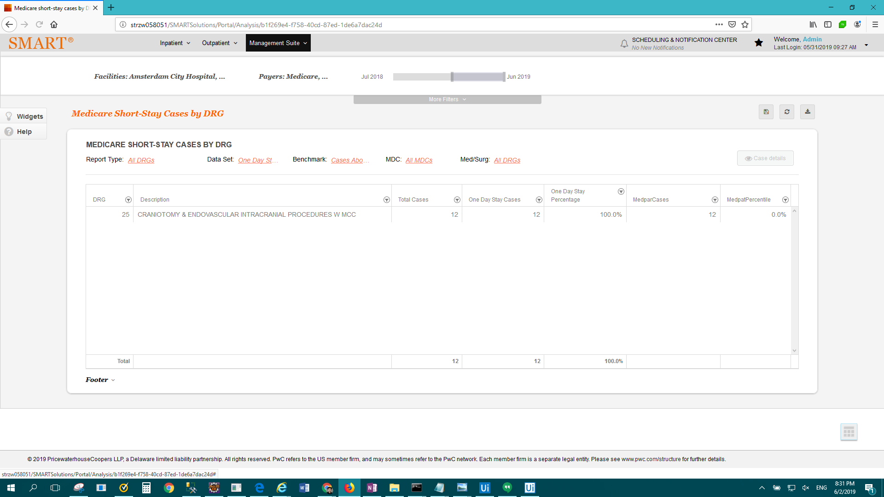

FAIL: Enterprise Report - SMART Report Card - Trending Version > Result Description: Test Passed for Report: Enterprise Report - SMART Report Card - Trending Version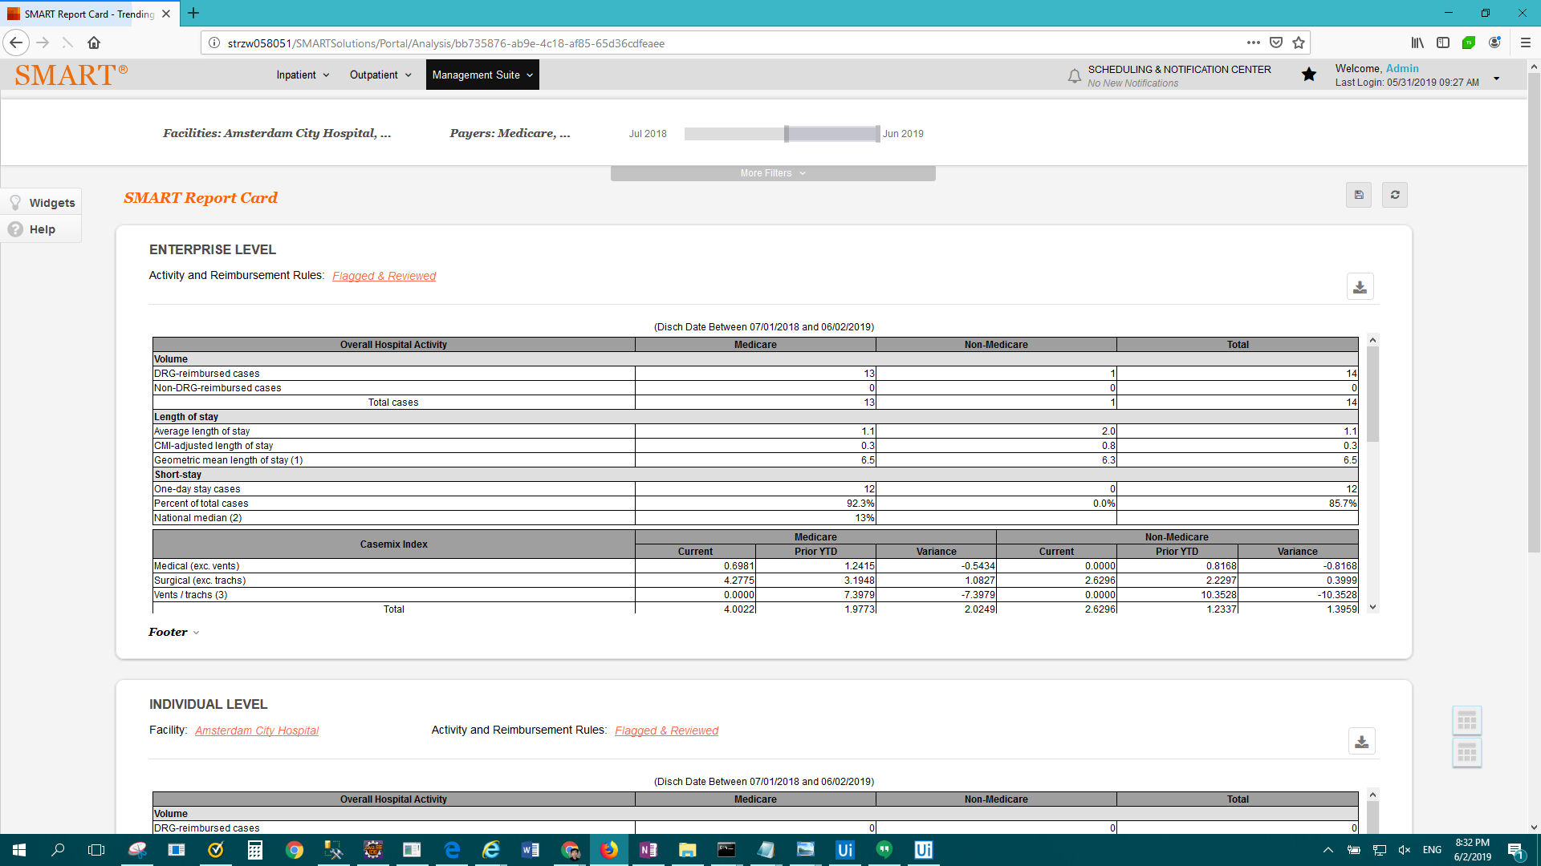

FAIL: Enterprise Report - Summary of flags on inpatient cases > Result Description: Test Failed For: Enterprise Report - Summary of flags on inpatient cases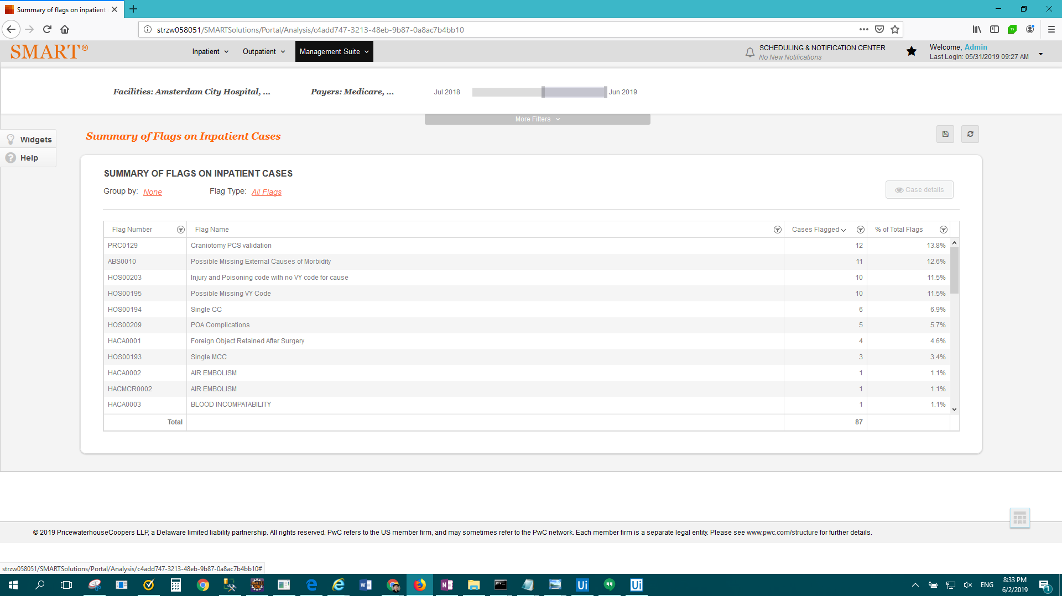

FAIL: Enterprise Report - Summary of flags on outpatient visits > Result Description: Test Failed For: Enterprise Report - Summary of flags on outpatient visits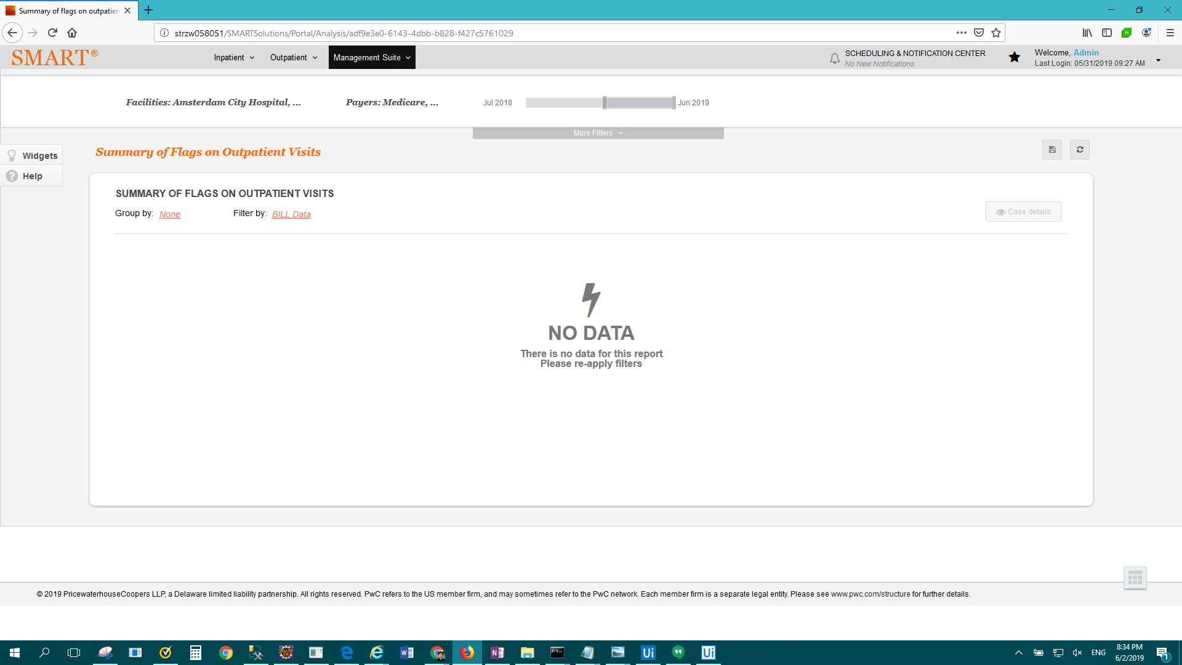

FAIL: IP Standard - Attending Physician Frequency by DRG > Result Description: Test Passed for Report: IP Standard - Attending Physician Frequency by DRG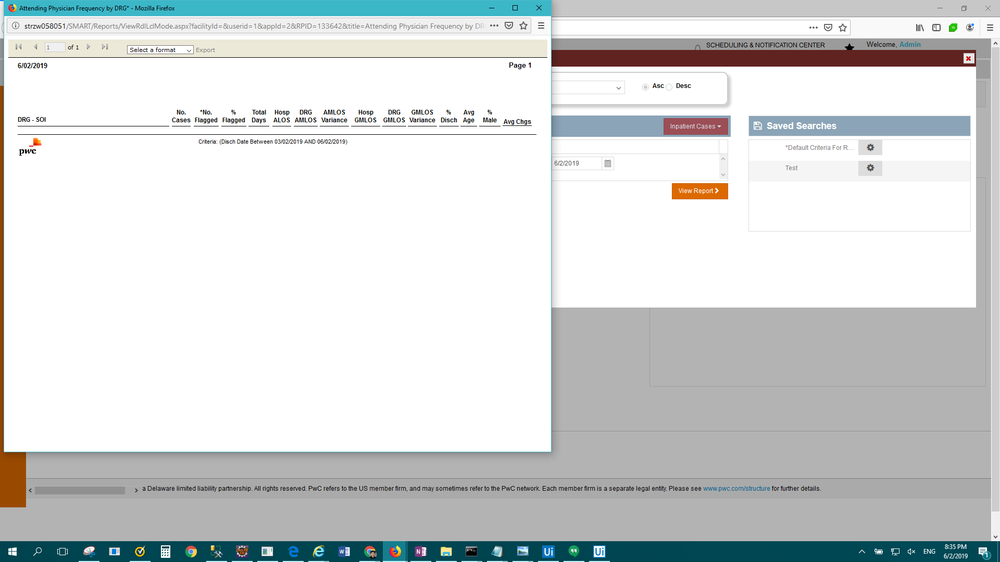

FAIL: IP Standard - Average Length of Stay by Payer by Month > Result Description: Test Passed for Report: IP Standard - Average Length of Stay by Payer by Month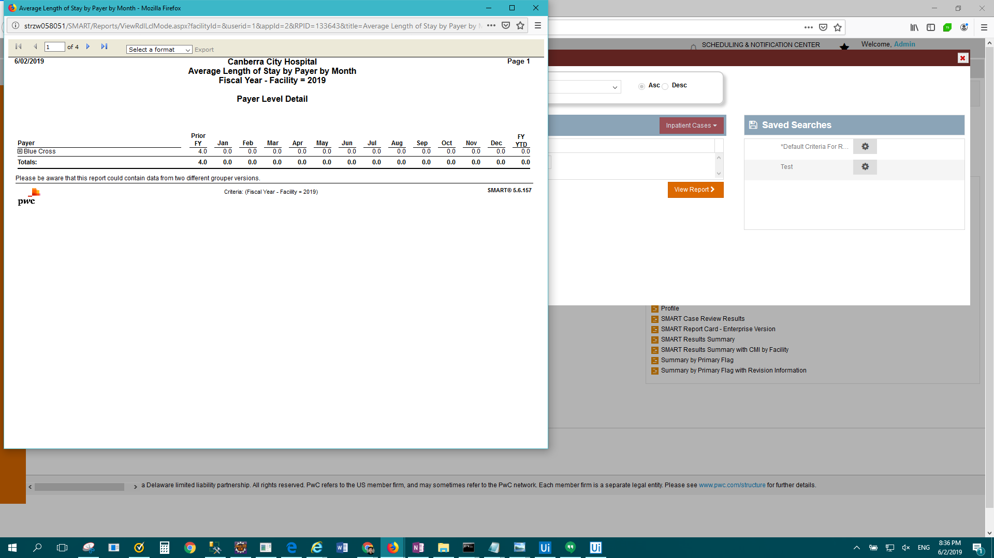

FAIL: IP Standard - Case Change Results > Result Description: Test Passed for Report: IP Standard - Case Change Results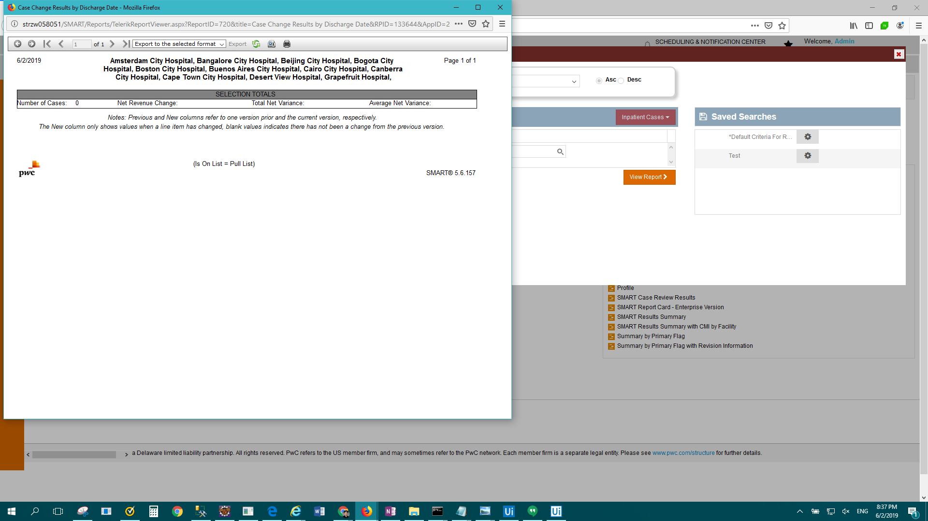

FAIL: IP Standard - Case Listing > Result Description: Test Passed for Report: IP Standard - Case Listing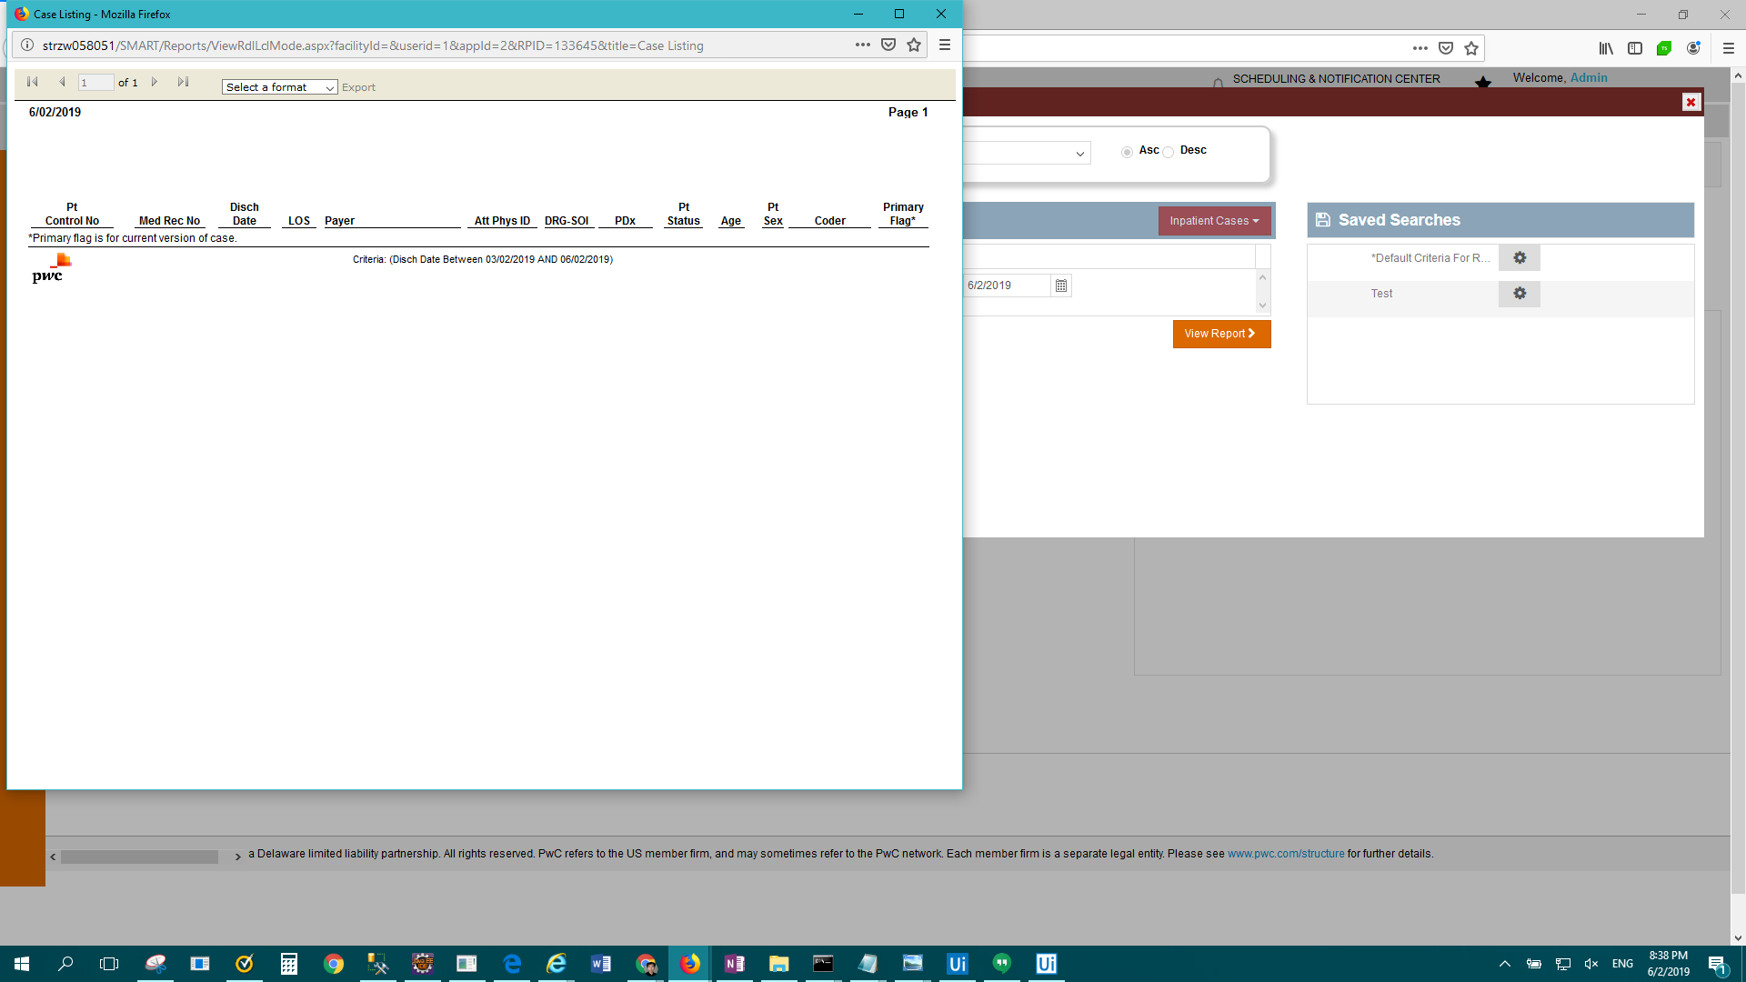

FAIL: Enterprise Report - Case Mix Index (CMI) Analysis > Result Description: Test Passed for Report: Enterprise Report - Case Mix Index (CMI) Analysis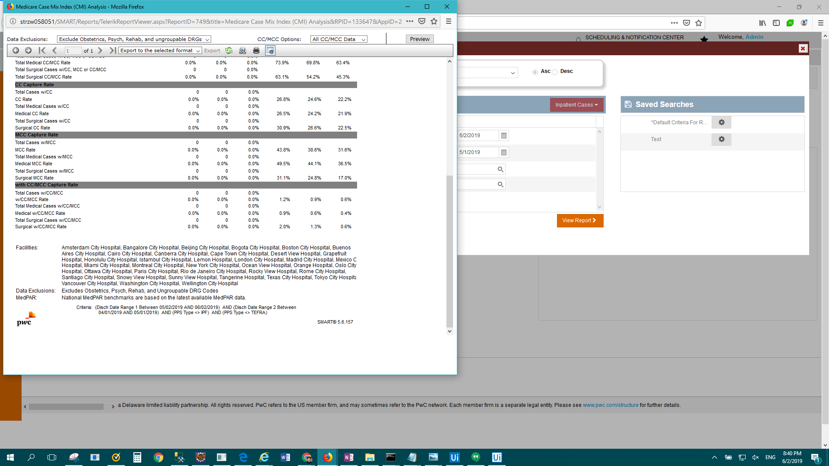

FAIL: Enterprise Report - Case Mix Index (CMI) Comparison > Result Description: Test Passed for Report: Enterprise Report - Case Mix Index (CMI) Comparison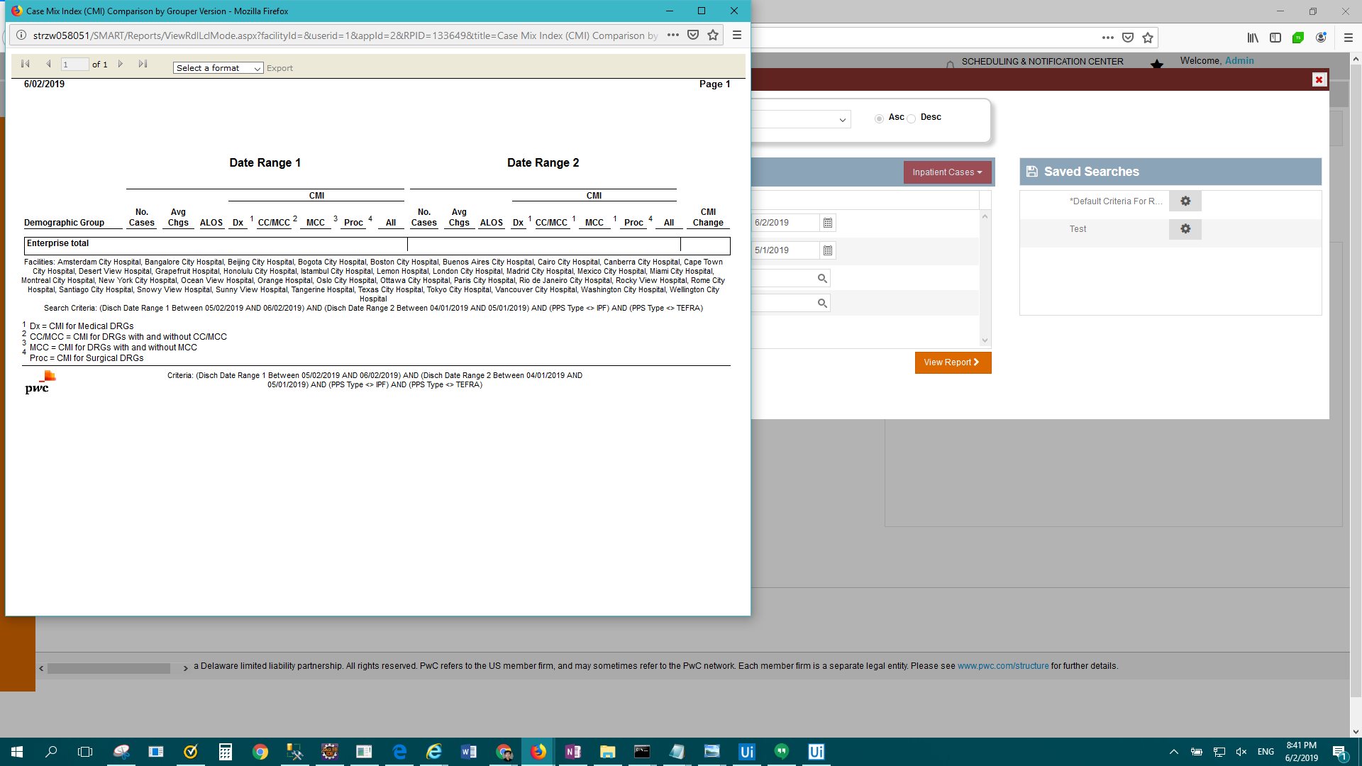

FAIL: IP Standard - Case Status Reimbursement Detail > Result Description: Test Passed for Report: IP Standard - Case Status Reimbursement Detail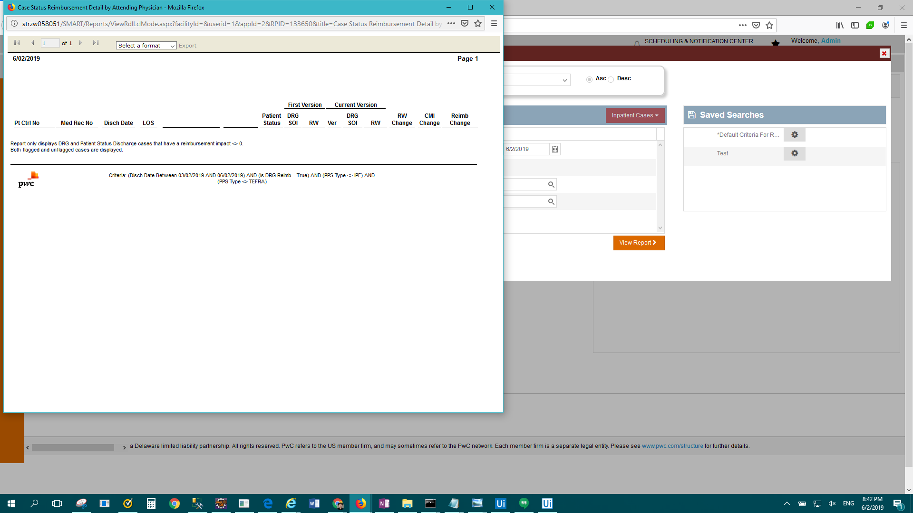

FAIL: IP Standard - Case Status Reimbursement Summary > Result Description: Test Passed for Report: IP Standard - Case Status Reimbursement Summary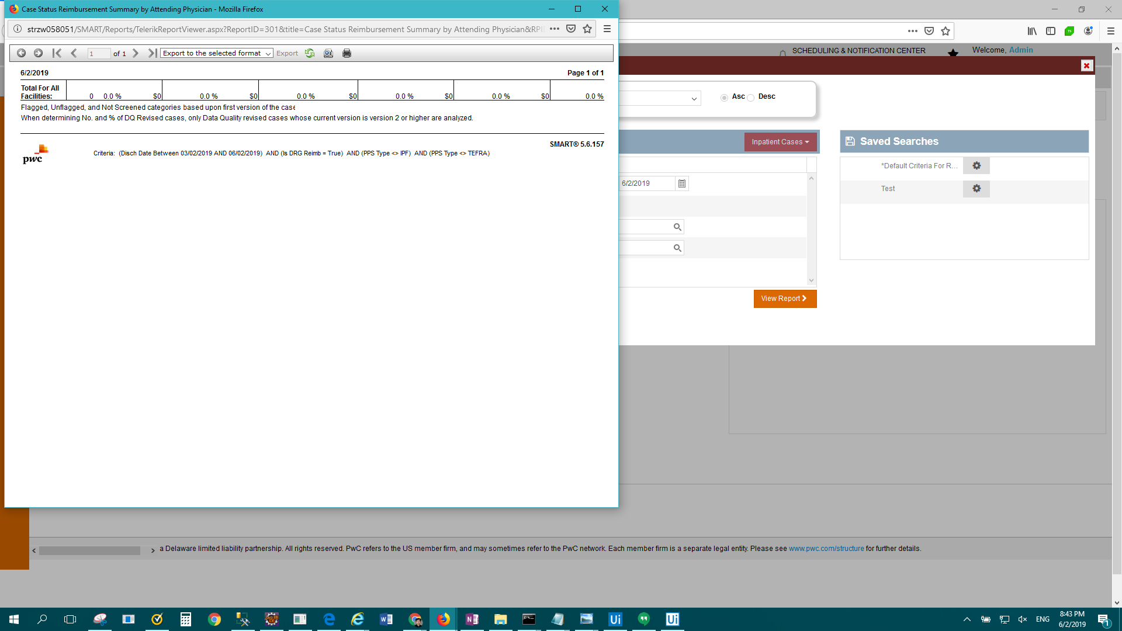

FAIL: IP Standard - Case Version Comparison > Result Description: Test Passed for Report: IP Standard - Case Version Comparison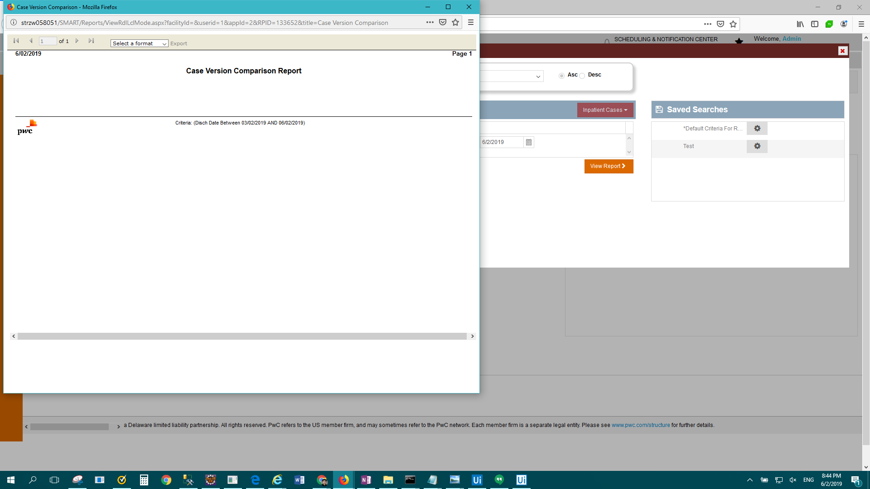

FAIL: IP Standard - Case-Mix by Payer by Month > Result Description: Test Passed for Report: IP Standard - Case-Mix by Payer by Month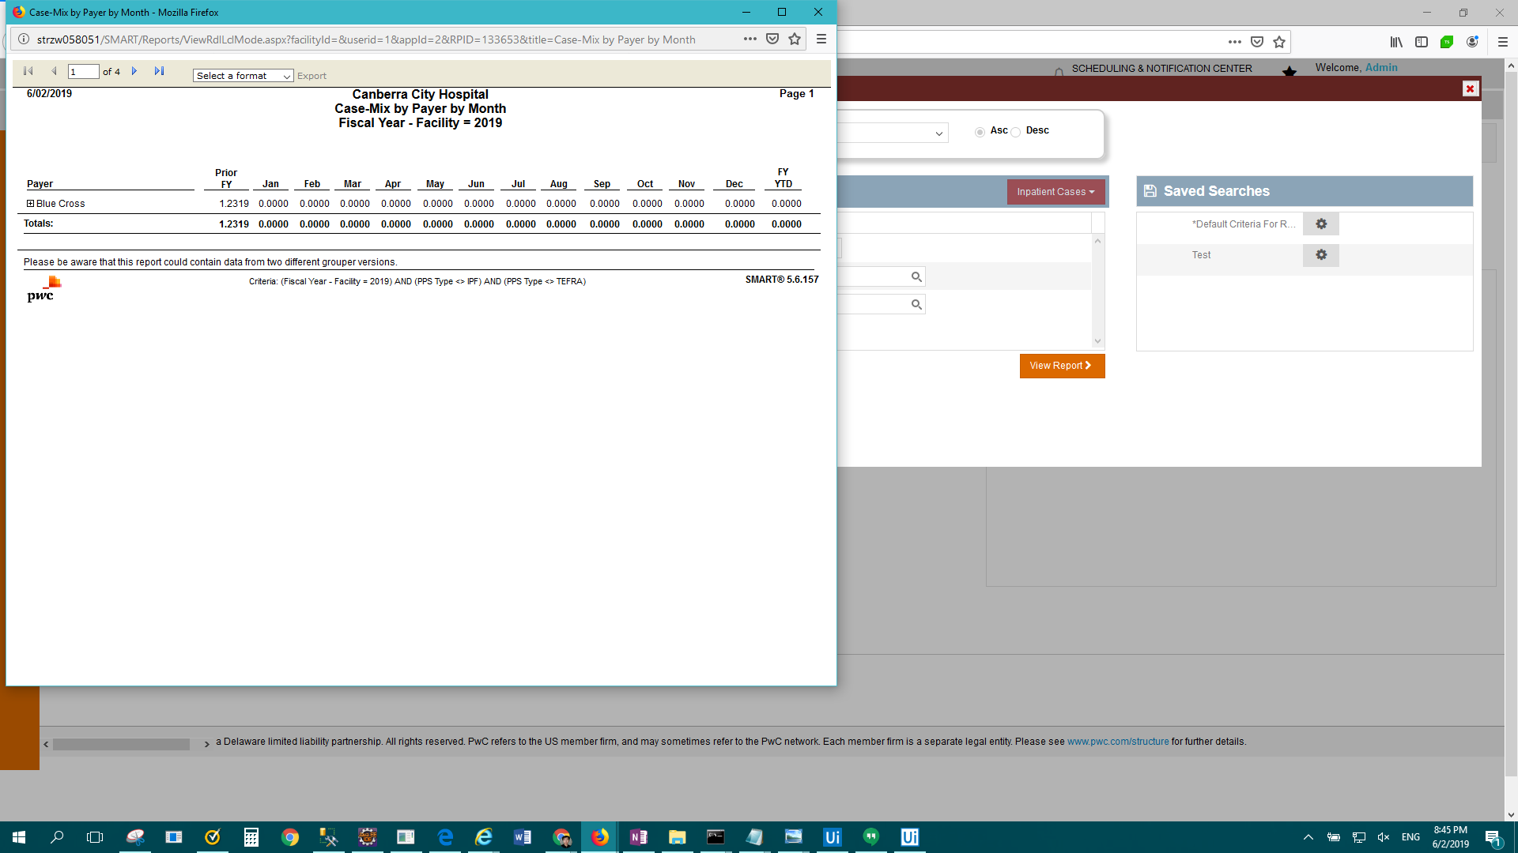

FAIL: IP Standard - Cases Processed on Import > Result Description: Test Passed for Report: IP Standard - Cases Processed on Import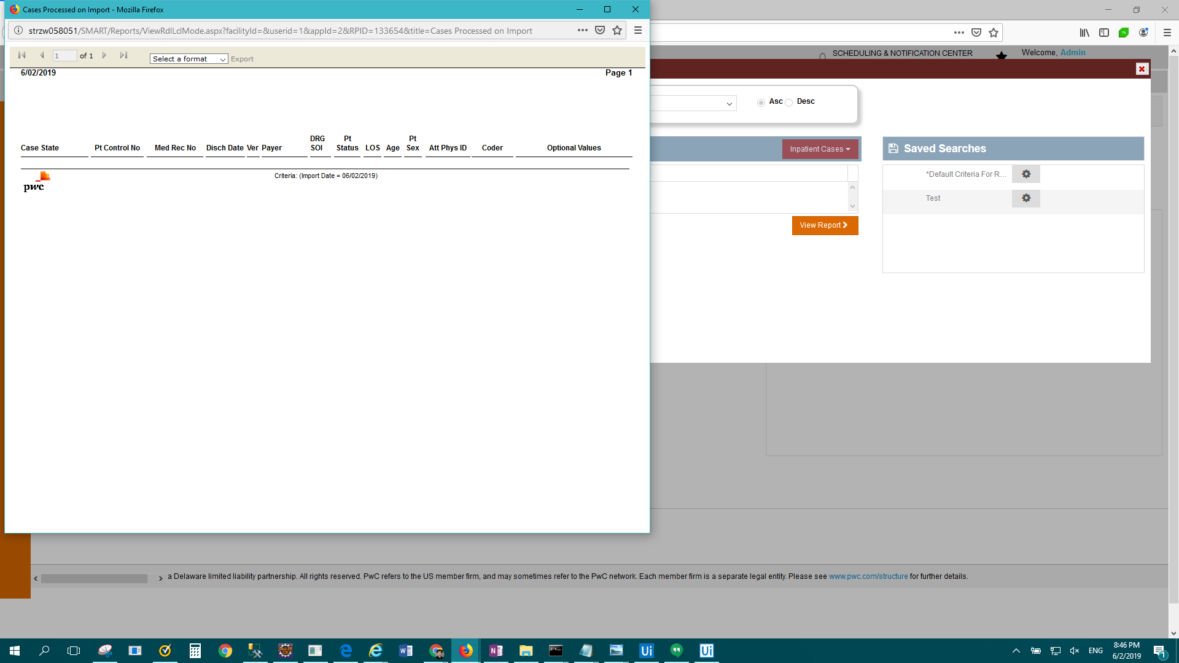

FAIL: Enterprise Report - CMI Reimbursement Summary > Result Description: Test Passed for Report: Enterprise Report - CMI Reimbursement Summary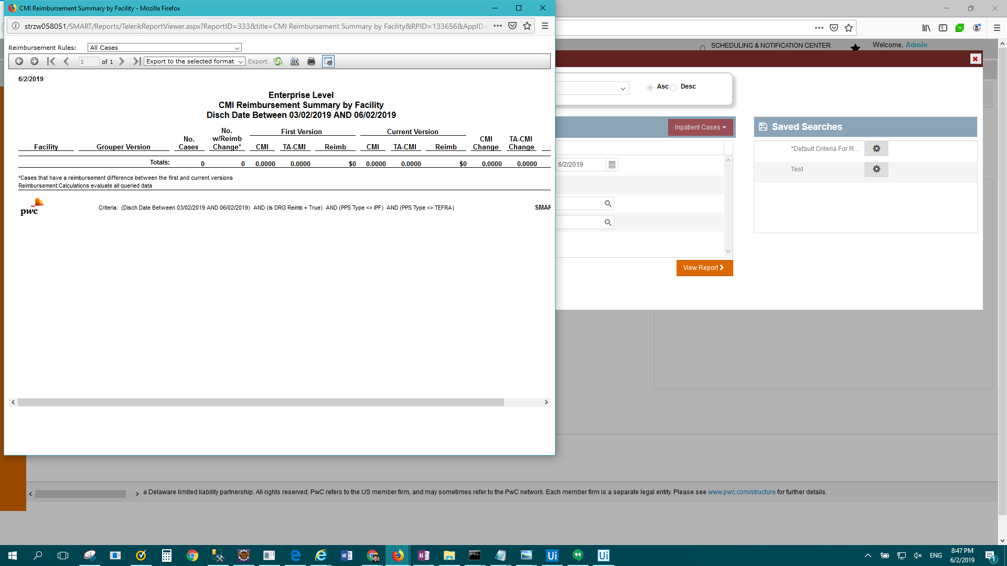

FAIL: IP Standard - Coder Information > Result Description: Test Passed for Report: IP Standard - Coder Information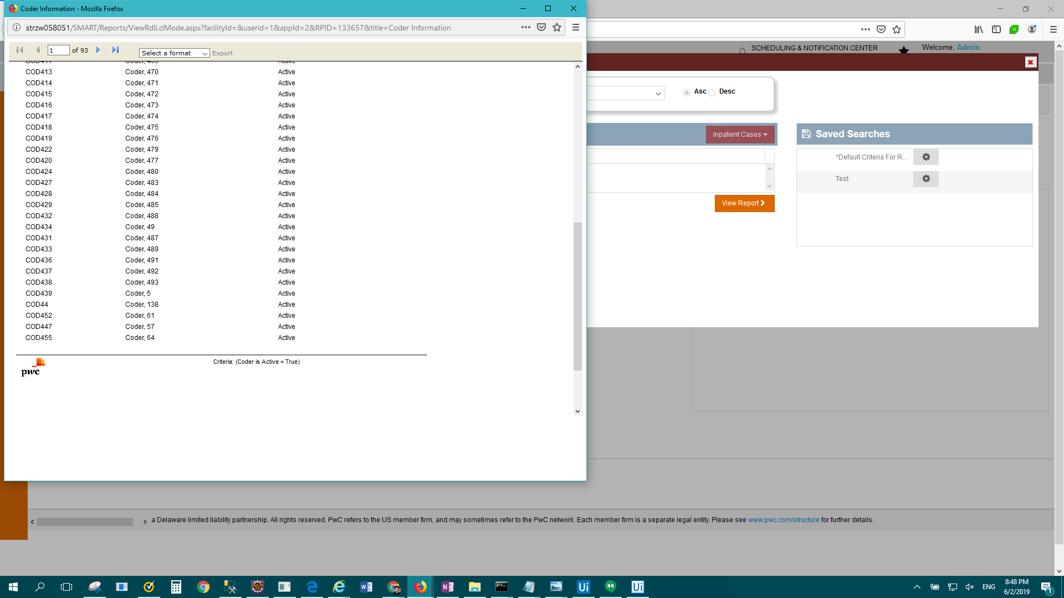

FAIL: Enterprise Report - Coding-DRG Accuracy Analysis > Result Description: Test Passed for Report: Enterprise Report - Coding-DRG Accuracy Analysis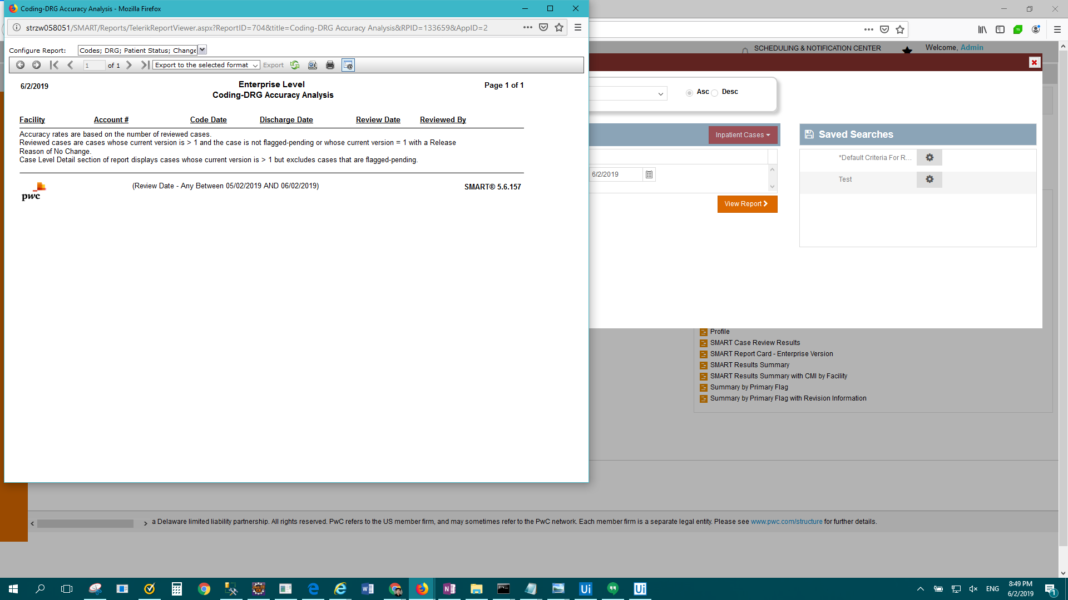

FAIL: IP Standard - Coding-DRG Review Summary > Result Description: Test Passed for Report: IP Standard - Coding-DRG Review Summary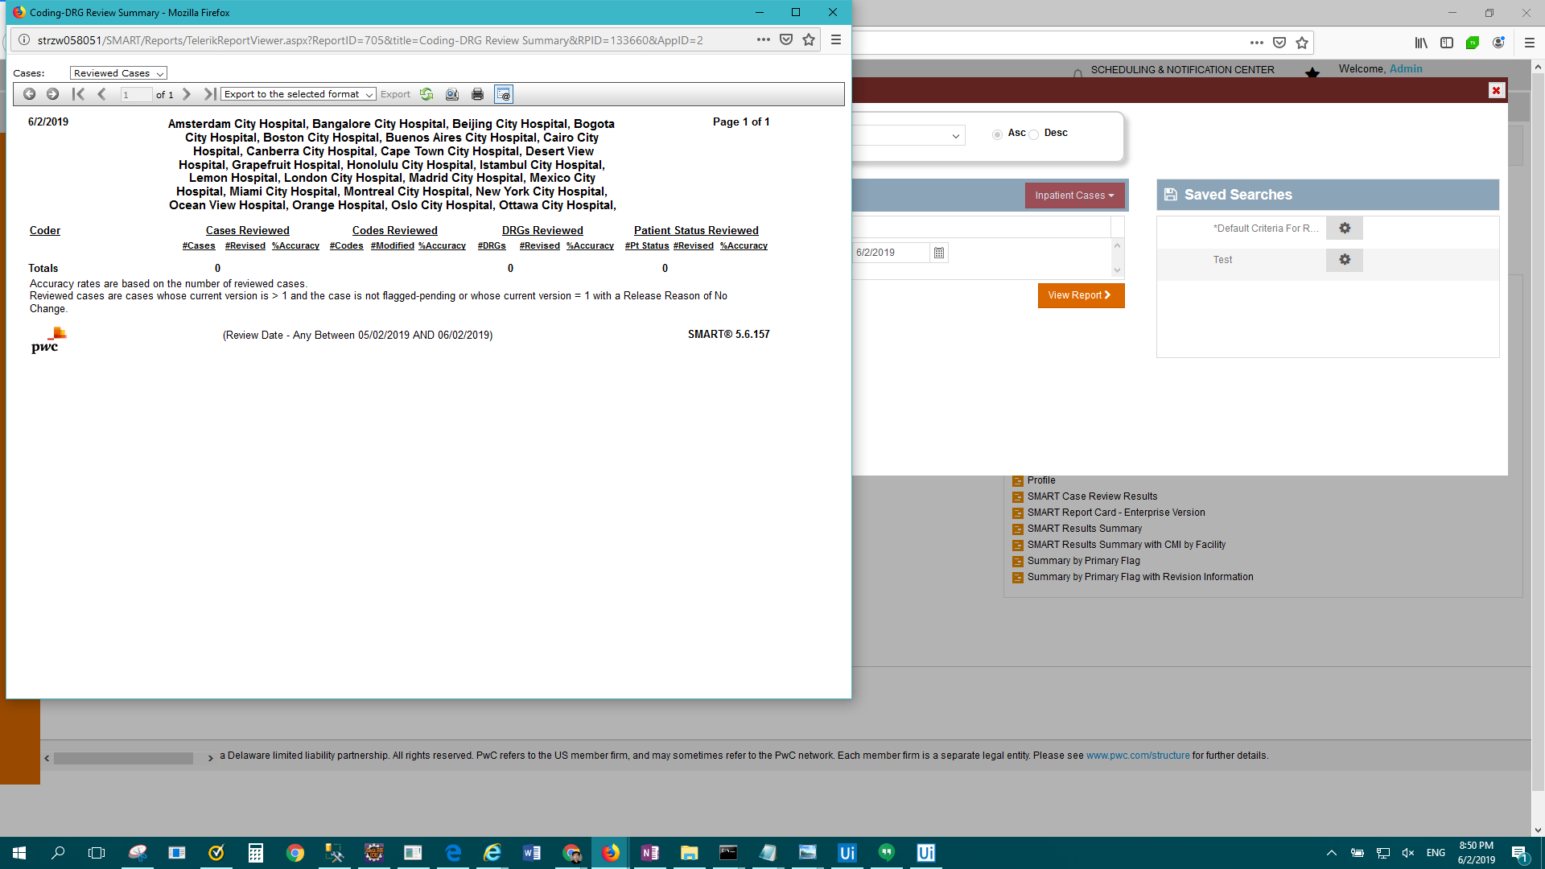

FAIL: Enterprise Report - Data Comparison > Result Description: Test Passed for Report: Enterprise Report - Data Comparison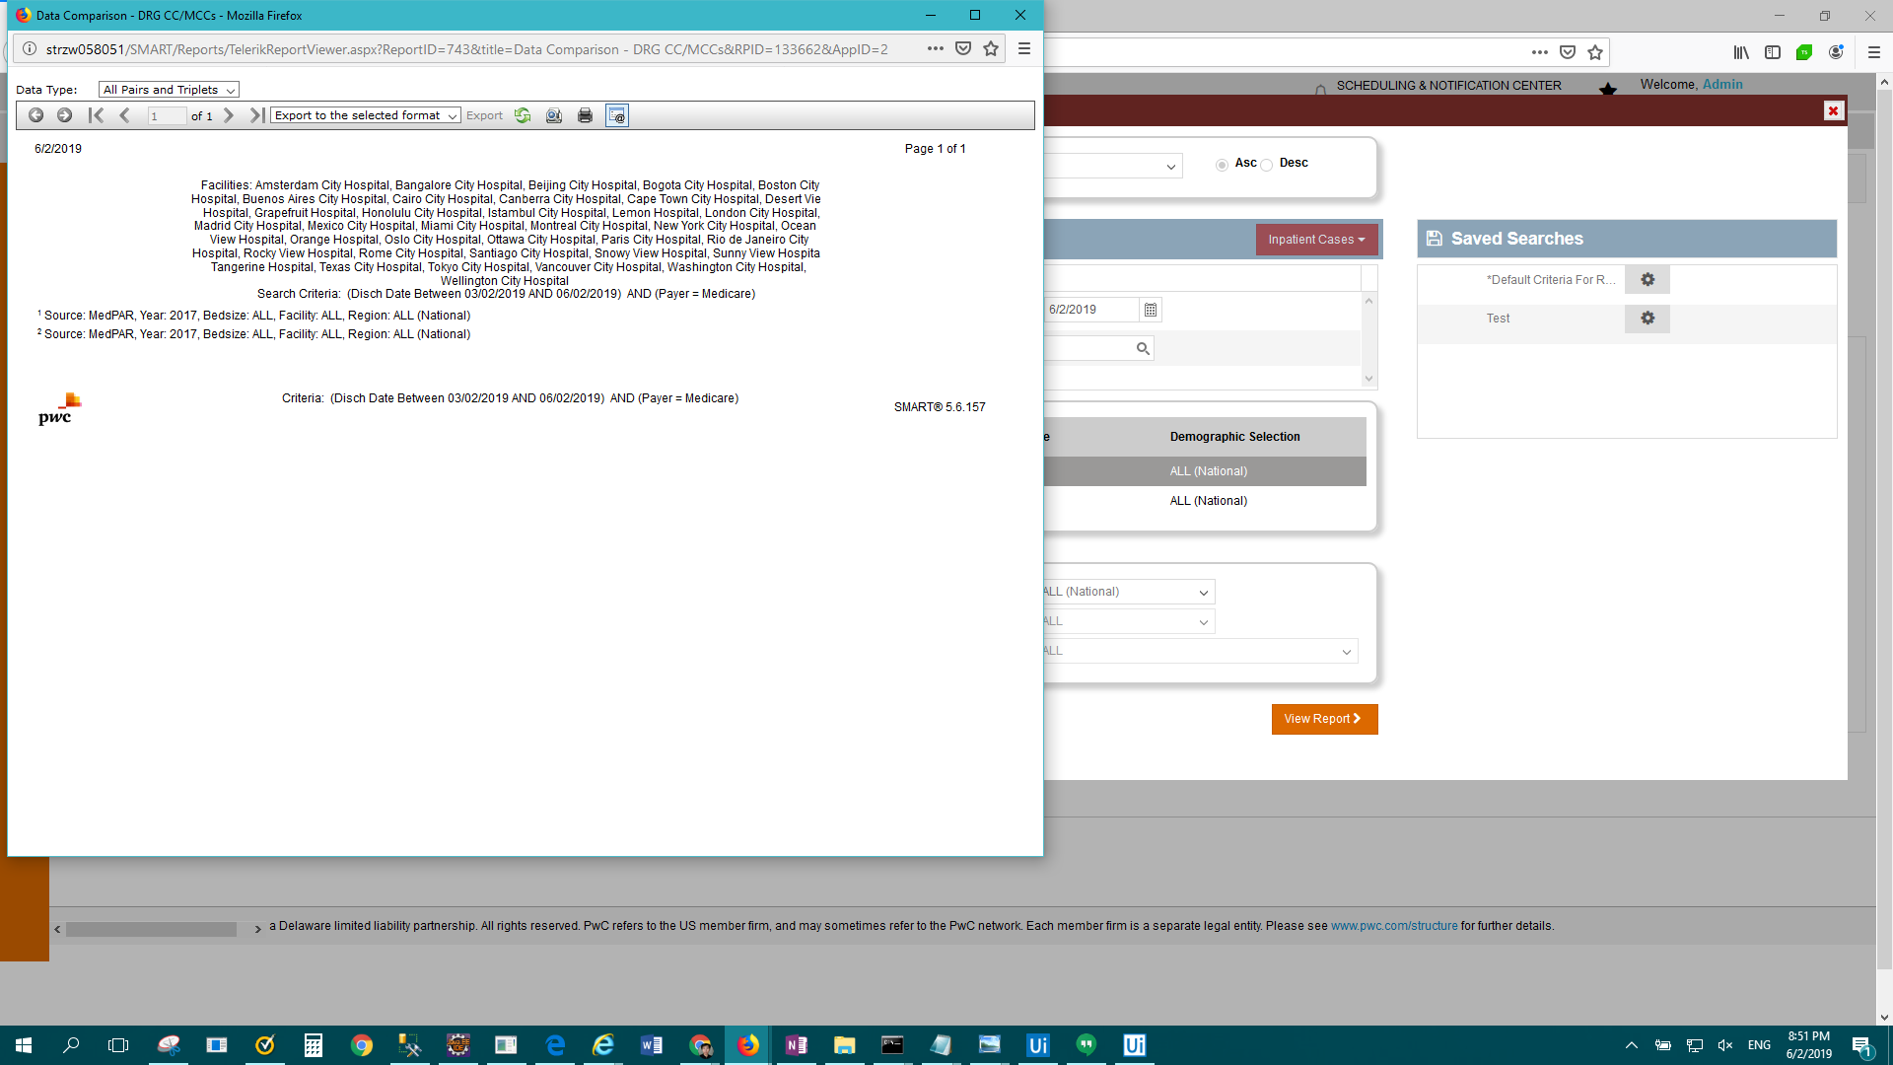

FAIL: IP Standard - Detailed Case Listing > Result Description: Test Passed for Report: IP Standard - Detailed Case Listing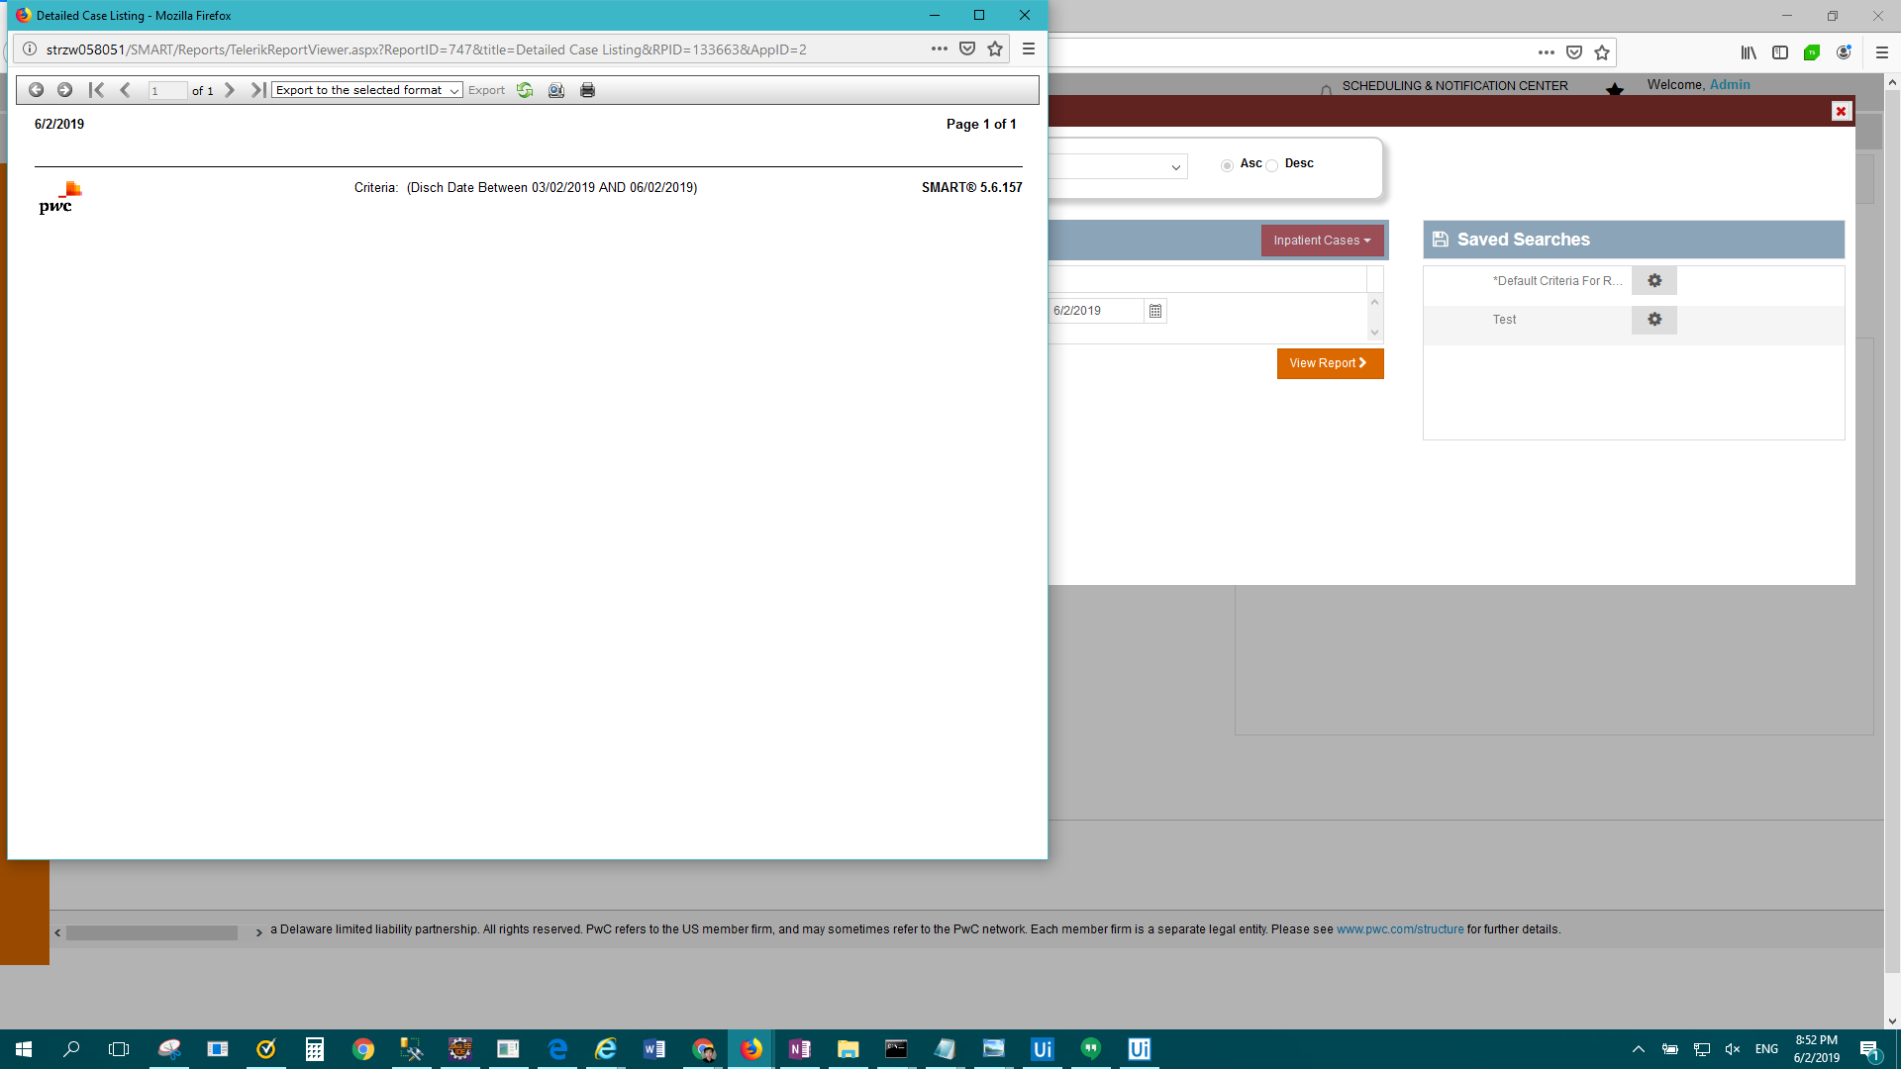

FAIL: Enterprise Report - Diagnosis Analysis by Present on Admission(POA) > Result Description: Test Passed for Report: Enterprise Report - Diagnosis Analysis by Present on Admission(POA)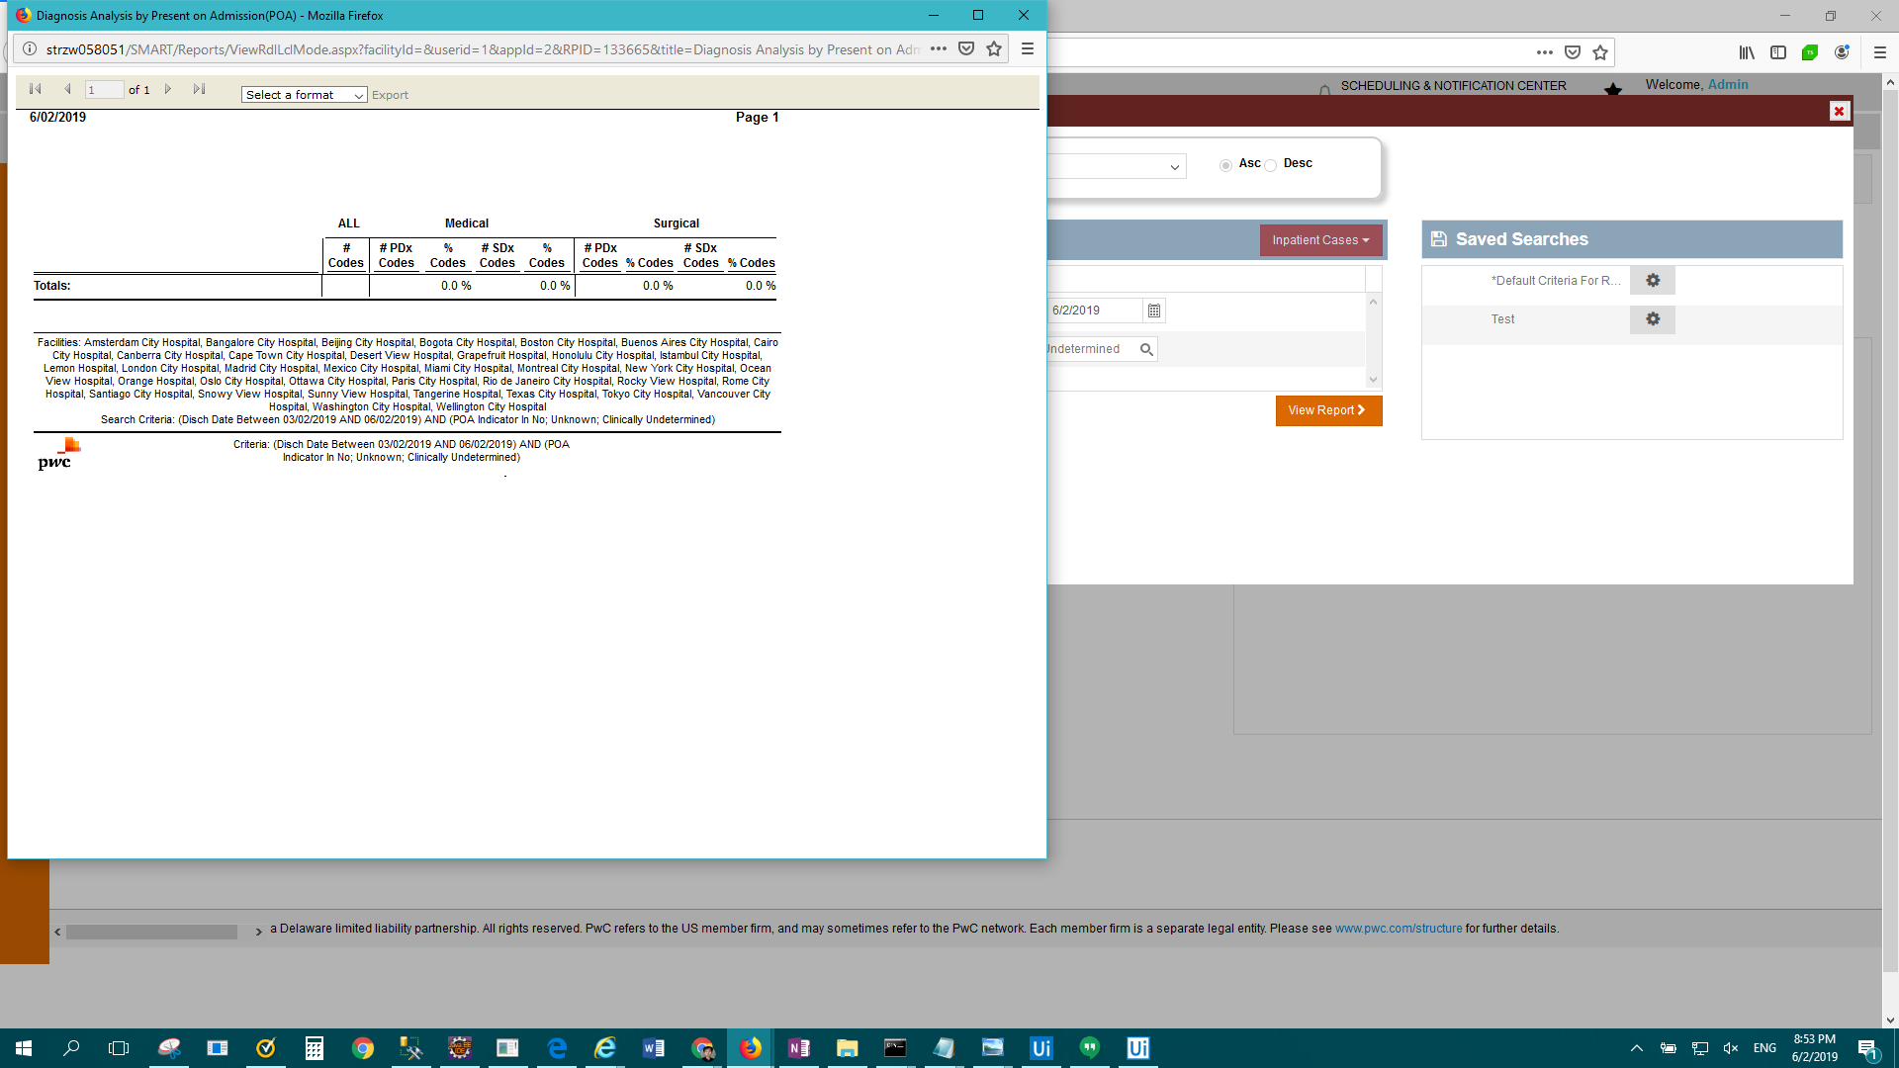

FAIL: IP Standard - Diagnosis Code Usage by Payer > Result Description: Test Passed for Report: IP Standard - Diagnosis Code Usage by Payer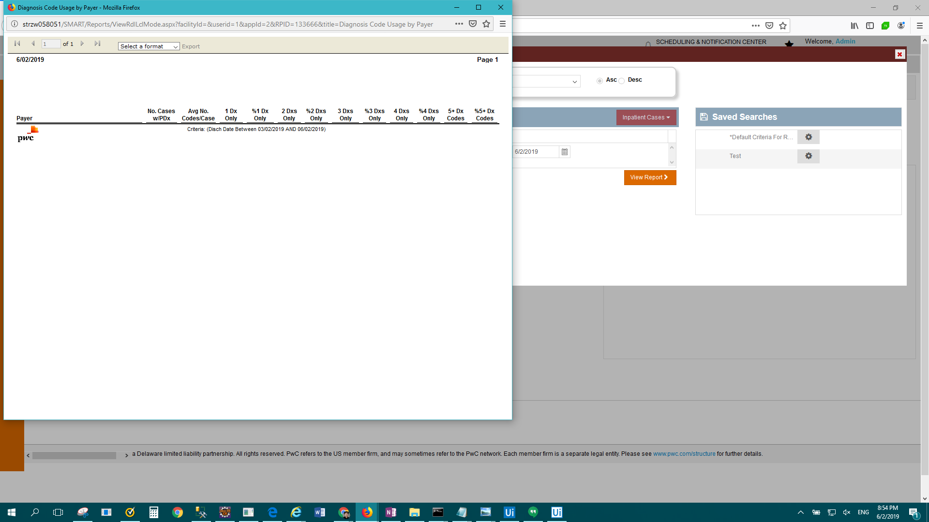

FAIL: IP Standard - Discharges by Grouper Version - DRG > Result Description: Test Passed for Report: IP Standard - Discharges by Grouper Version - DRG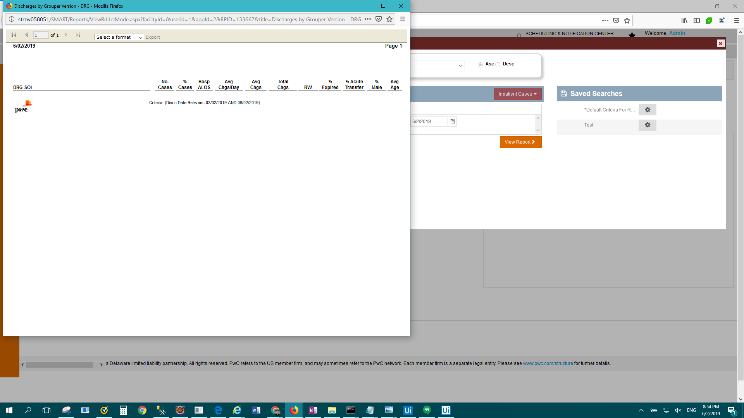

FAIL: IP Standard - DRG Change Condition Detail > Result Description: Test Passed for Report: IP Standard - DRG Change Condition Detail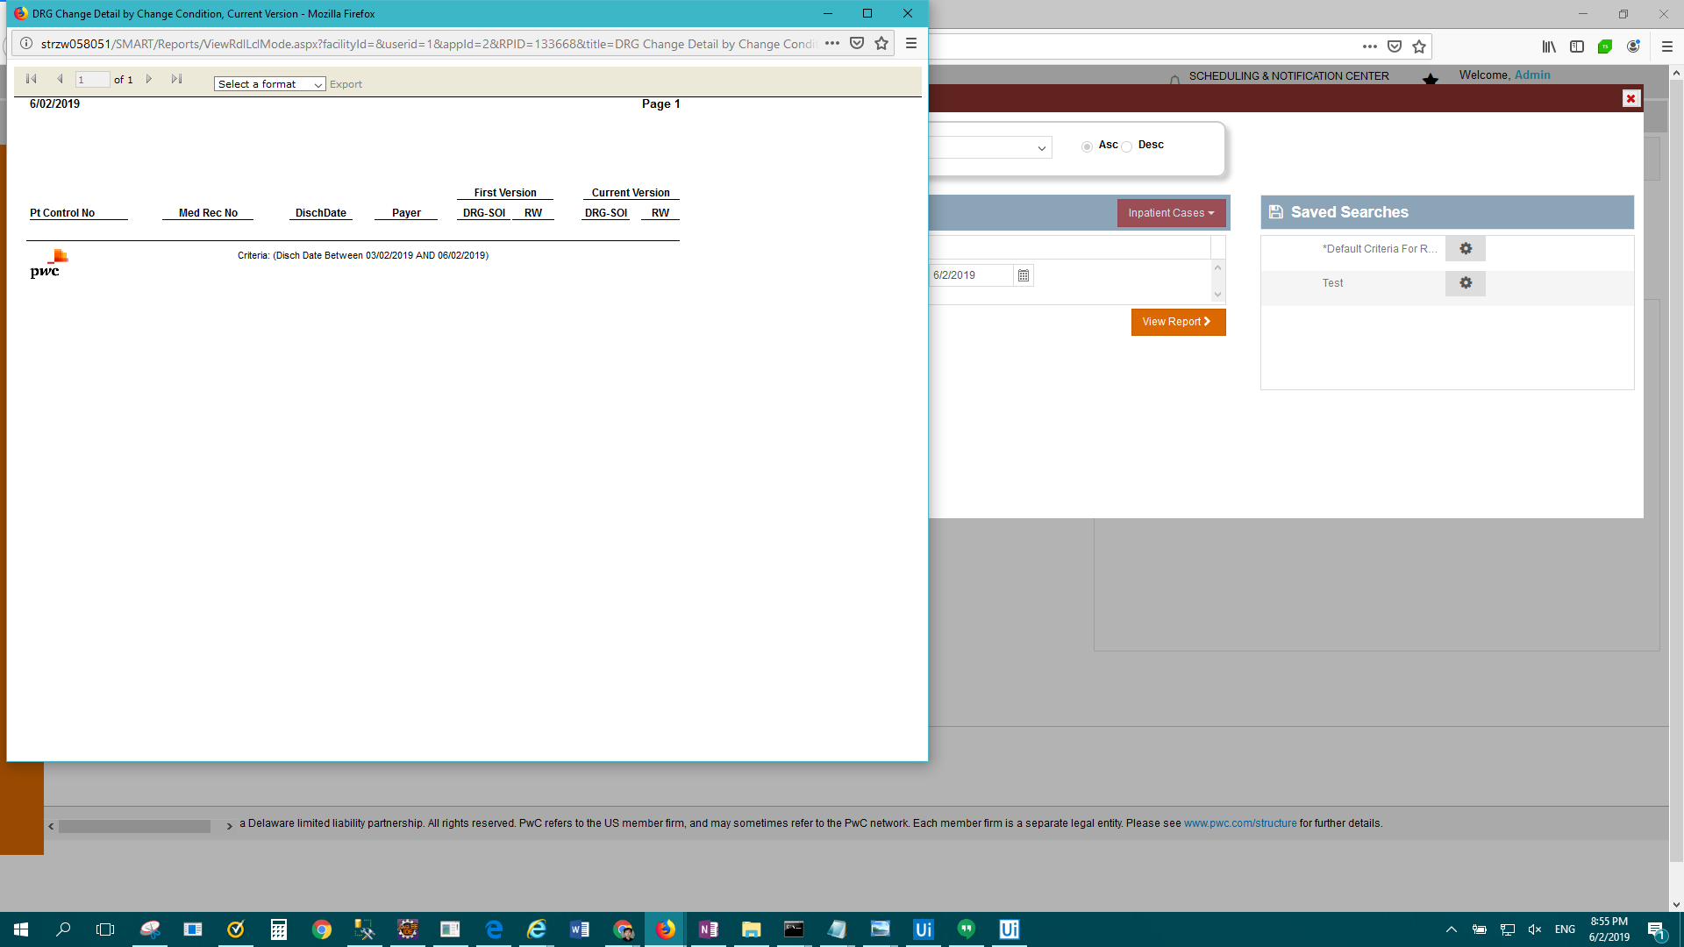

FAIL: IP Standard - DRG Change Impact > Result Description: Test Passed for Report: IP Standard - DRG Change Impact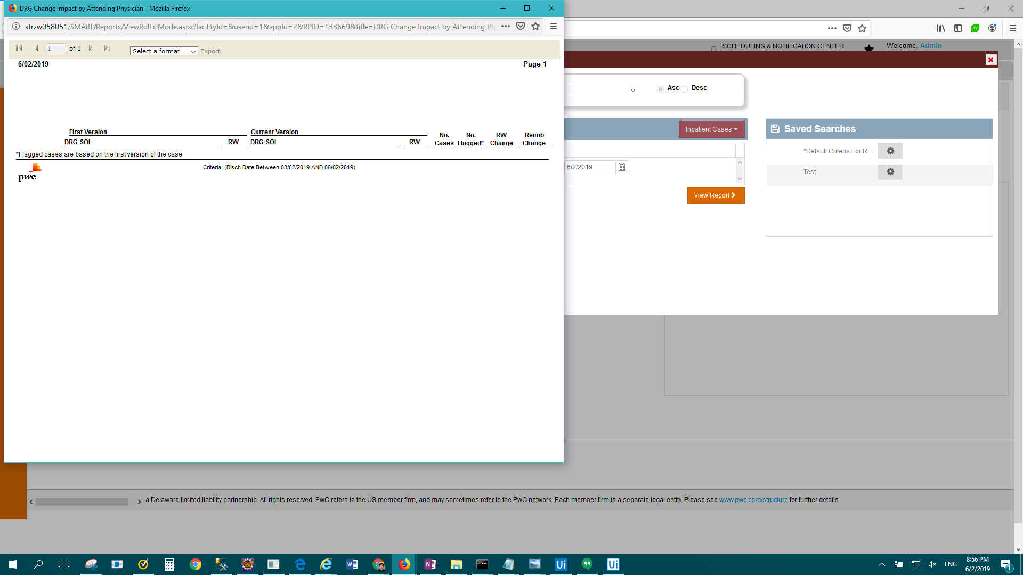

FAIL: Enterprise Report - DRG Clinical Profile > Result Description: Test Passed for Report: Enterprise Report - DRG Clinical Profile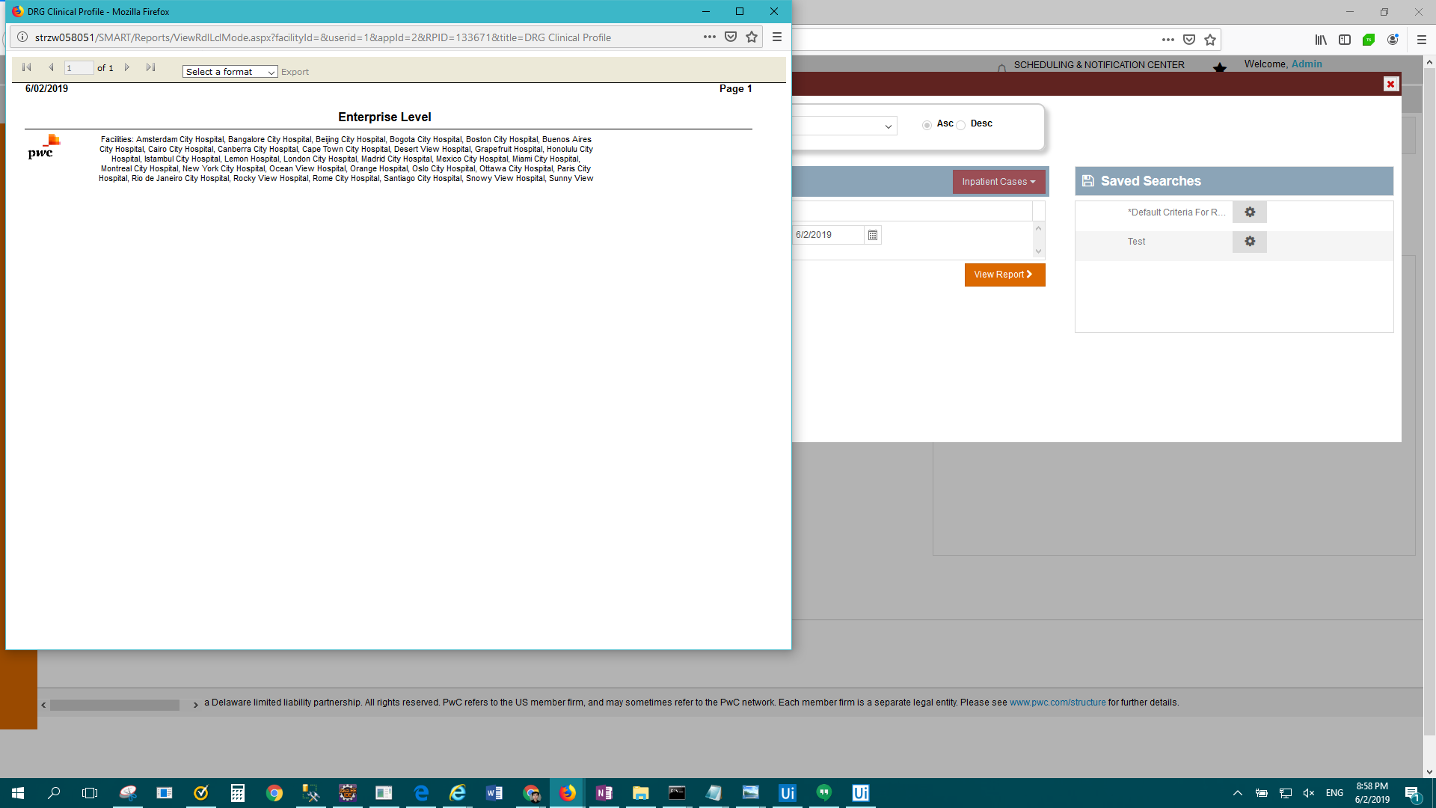

FAIL: IP Standard - DRG Contribution to CMI > Result Description: Test Passed for Report: IP Standard - DRG Contribution to CMI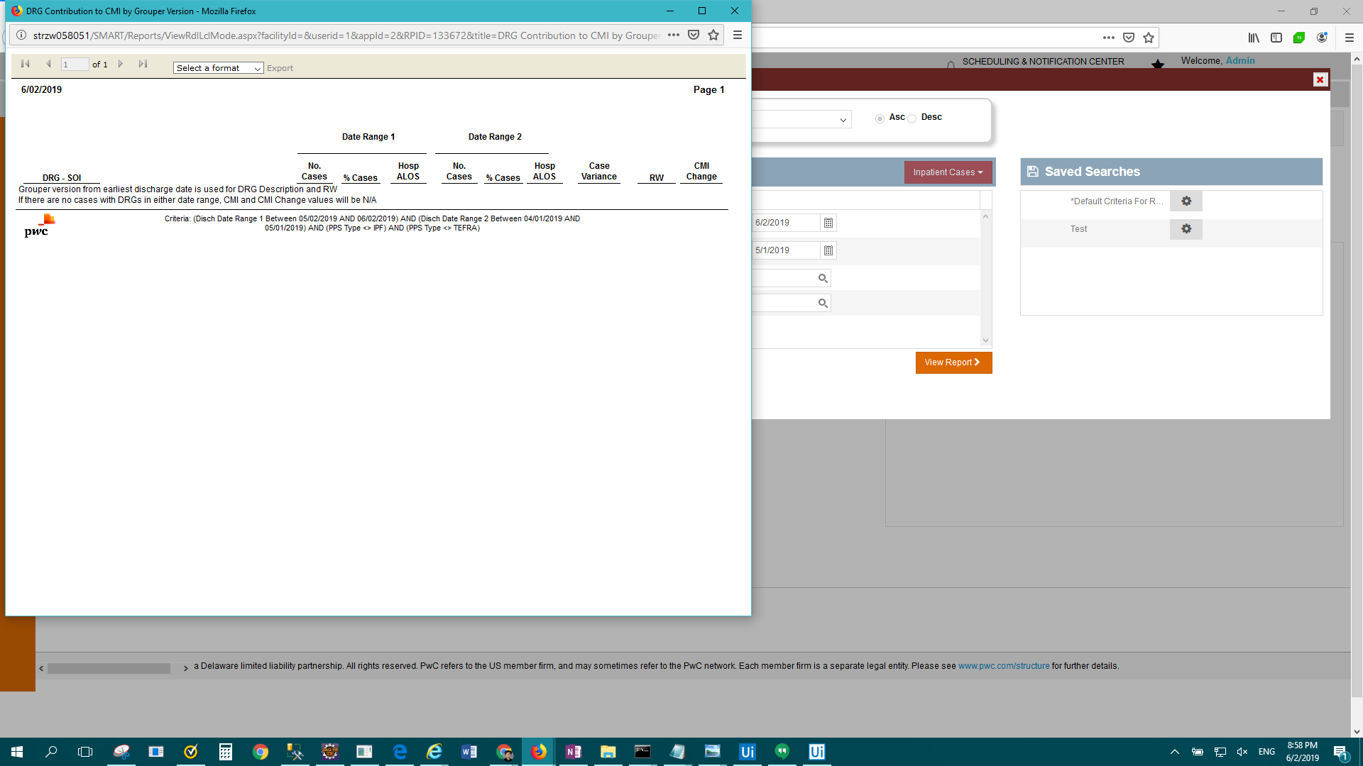

FAIL: Enterprise Report - DRG Frequency > Result Description: Test Passed for Report: Enterprise Report - DRG Frequency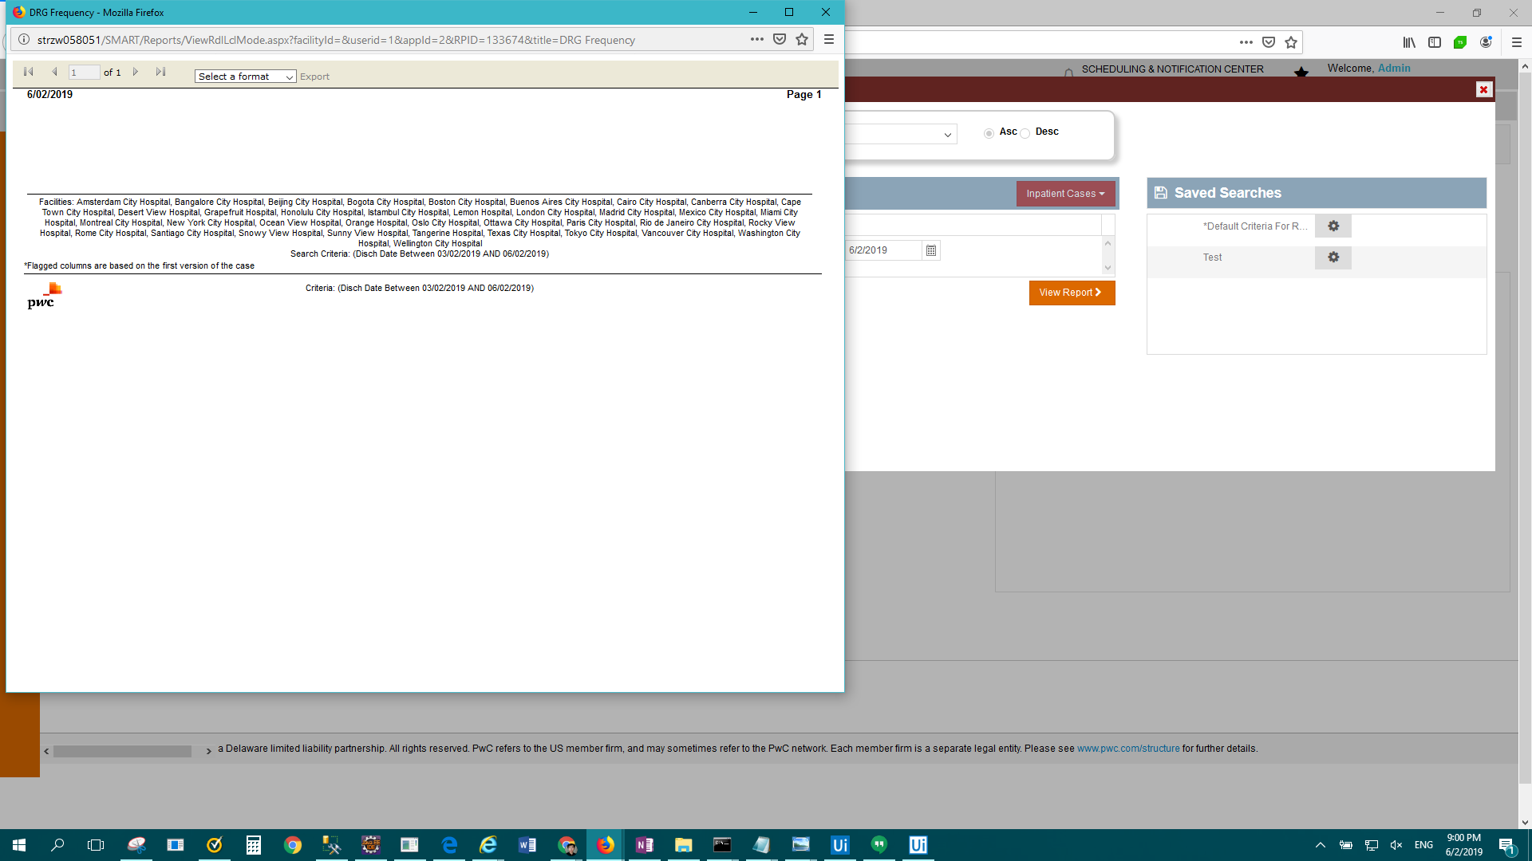

FAIL: IP Standard - DRG Listing by Payer > Result Description: Test Failed For: IP Standard - DRG Listing by Payer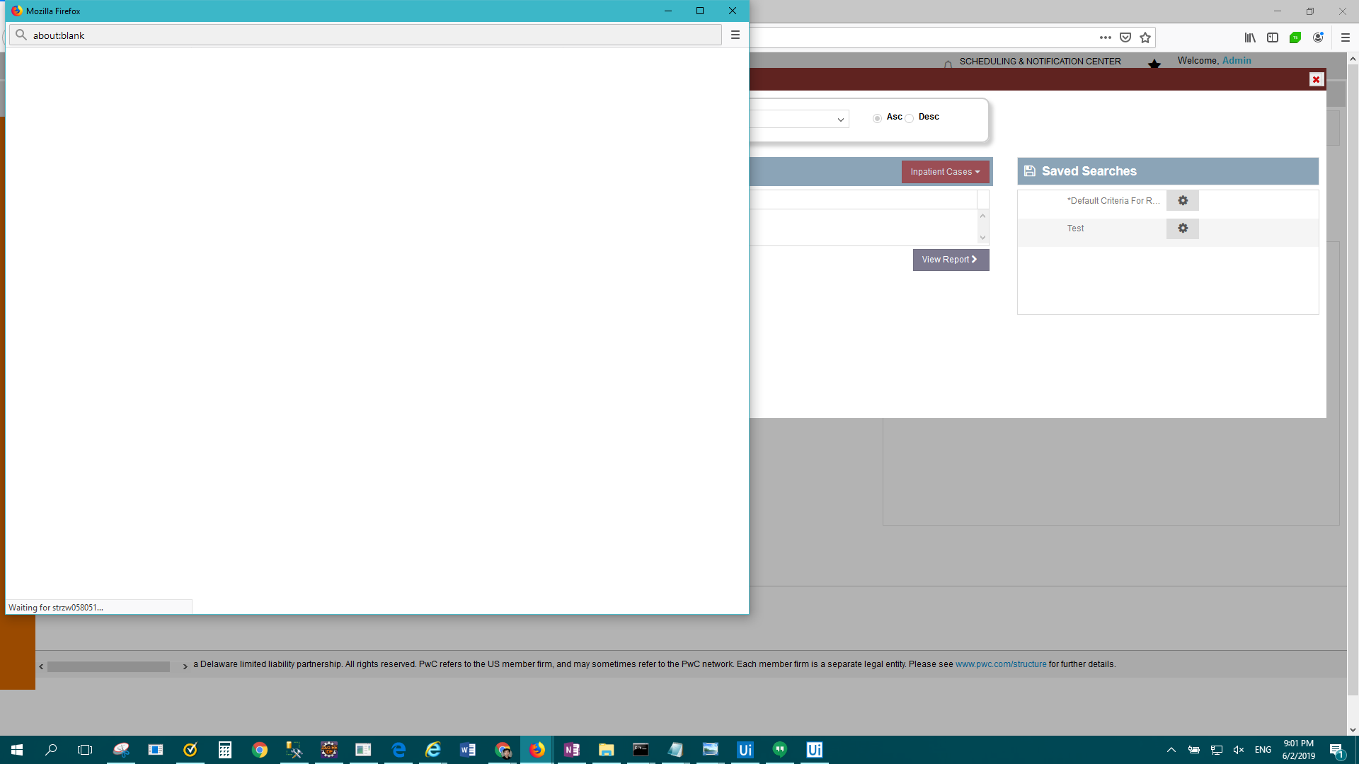

FAIL: IP Standard - DRG Summary by Grouper Version - MDC > Result Description: Test Passed for Report: IP Standard - DRG Summary by Grouper Version - MDC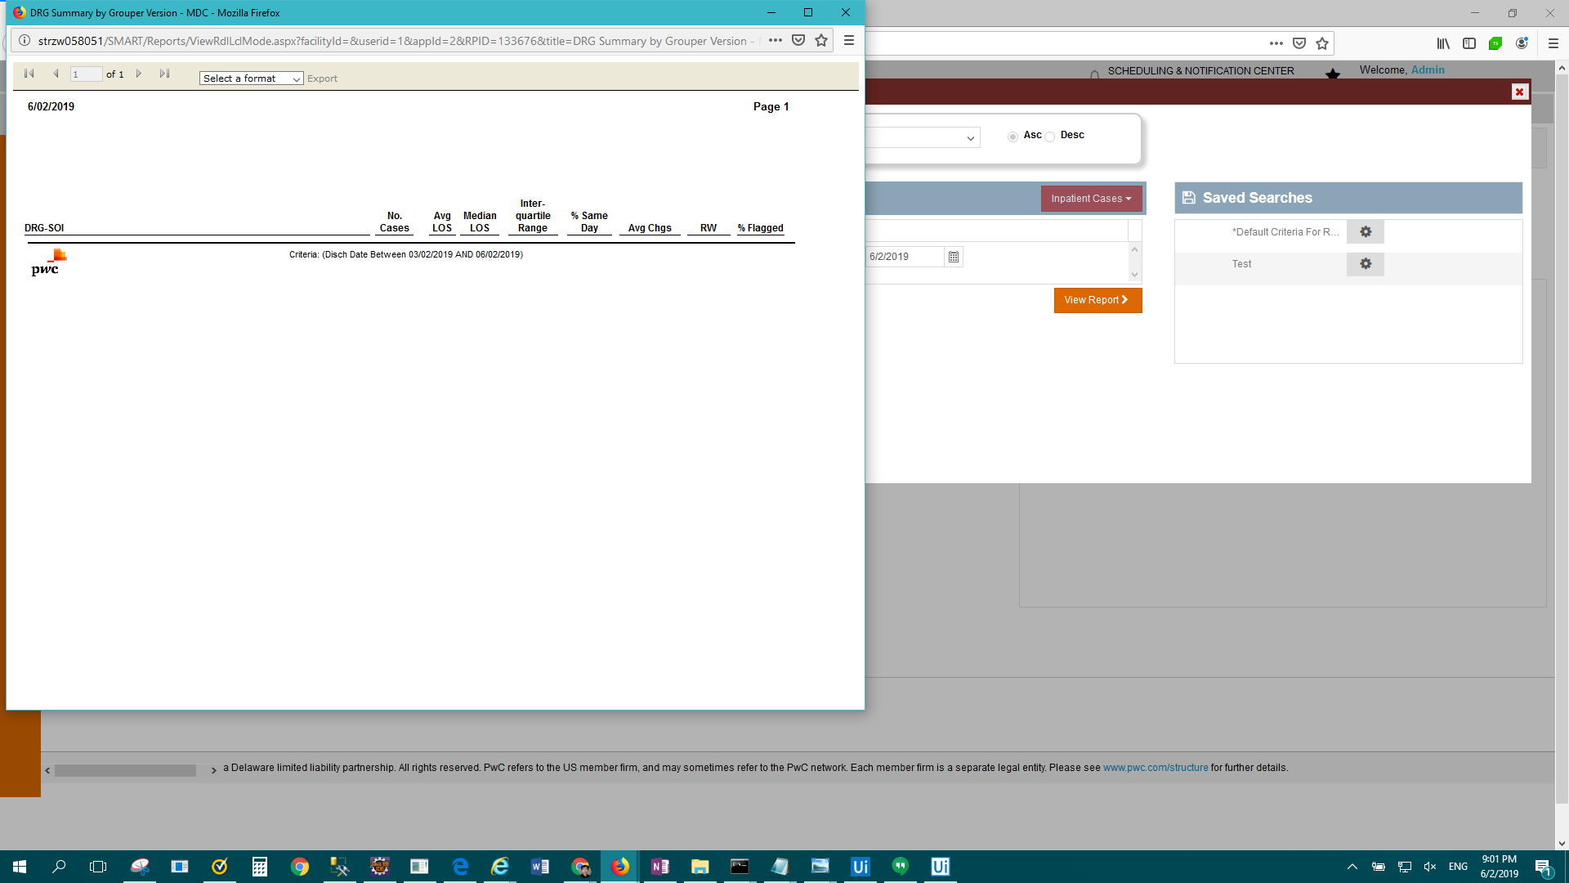

FAIL: IP Standard - Flag Management Setting Audit > Result Description: Test Passed for Report: IP Standard - Flag Management Setting Audit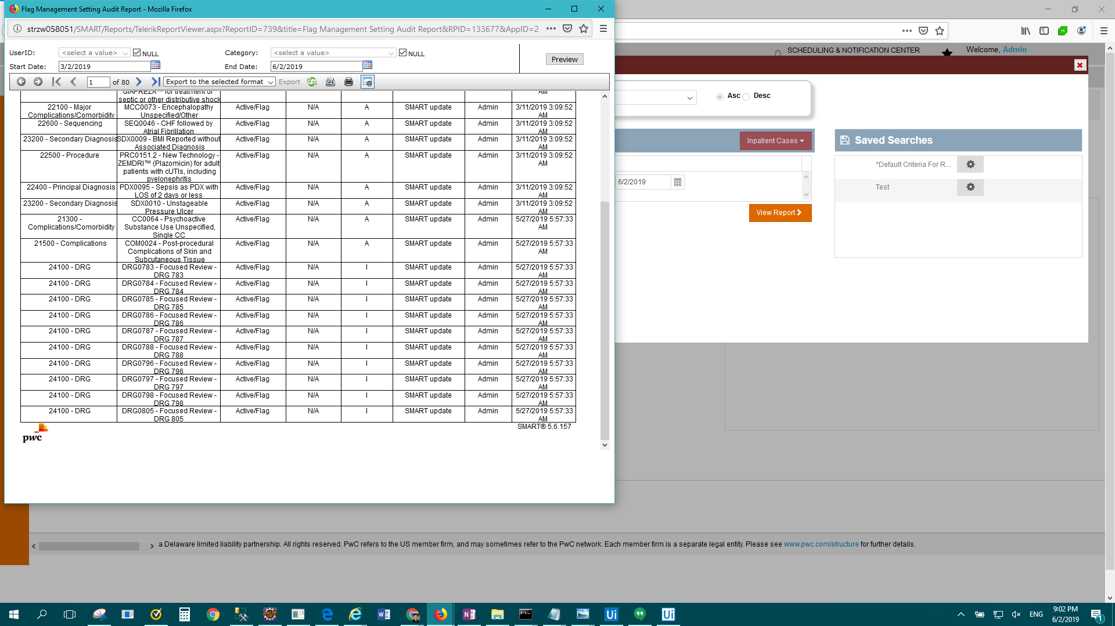

FAIL: Enterprise Report - Frequency > Result Description: Test Failed For: Enterprise Report - Frequency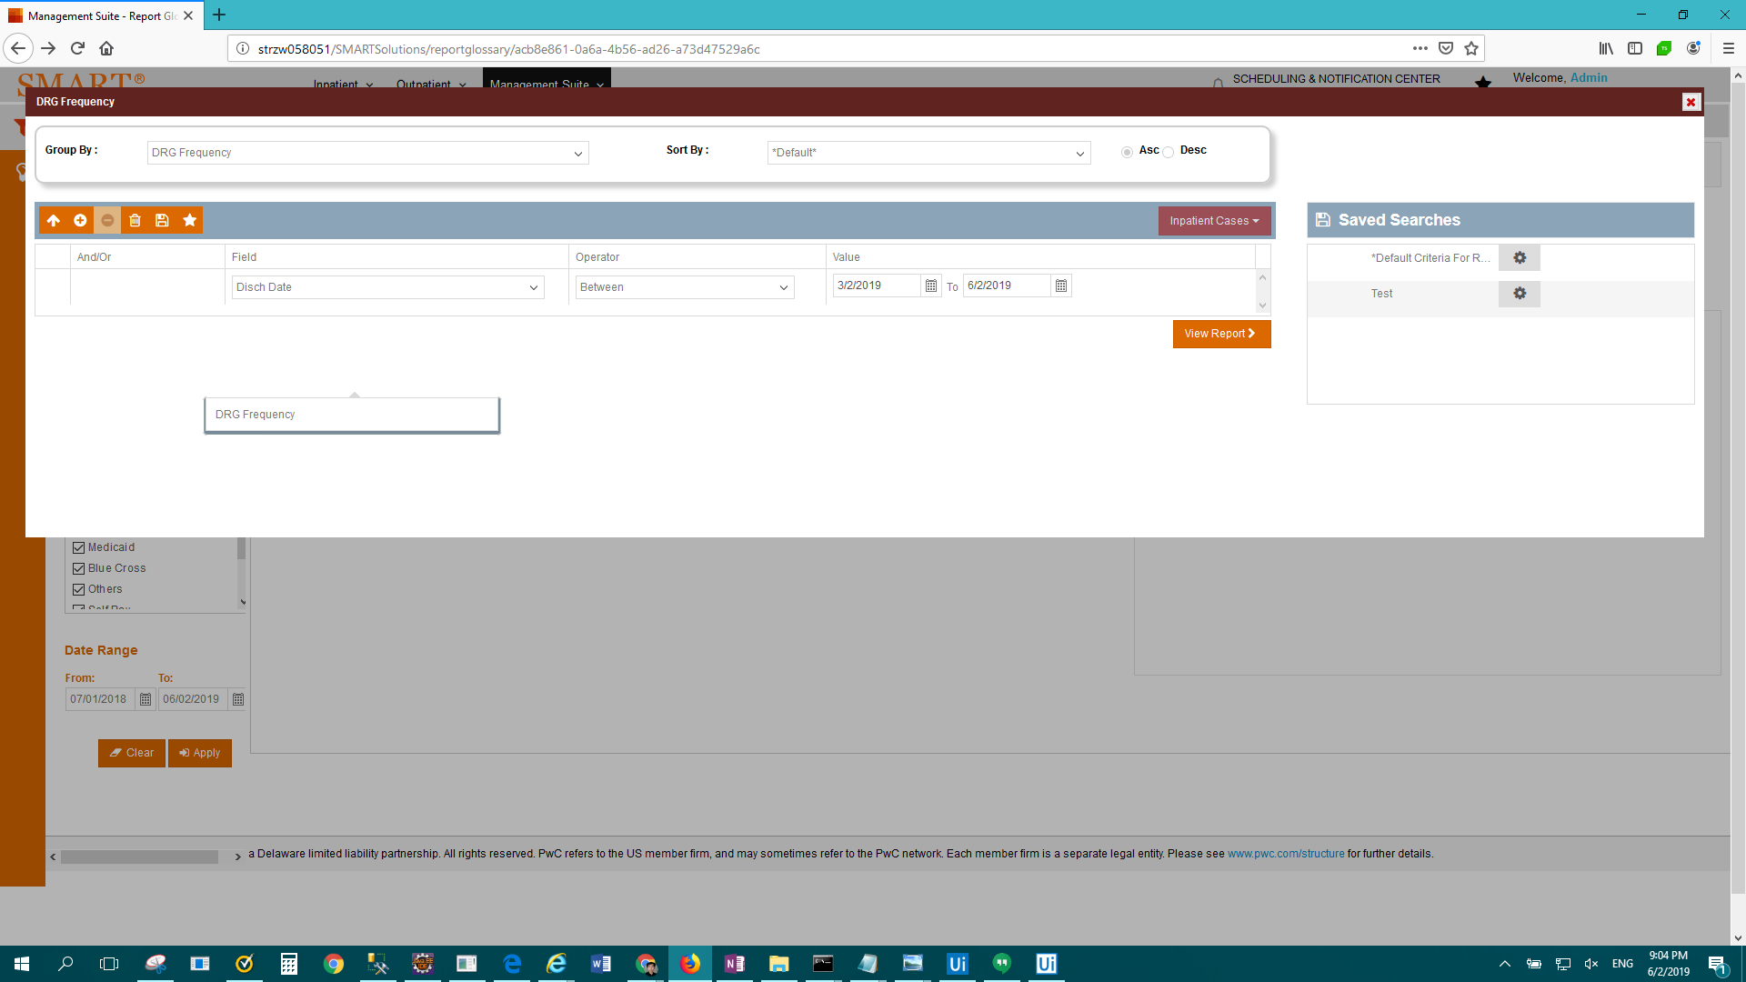

FAIL: IP Standard - Grouper Version Reimbursement Detail > Result Description: Test Passed for Report: IP Standard - Grouper Version Reimbursement Detail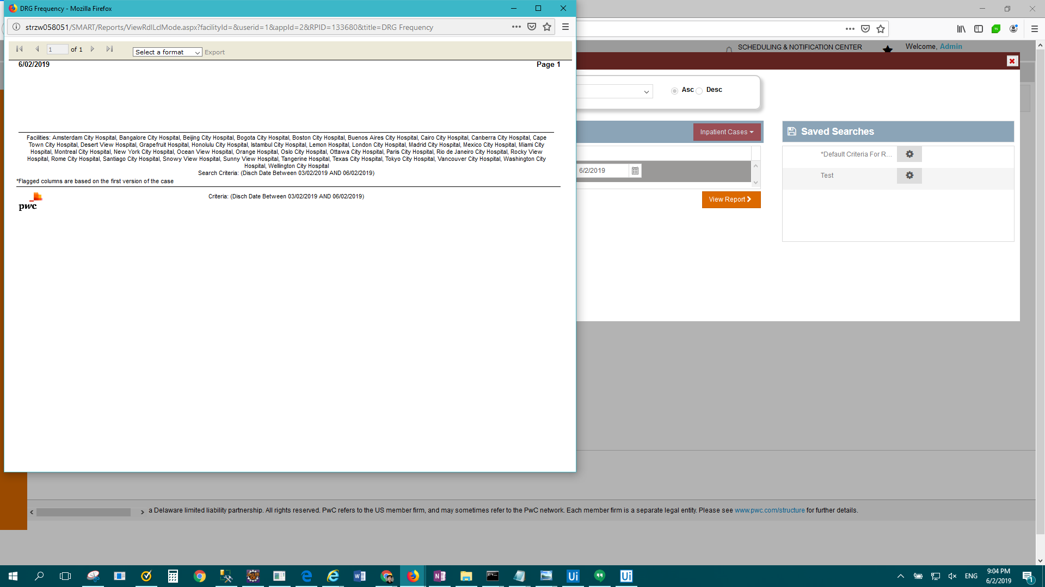

FAIL: IP Standard - Inpatient Flag Information > Result Description: Test Failed For: IP Standard - Inpatient Flag Information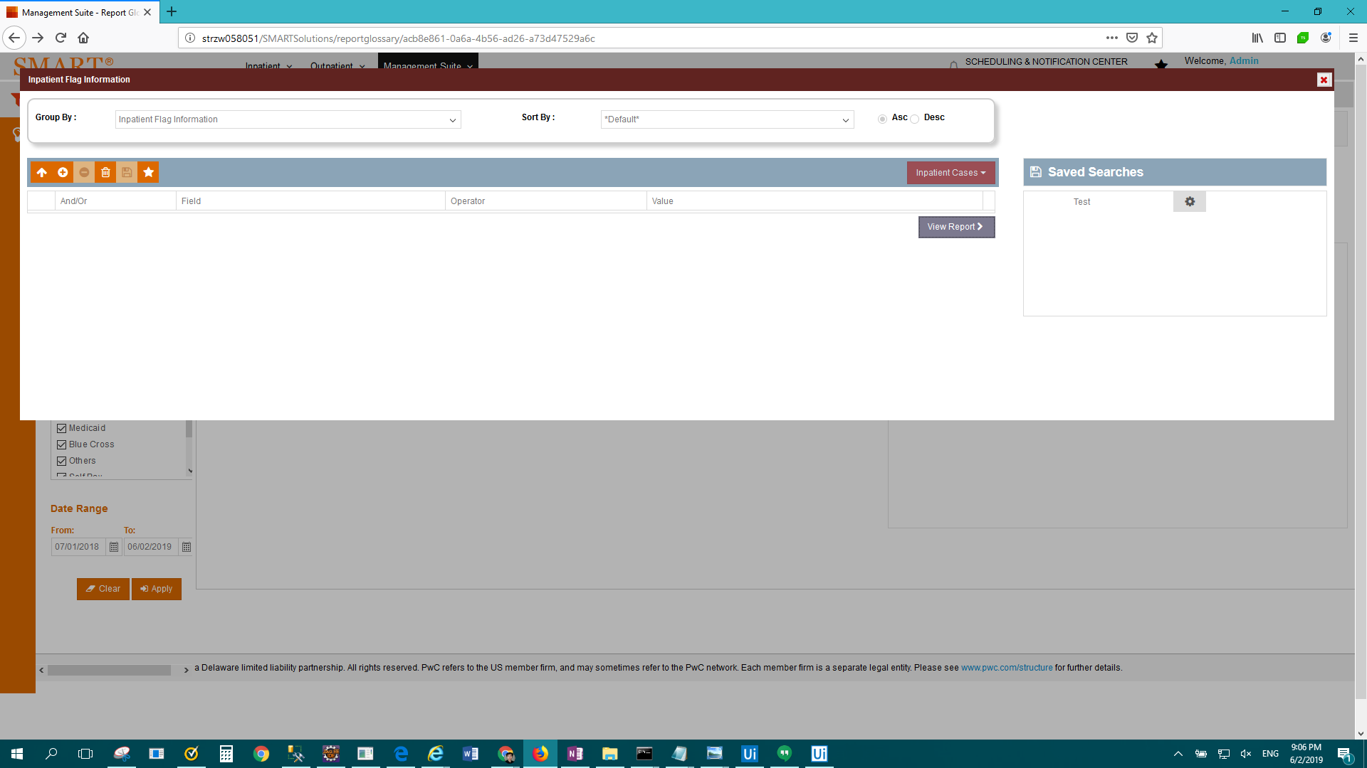

FAIL: IP Standard - Medicare Case-Mix by Month > Result Description: Test Failed For: IP Standard - Medicare Case-Mix by Month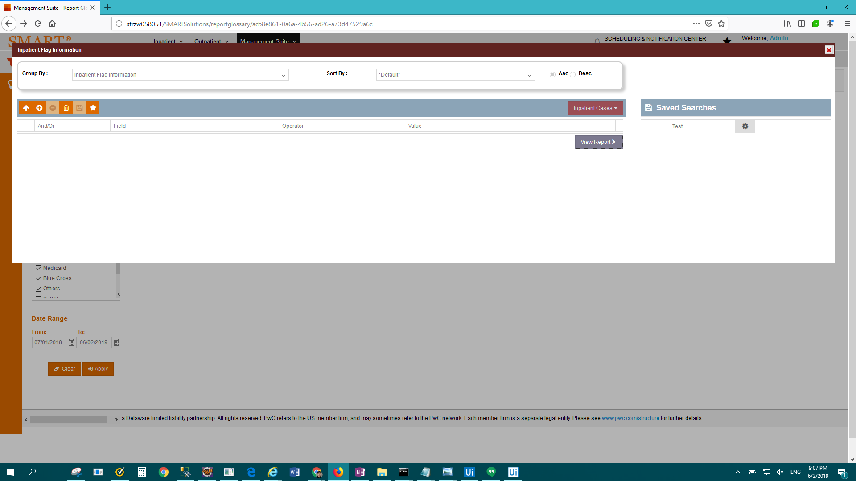

FAIL: Enterprise Report - Medicare Hospital-Acquired Conditions > Result Description: Test Passed for Report: Enterprise Report - Medicare Hospital-Acquired Conditions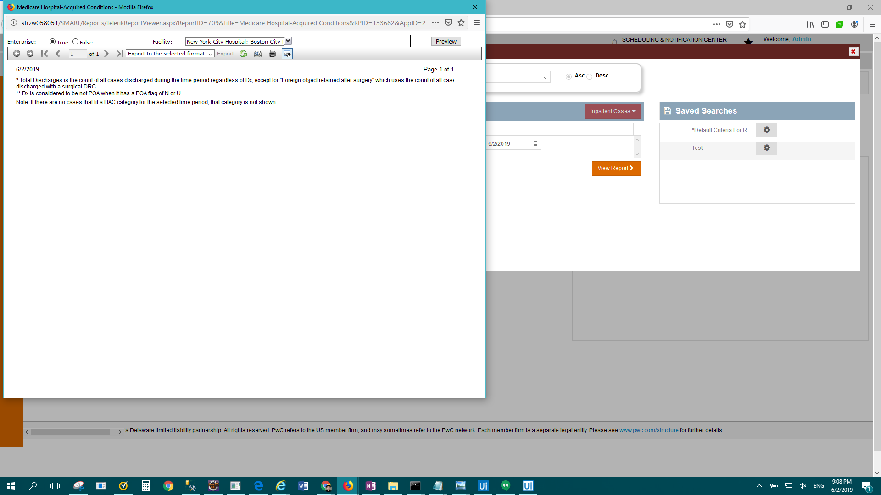

FAIL: IP Standard - Medicare Post-Acute Care (PAC) DRG Frequency > Result Description: Test Passed for Report: IP Standard - Medicare Post-Acute Care (PAC) DRG Frequency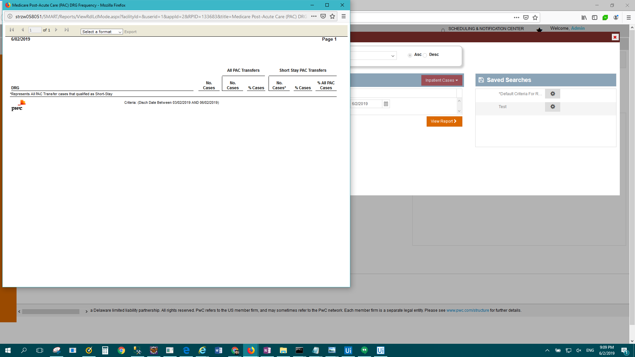

FAIL: IP Standard - Medicare Post-Acute Care (PAC) DRG Reimbursement > Result Description: Test Passed for Report: IP Standard - Medicare Post-Acute Care (PAC) DRG Reimbursement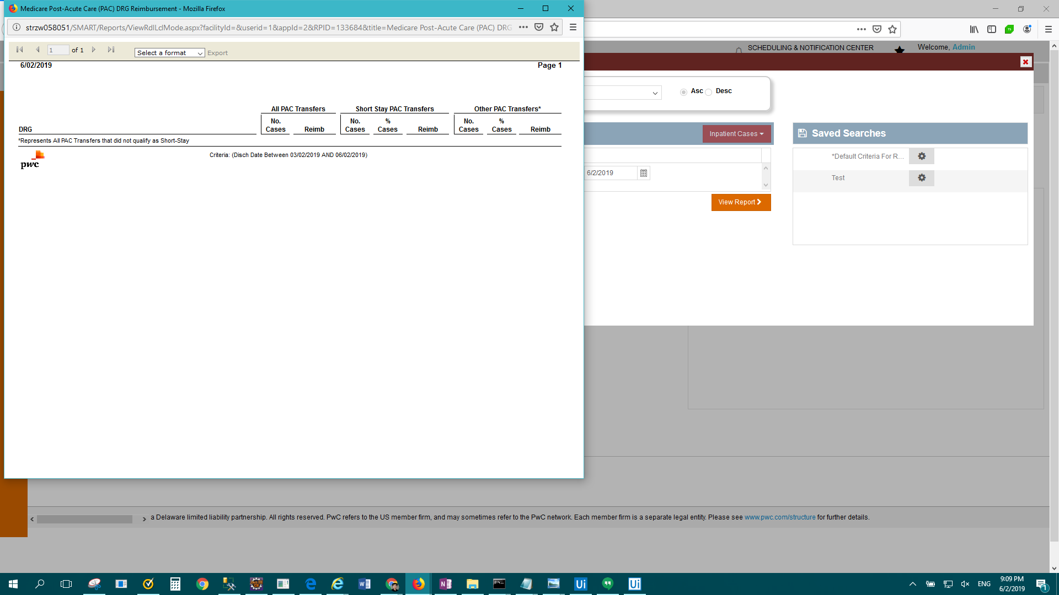

FAIL: OP Standard - Patient Status Mapping Information > Result Description: Test Passed for Report: OP Standard - Patient Status Mapping Information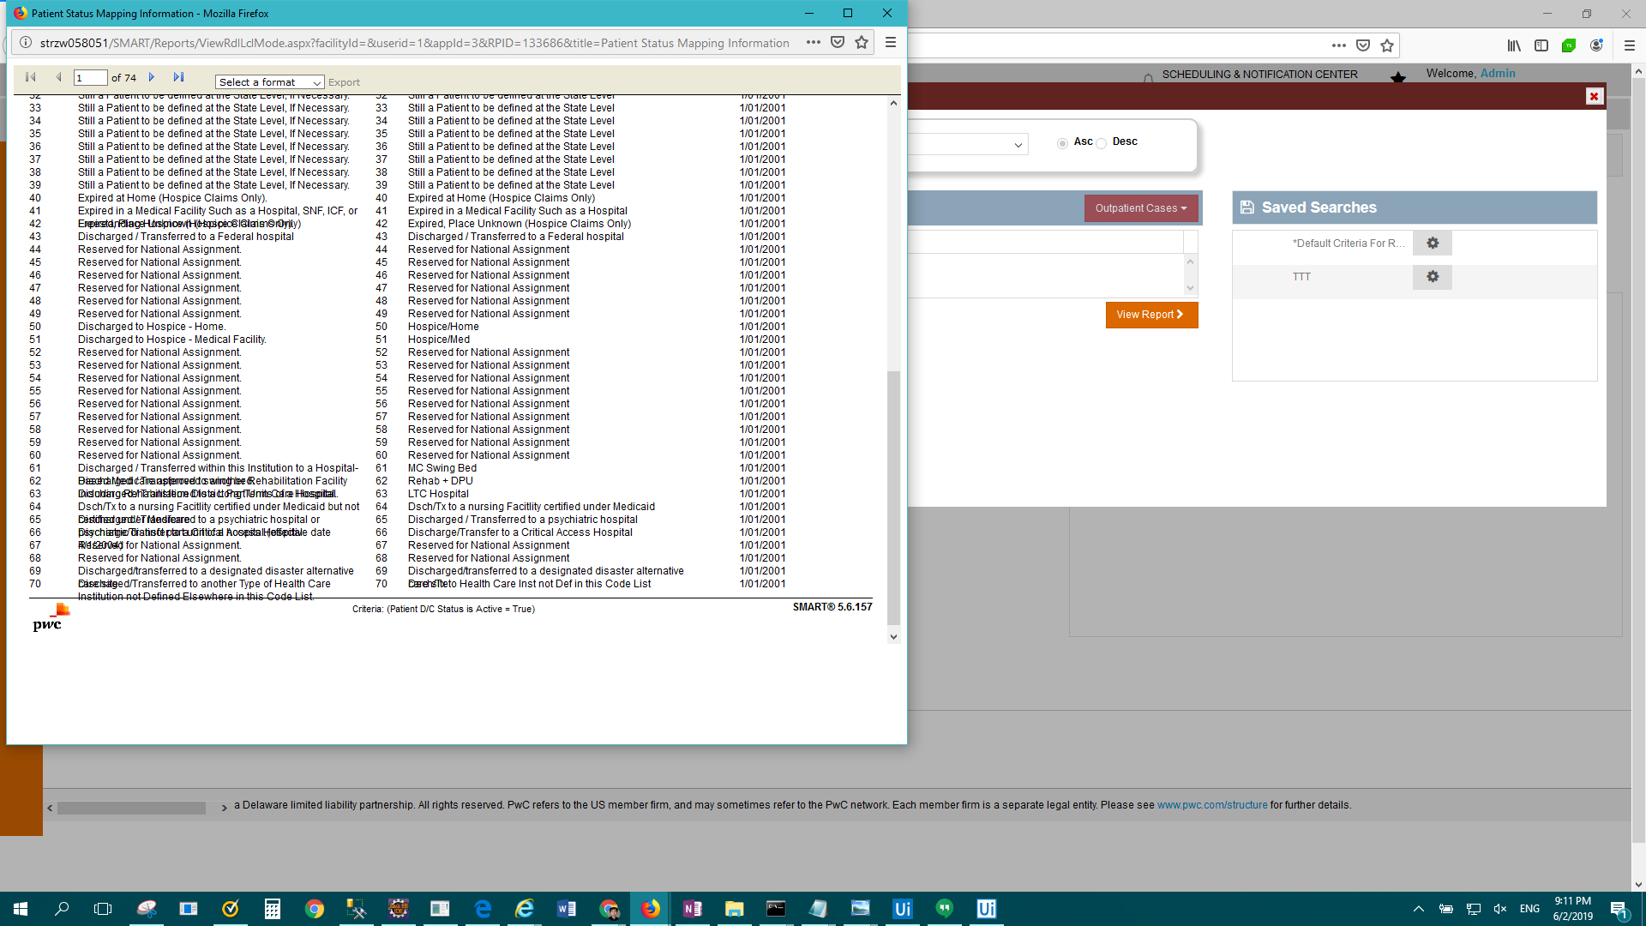

FAIL: IP Standard - Performance Metrics > Result Description: Test Passed for Report: IP Standard - Performance Metrics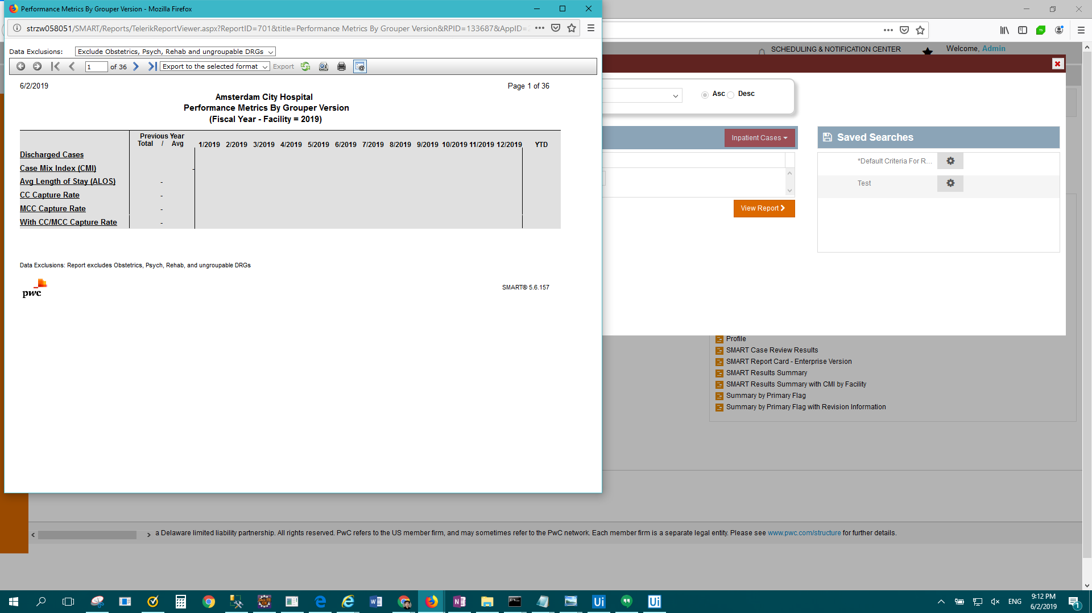

FAIL: IP Standard - Present on Admission(POA) Comparison > Result Description: Test Passed for Report: IP Standard - Present on Admission(POA) Comparison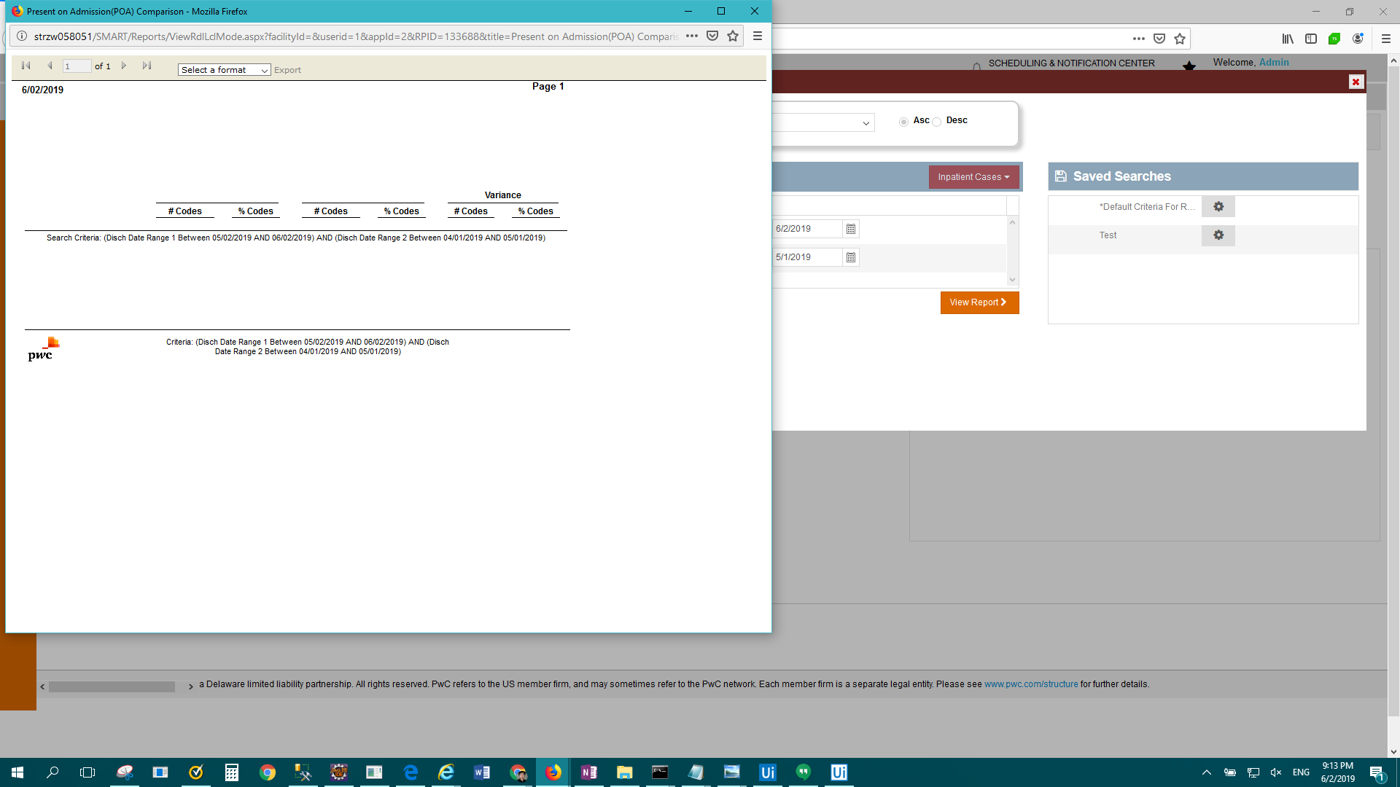

FAIL: Enterprise Report - Profile > Result Description: Test Failed For: Enterprise Report - Profile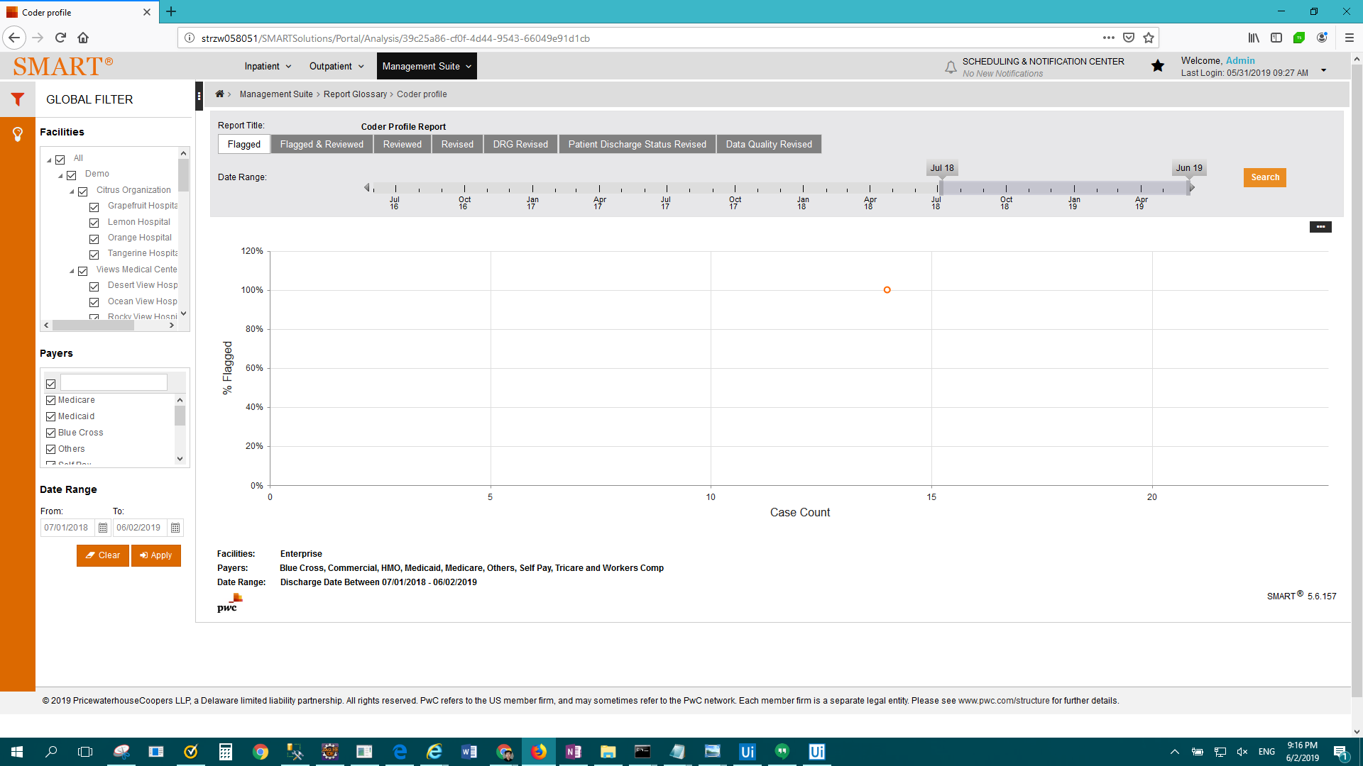

FAIL: Enterprise Report - Readmissions > Result Description: Test Passed for Report: Enterprise Report - Readmissions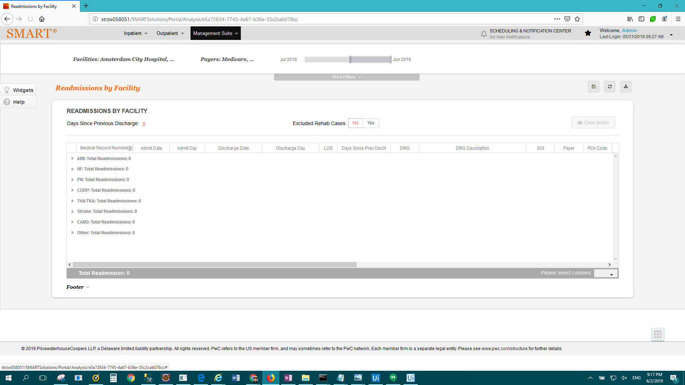

FAIL: Enterprise Report - Reimbursement Change Summary > Result Description: Test Passed for Report: Enterprise Report - Reimbursement Change Summary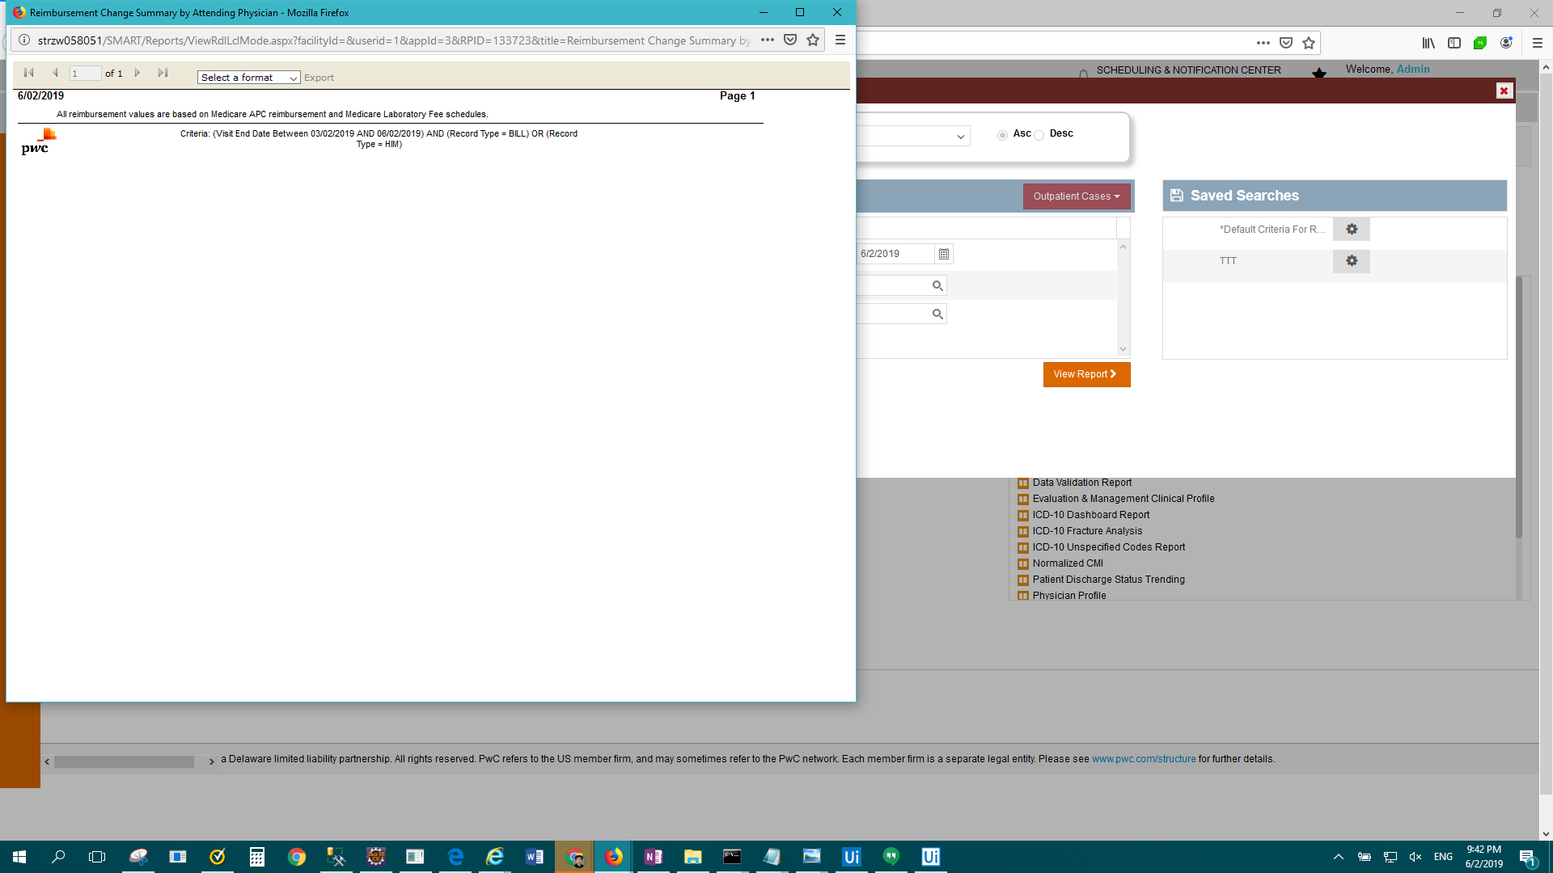

FAIL: Enterprise Report - SMART Case Review Results > Result Description: Test Passed for Report: Enterprise Report - SMART Case Review Results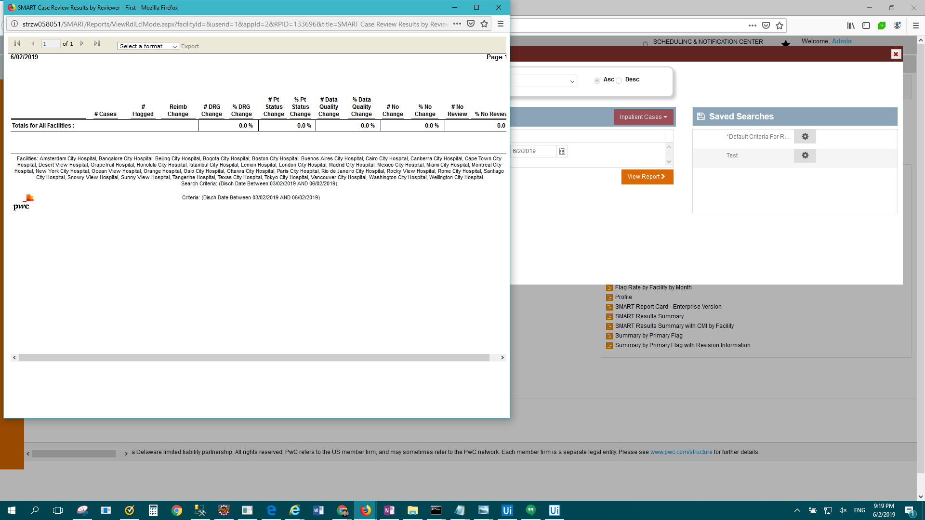

FAIL: Enterprise Report - SMART Reimbursement Activity > Result Description: Test Passed for Report: Enterprise Report - SMART Reimbursement Activity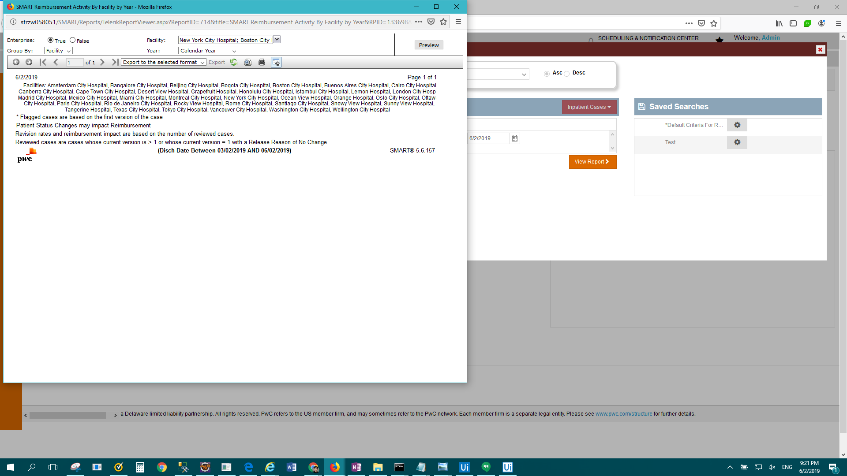

FAIL: Enterprise Report - SMART Report Card > Result Description: Test Passed for Report: Enterprise Report - SMART Report Card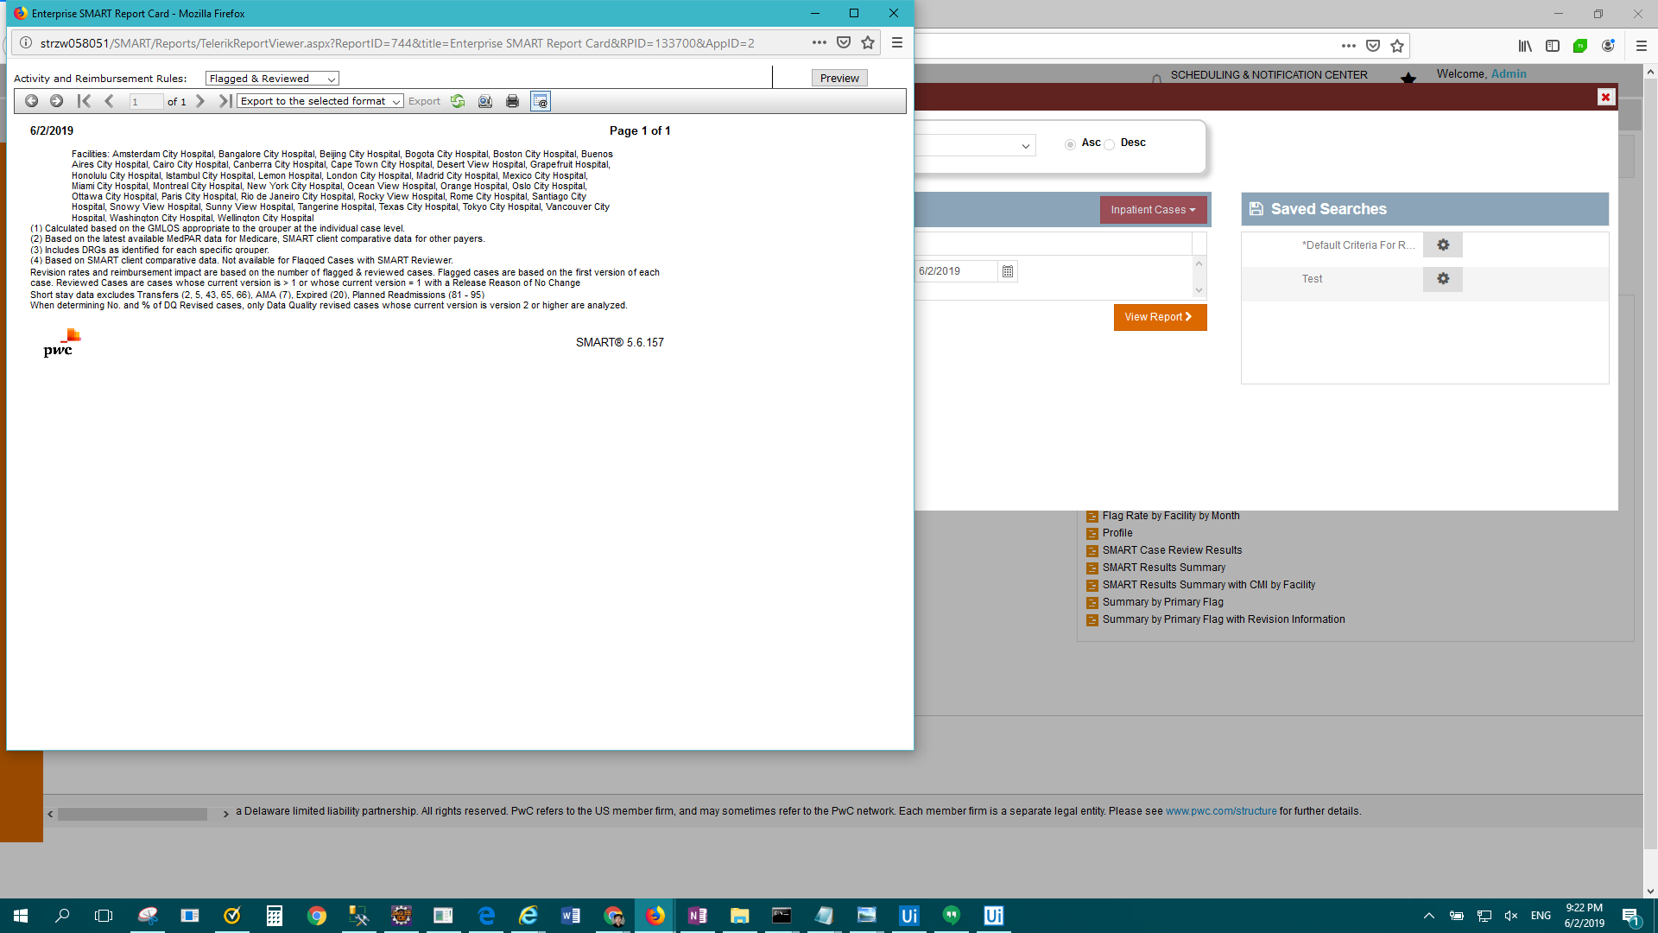

FAIL: Enterprise Report - SMART Results Summary > Result Description: Test Passed for Report: Enterprise Report - SMART Results Summary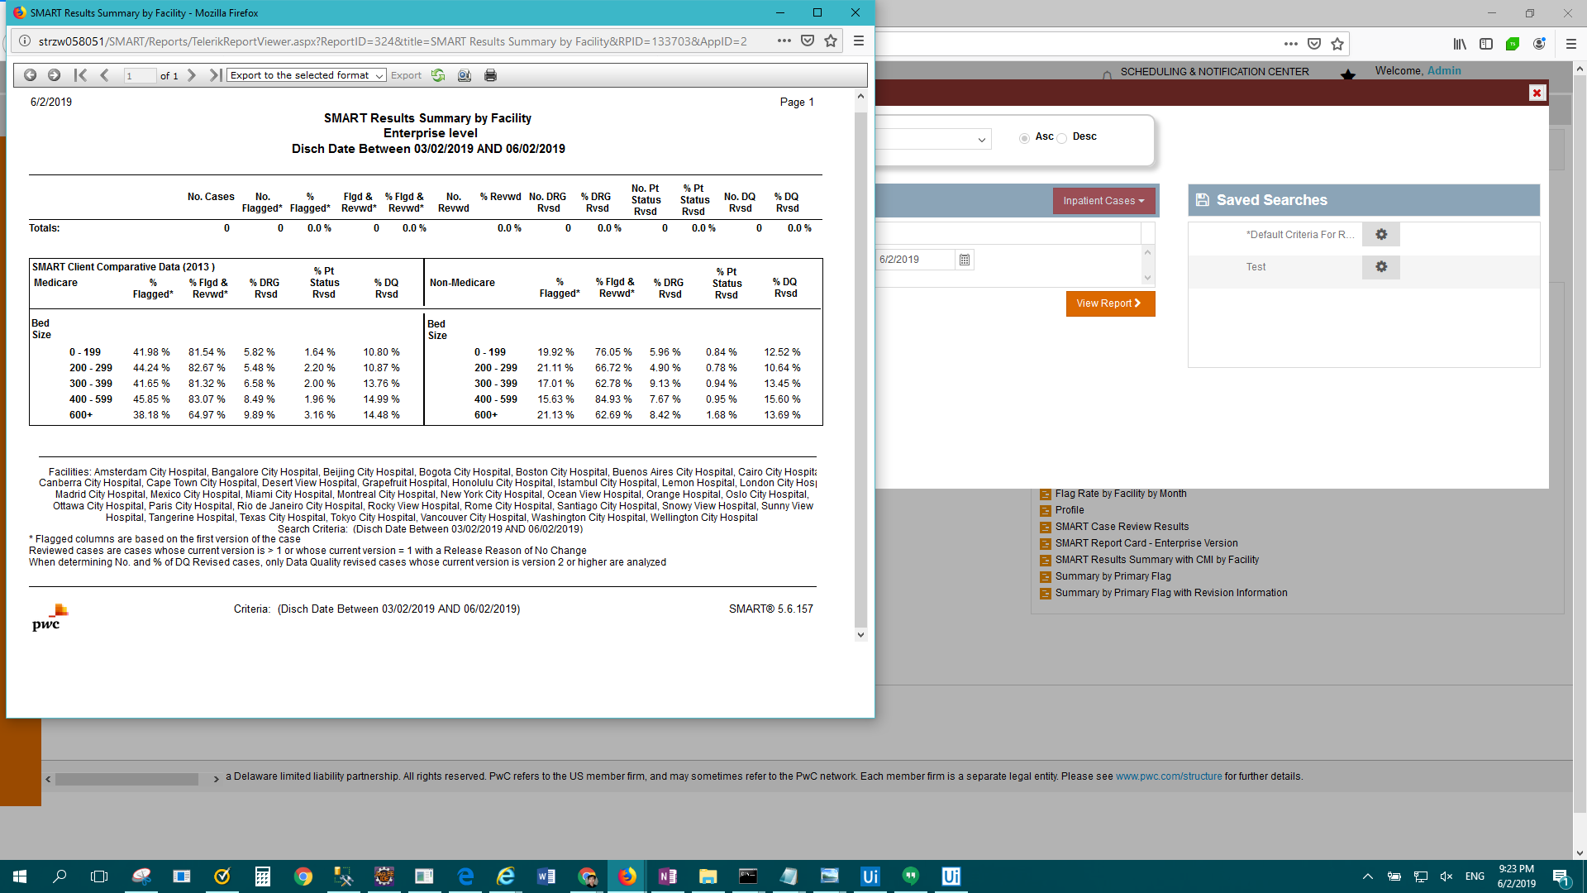

FAIL: Enterprise Report - Summary by Primary Flag > Result Description: Test Passed for Report: Enterprise Report - Summary by Primary Flag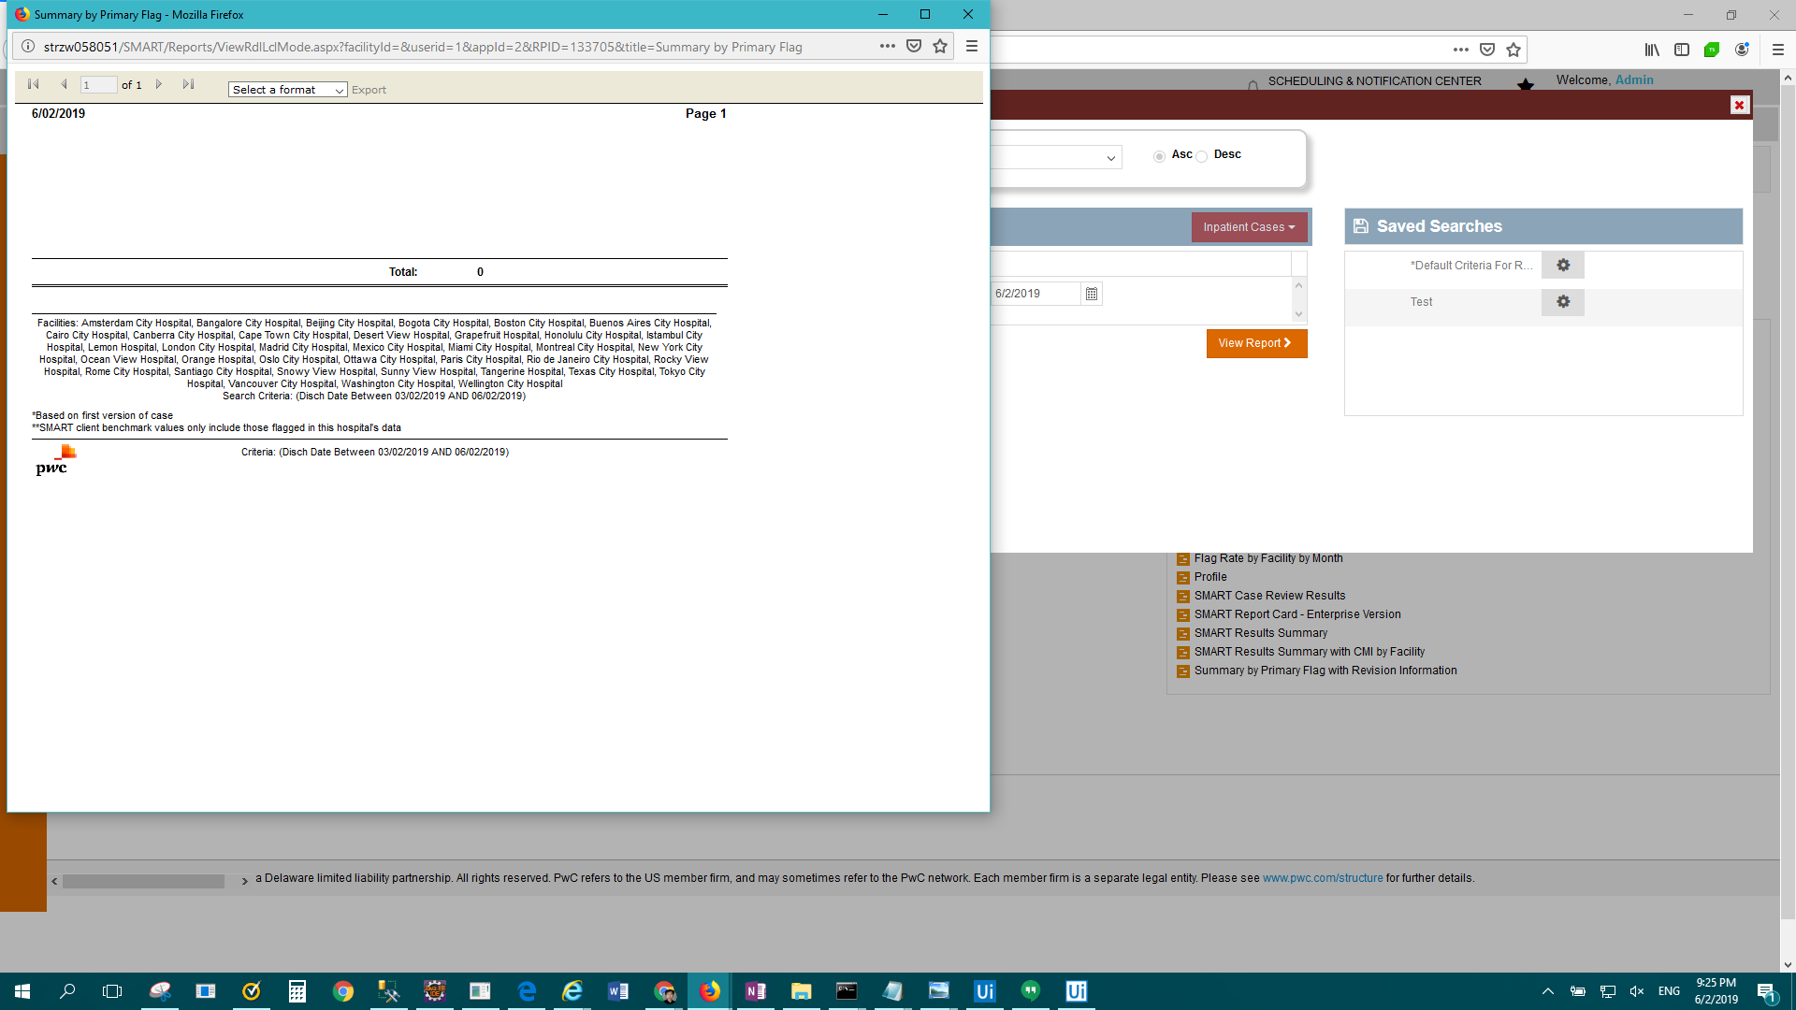

FAIL: OP Standard - APC reimbursement visit summary > Result Description: Test Passed for Report: OP Standard - APC reimbursement visit summary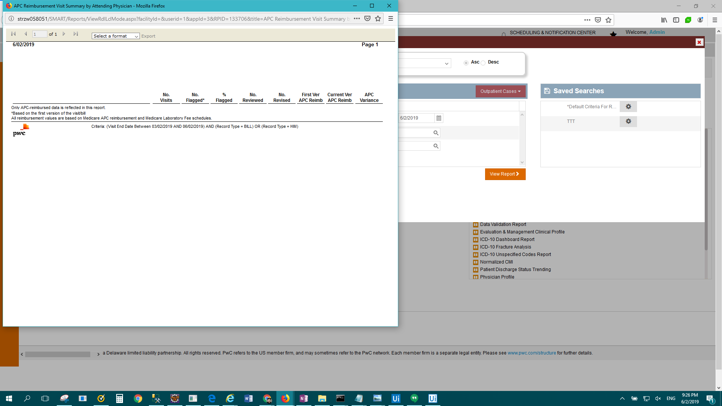

FAIL: OP Standard - Brief visit listing > Result Description: Test Passed for Report: OP Standard - Brief visit listing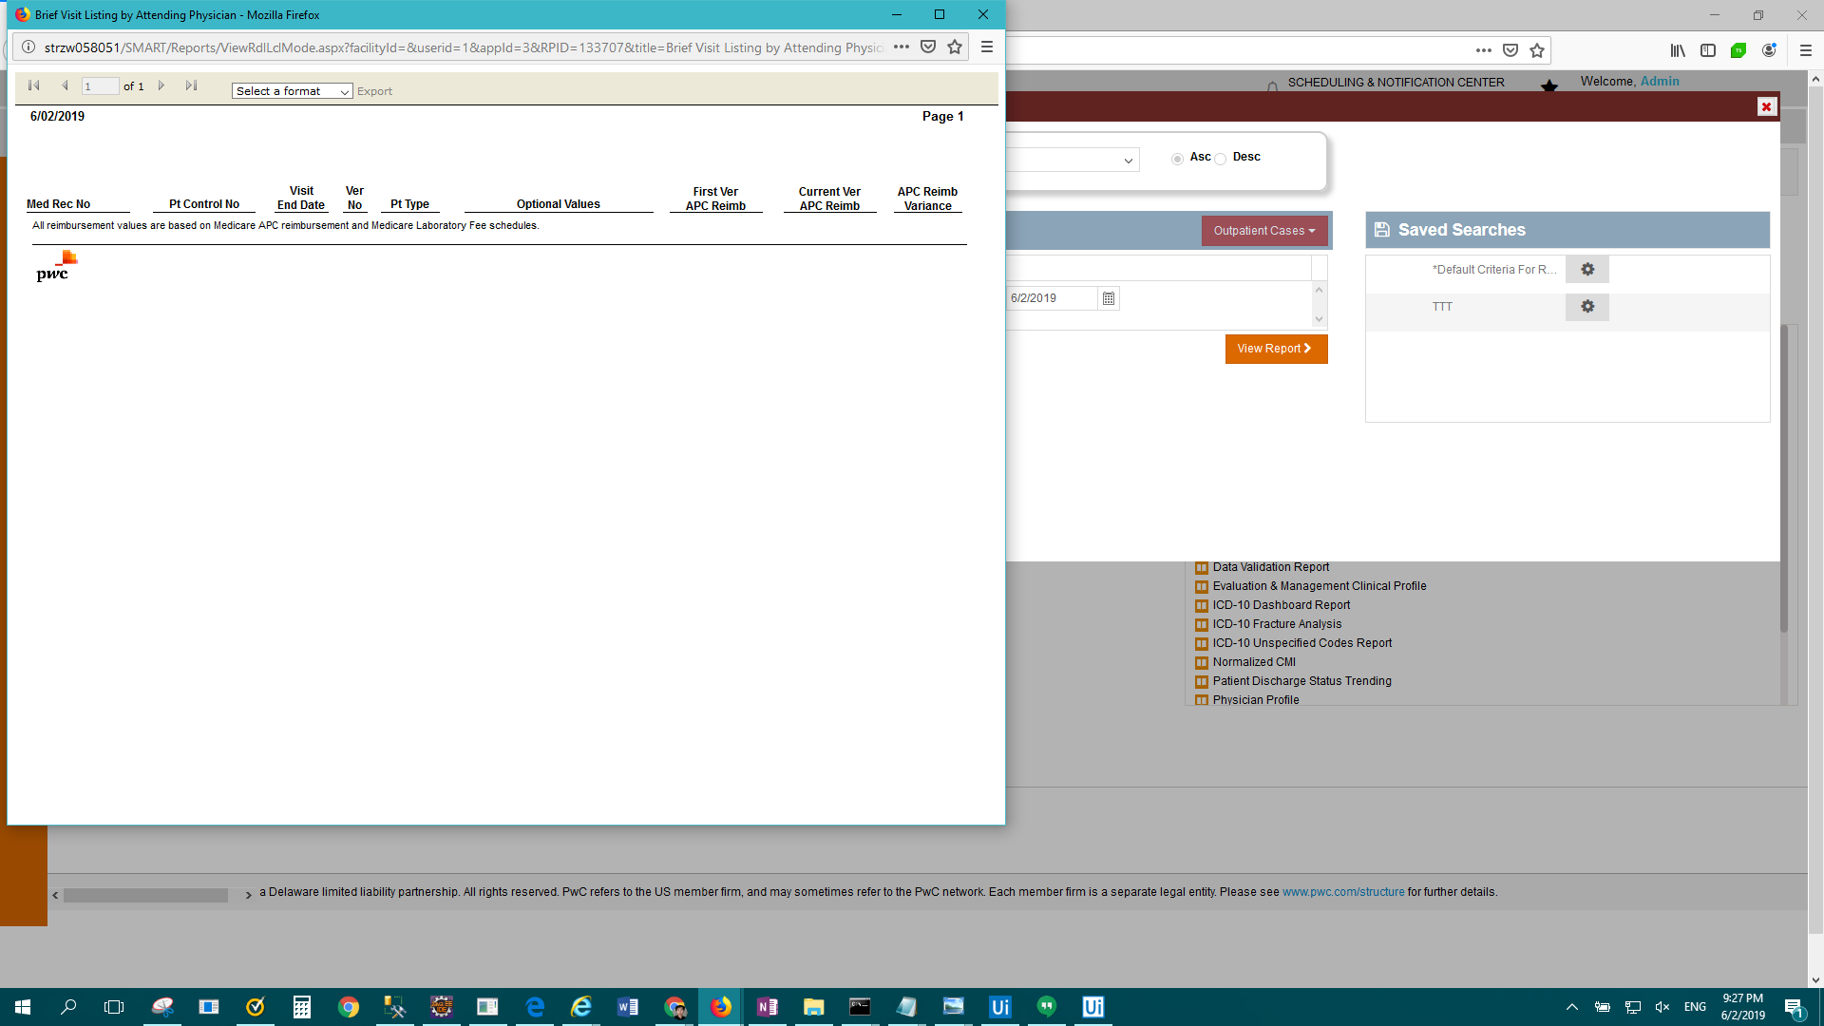

FAIL: Enterprise Report - Coder profile > Result Description: Test Failed For: Enterprise Report - Coder profile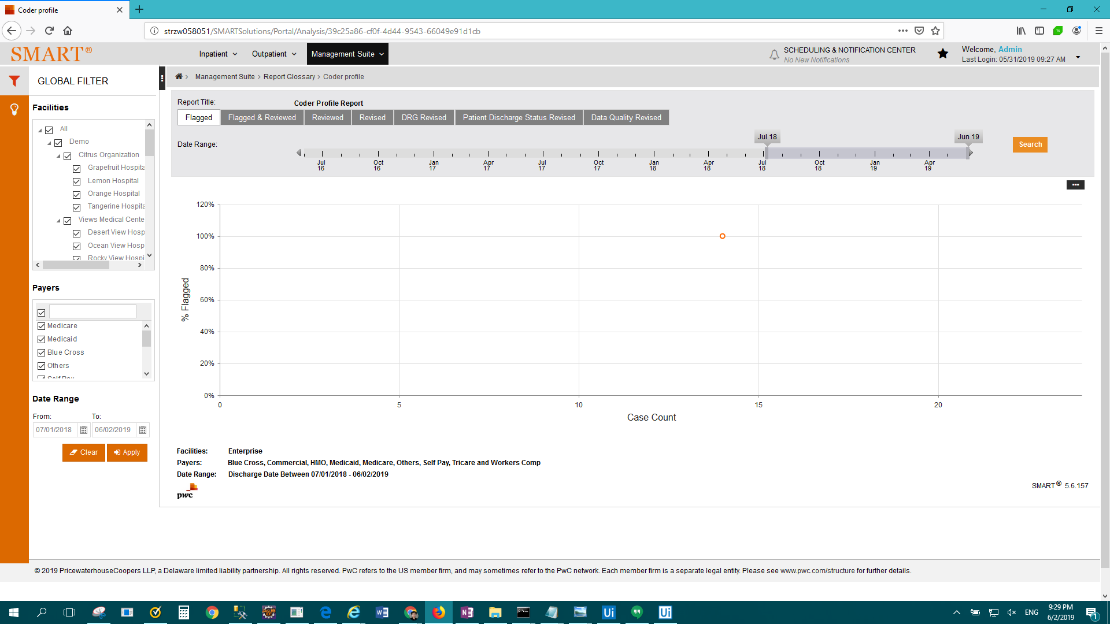

FAIL: OP Standard - Detailed visit listing > Result Description: Test Passed for Report: OP Standard - Detailed visit listing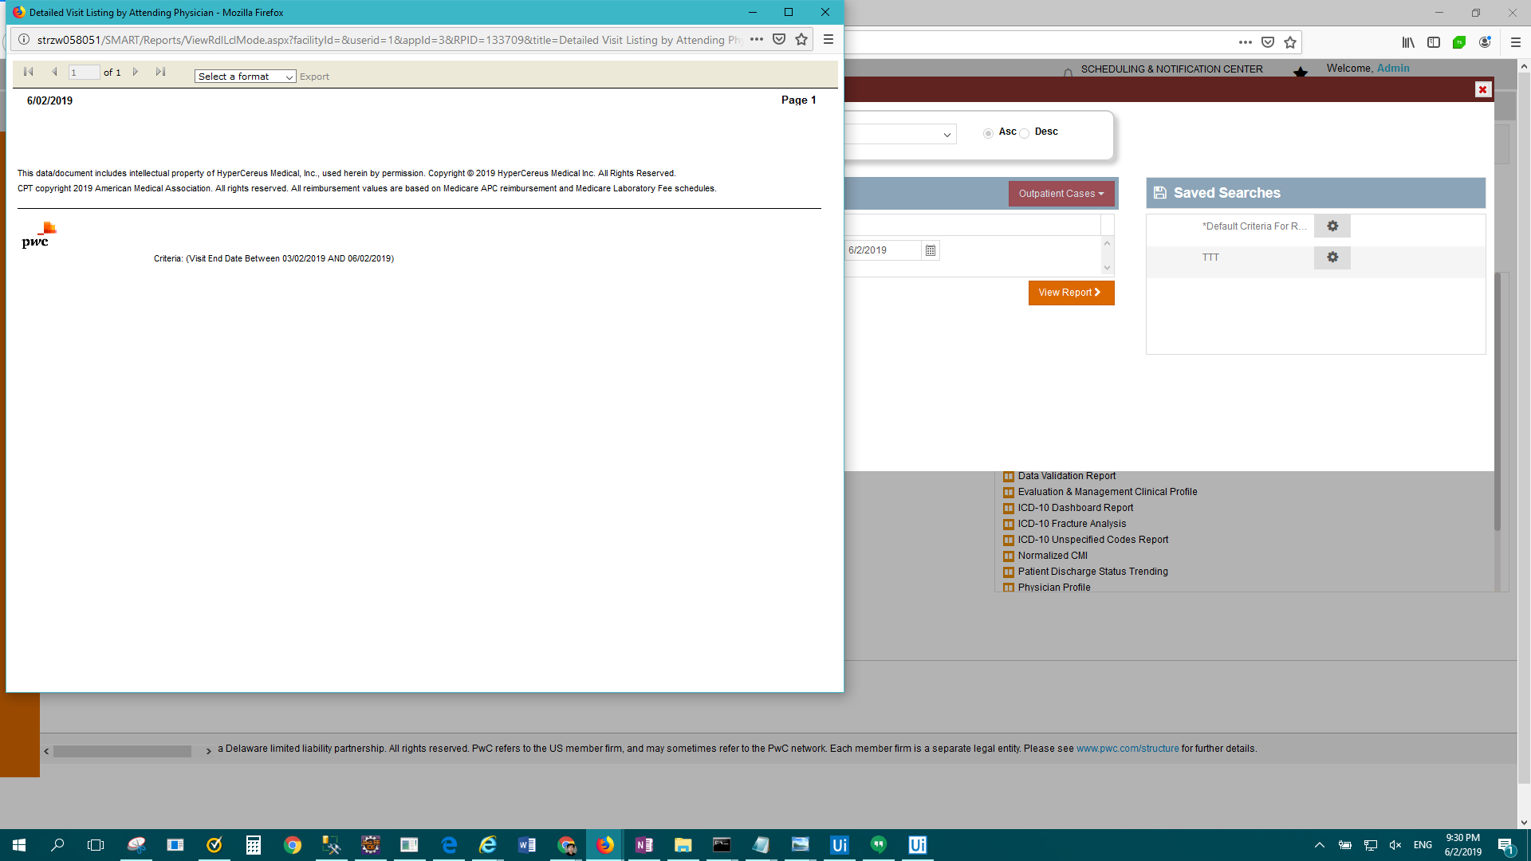

FAIL: OP Standard - Discrepancy analysis > Result Description: Test Passed for Report: OP Standard - Discrepancy analysis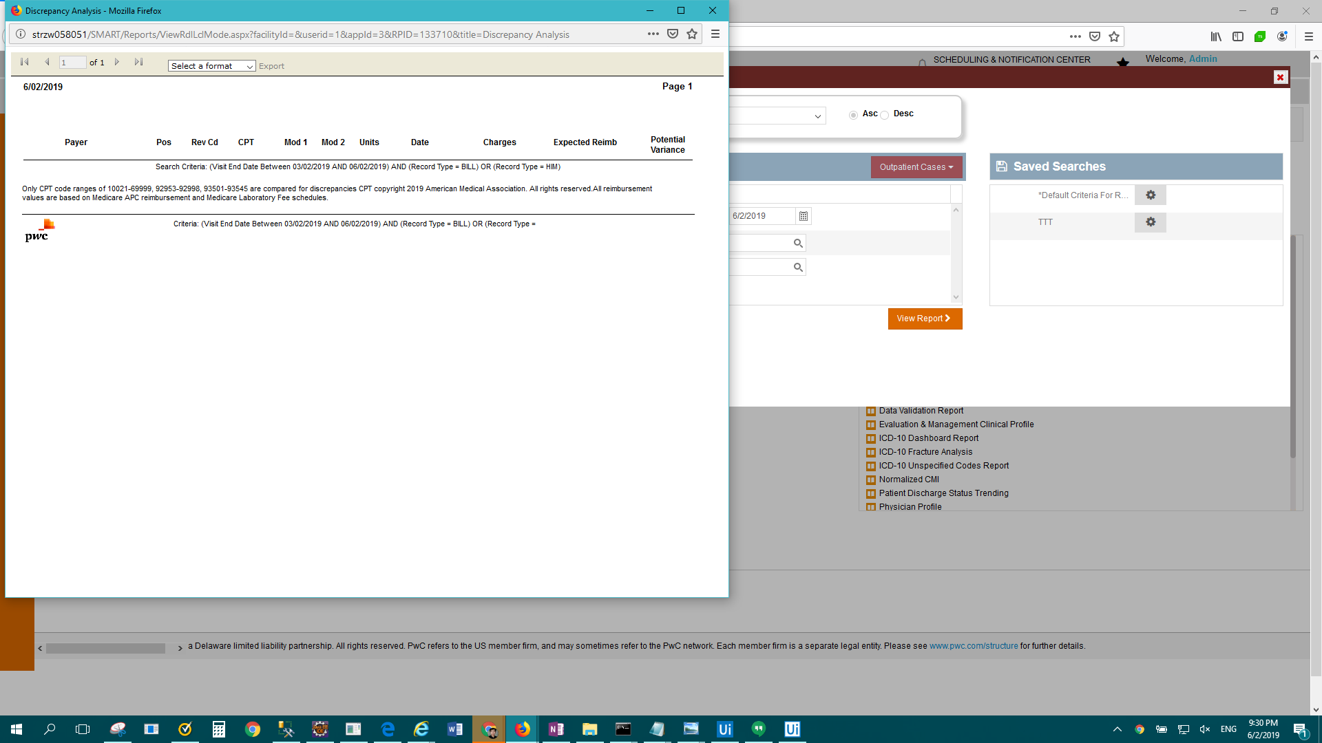

FAIL: OP Standard - Frequency Anlaysis > Result Description: Test Passed for Report: OP Standard - Frequency Anlaysis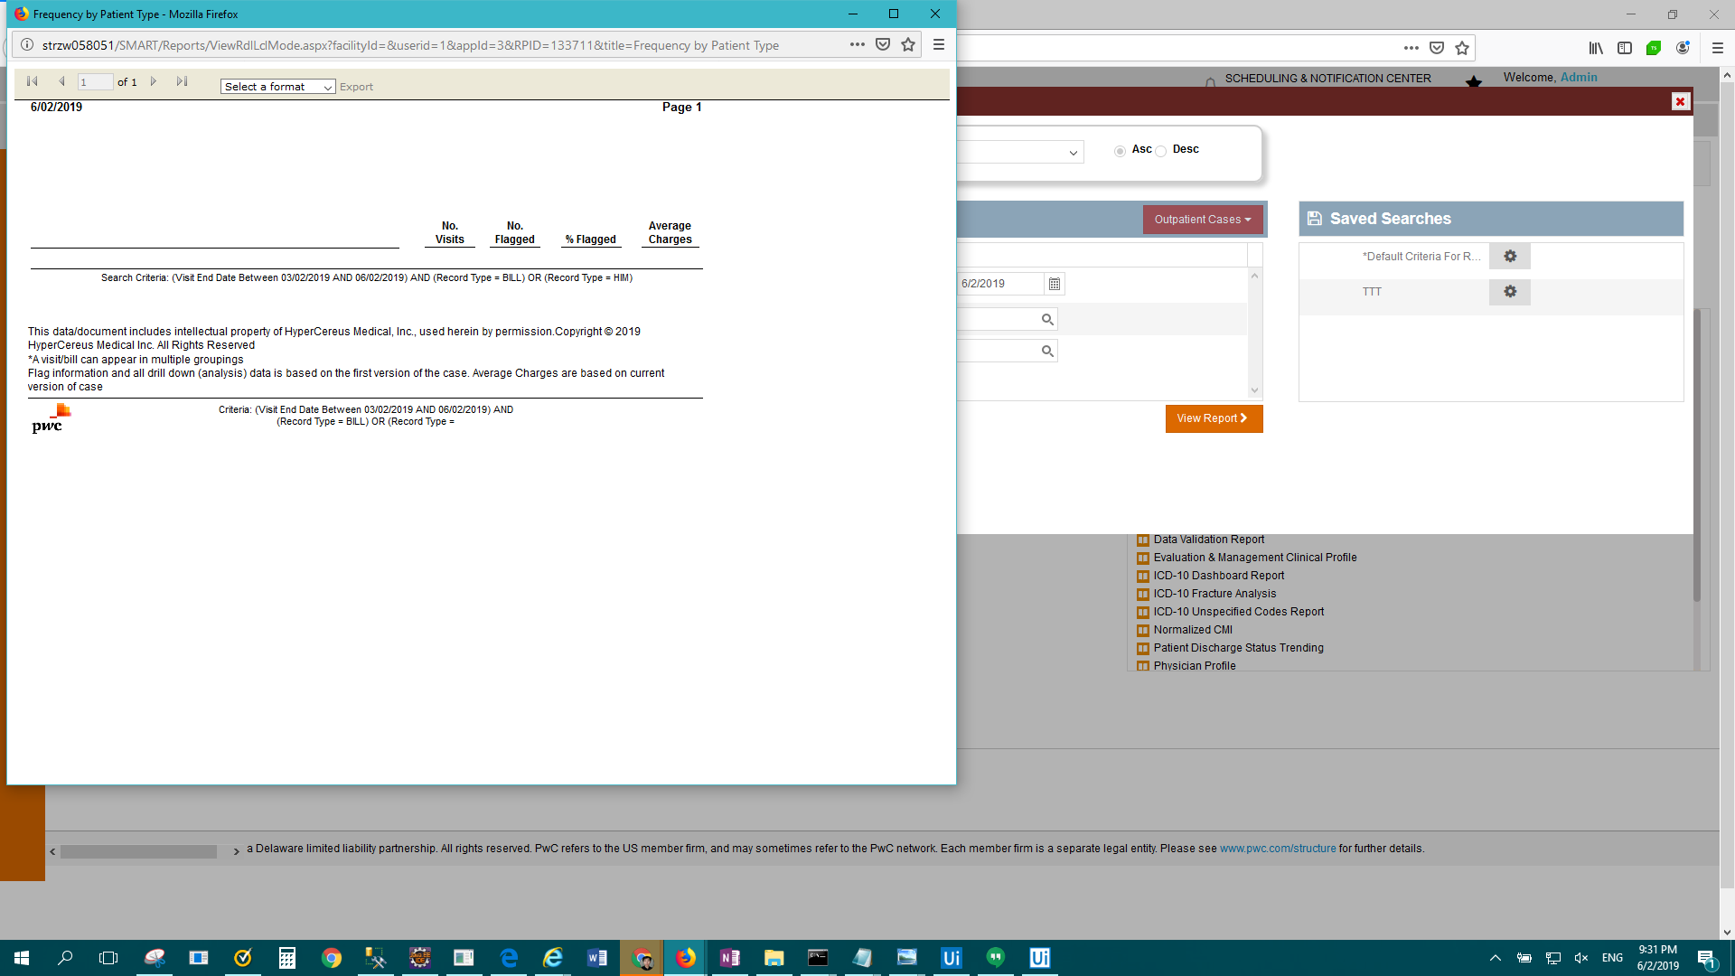

FAIL: OP Standard - Frequency Summary > Result Description: Test Passed for Report: OP Standard - Frequency Summary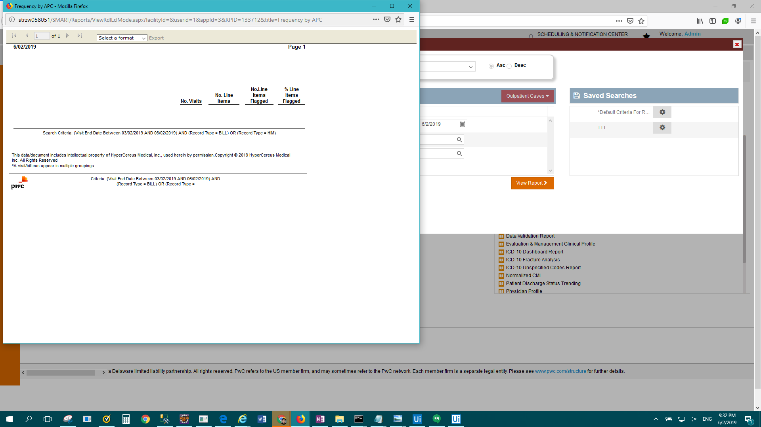

FAIL: OP Standard - Medicare medical necessity flags > Result Description: Test Passed for Report: OP Standard - Medicare medical necessity flags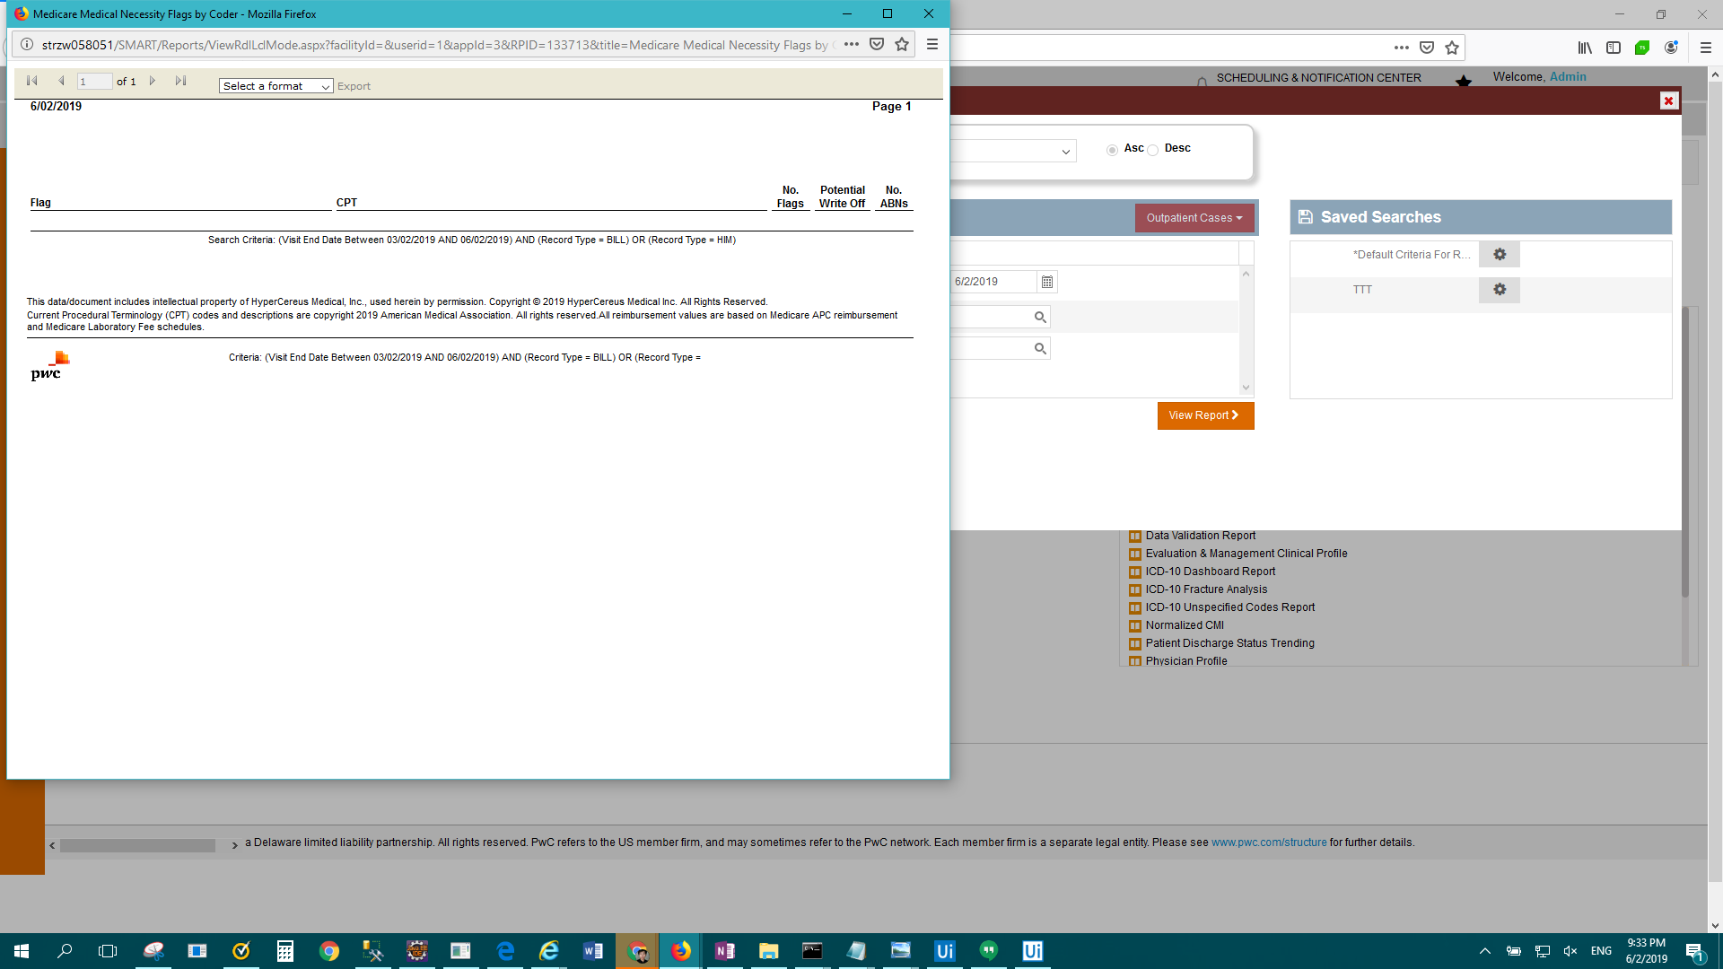

FAIL: OP Standard - Outpatient Flag Information > Result Description: Test Passed for Report: OP Standard - Outpatient Flag Information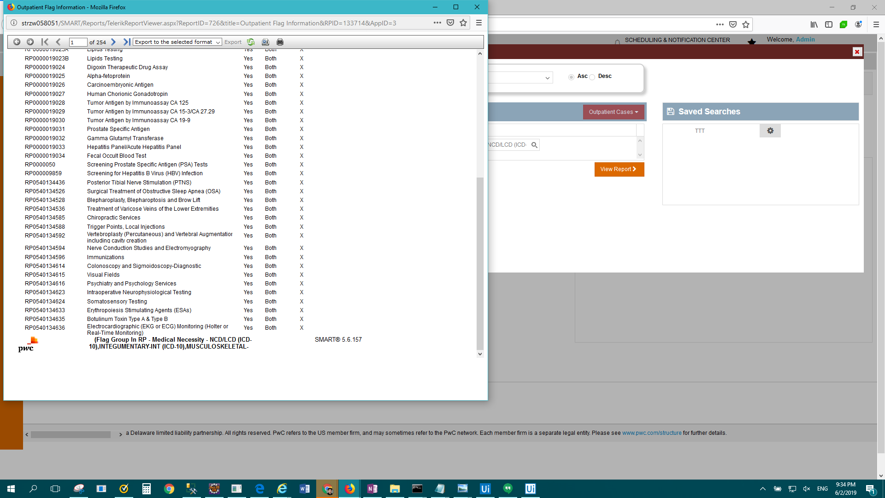

FAIL: OP Standard - Visit flag summary > Result Description: Test Passed for Report: OP Standard - Visit flag summary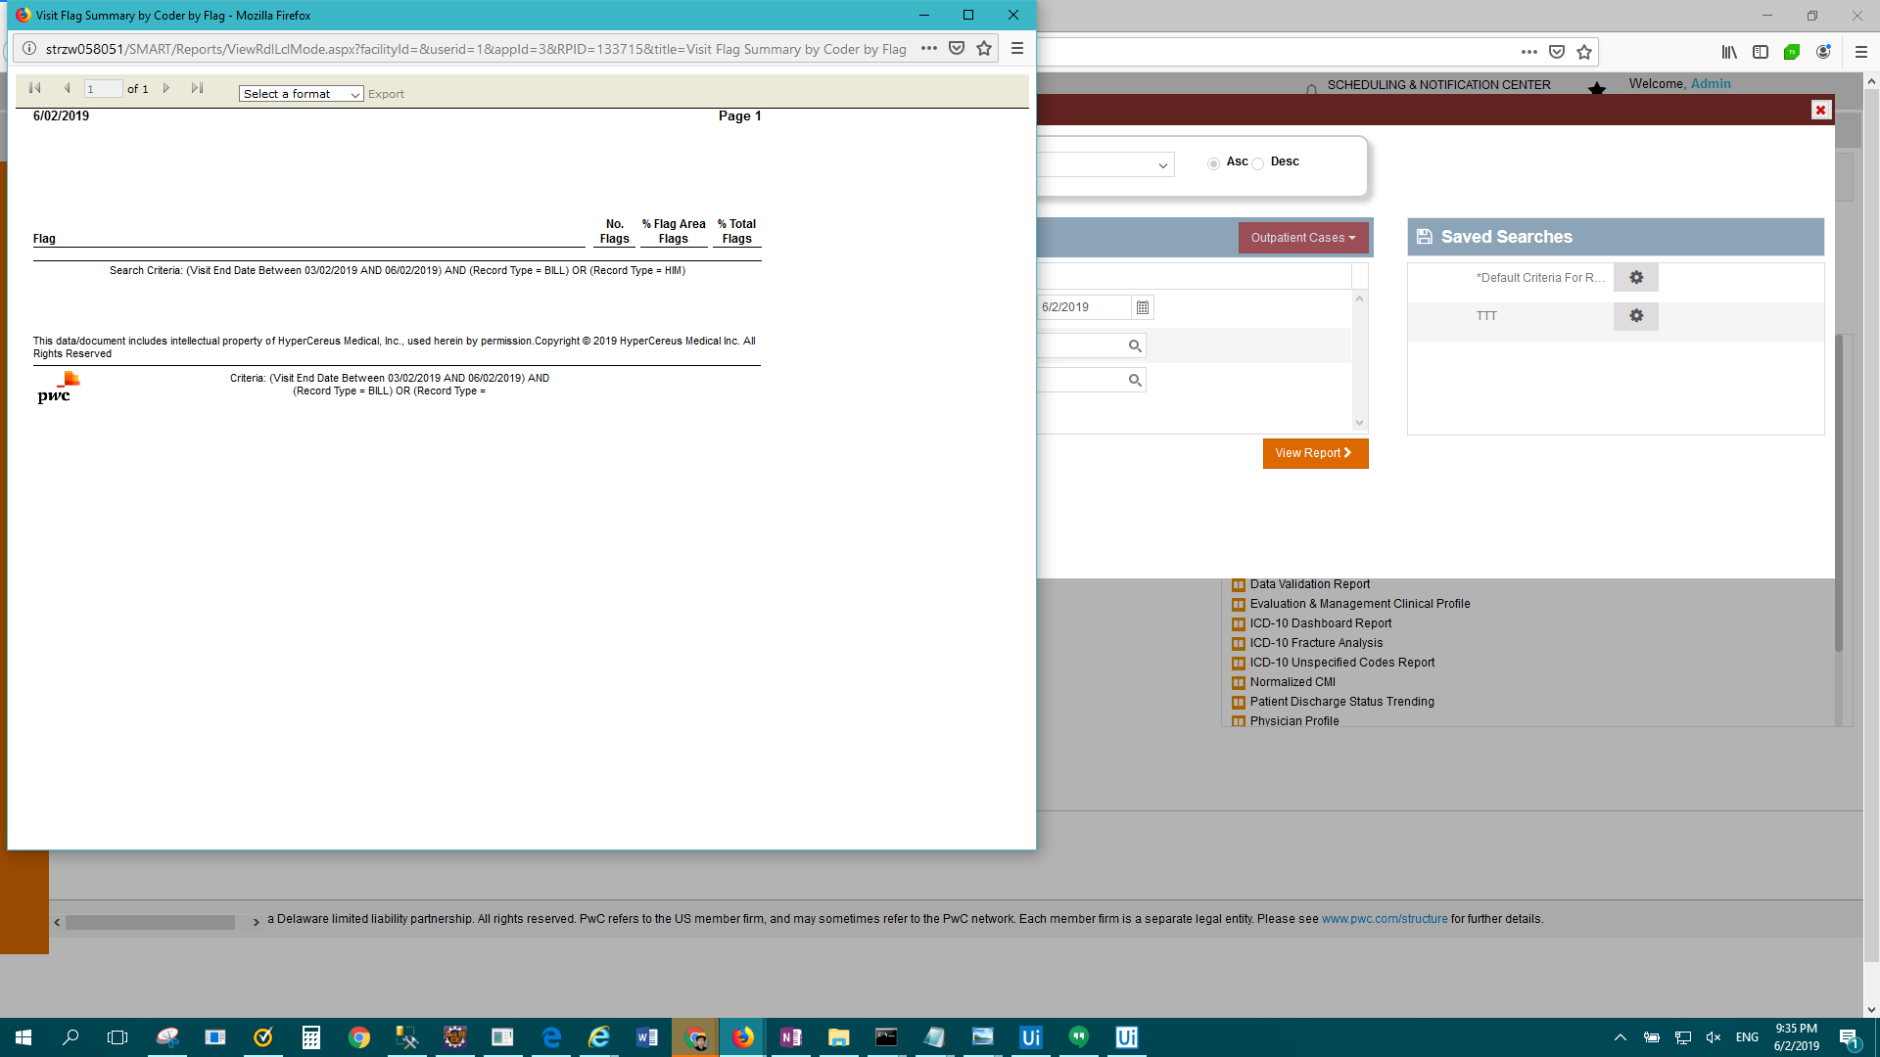

FAIL: OP Standard - Visit Reimbursement Summary > Result Description: Test Passed for Report: OP Standard - Visit Reimbursement Summary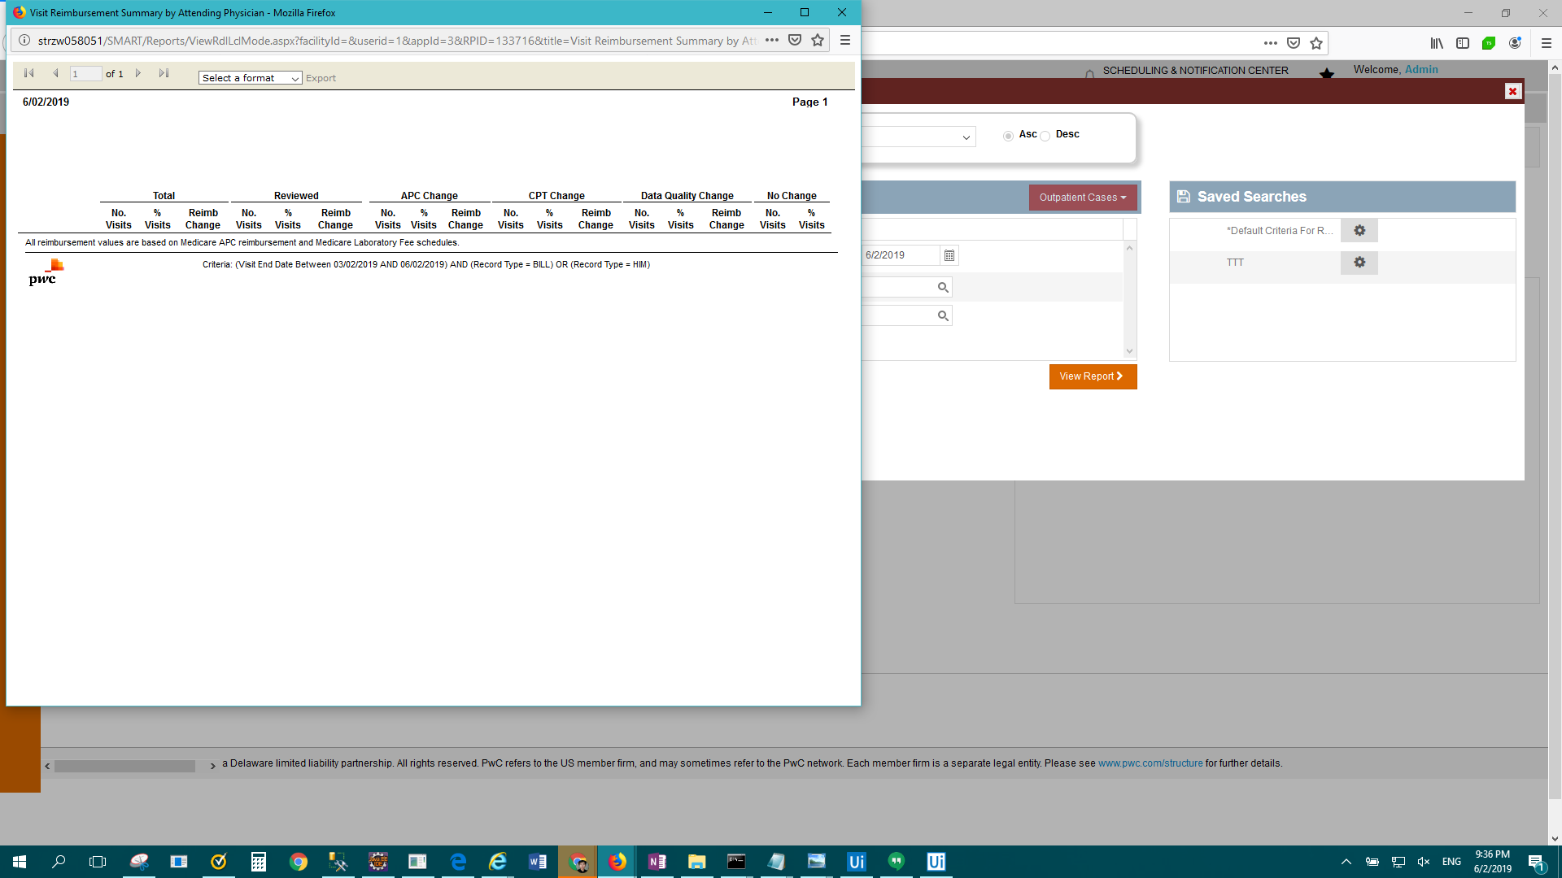

FAIL: Enterprise Report - SMART Results Summary with CMI by Facility > Result Description: Test Failed For: Enterprise Report - SMART Results Summary with CMI by Facility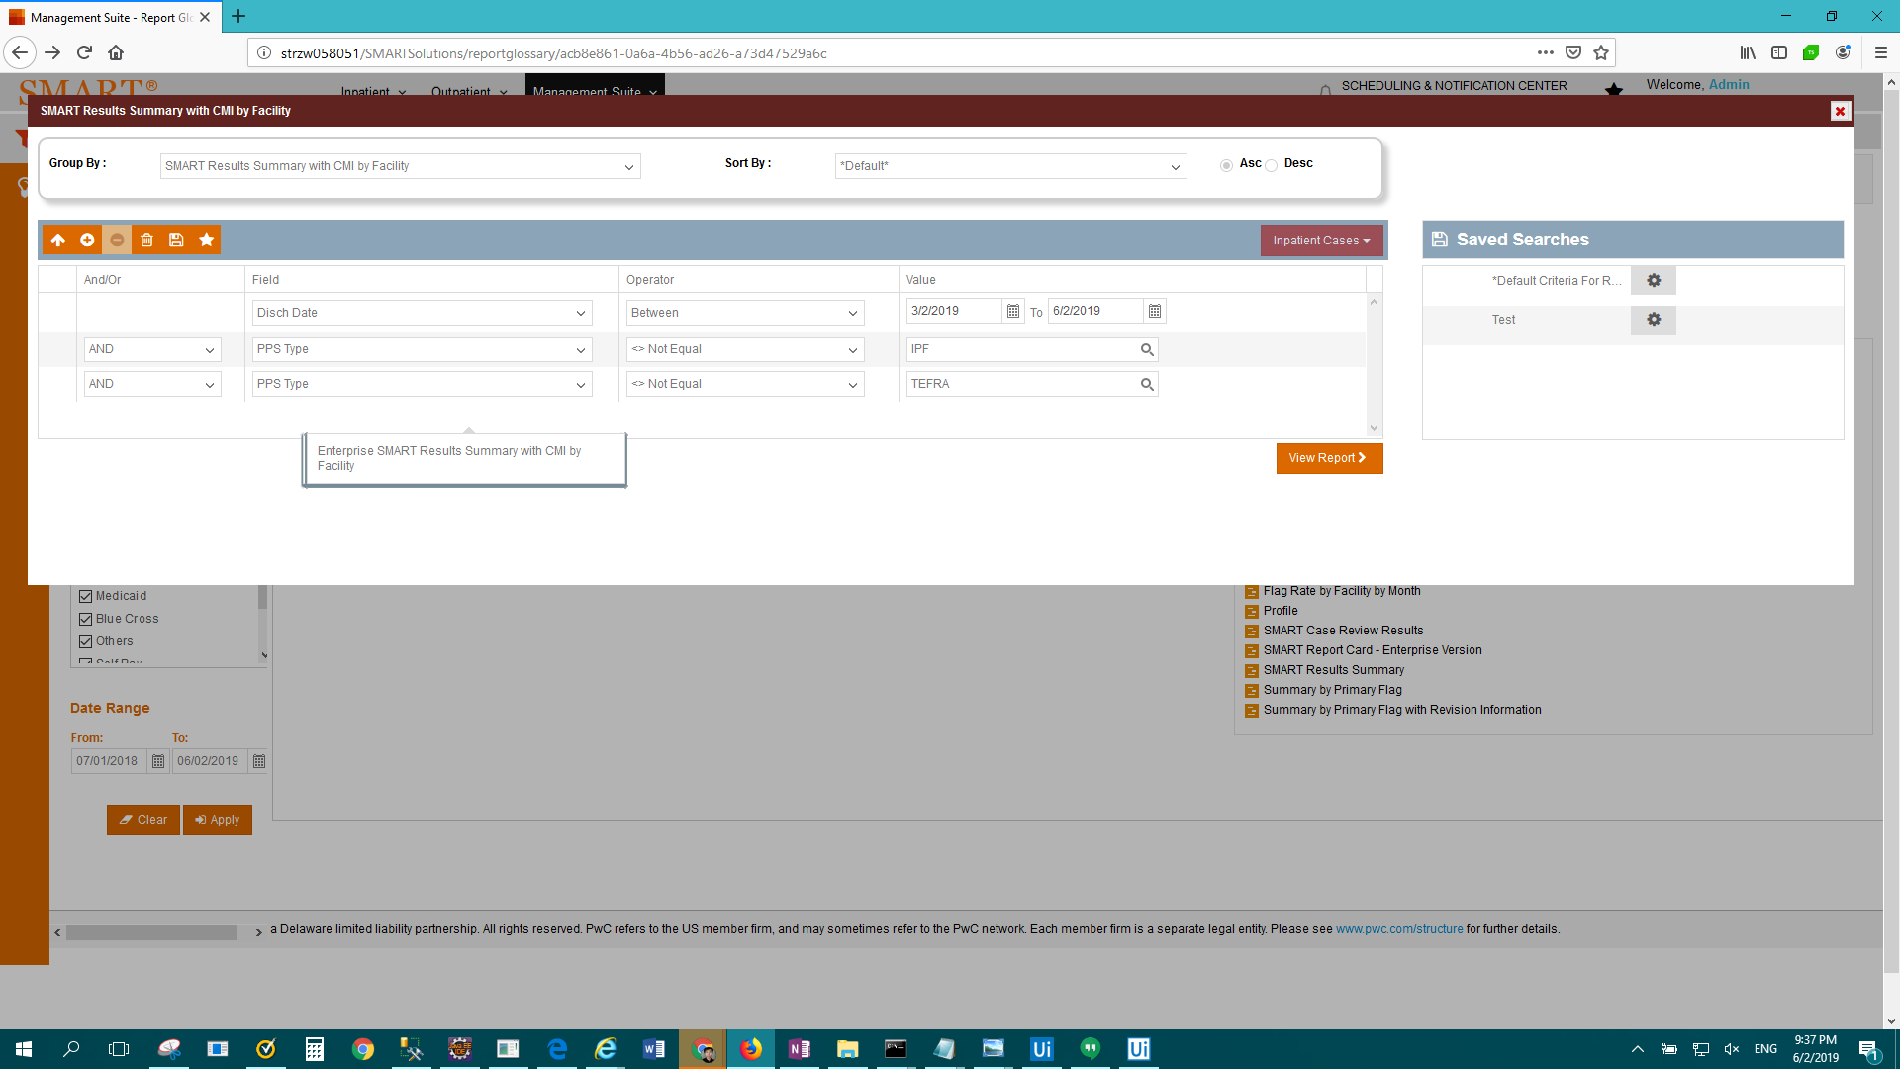

FAIL: Enterprise Report - Summary by Primary Flag with Revision Information > Result Description: Test Failed For: Enterprise Report - Summary by Primary Flag with Revision Information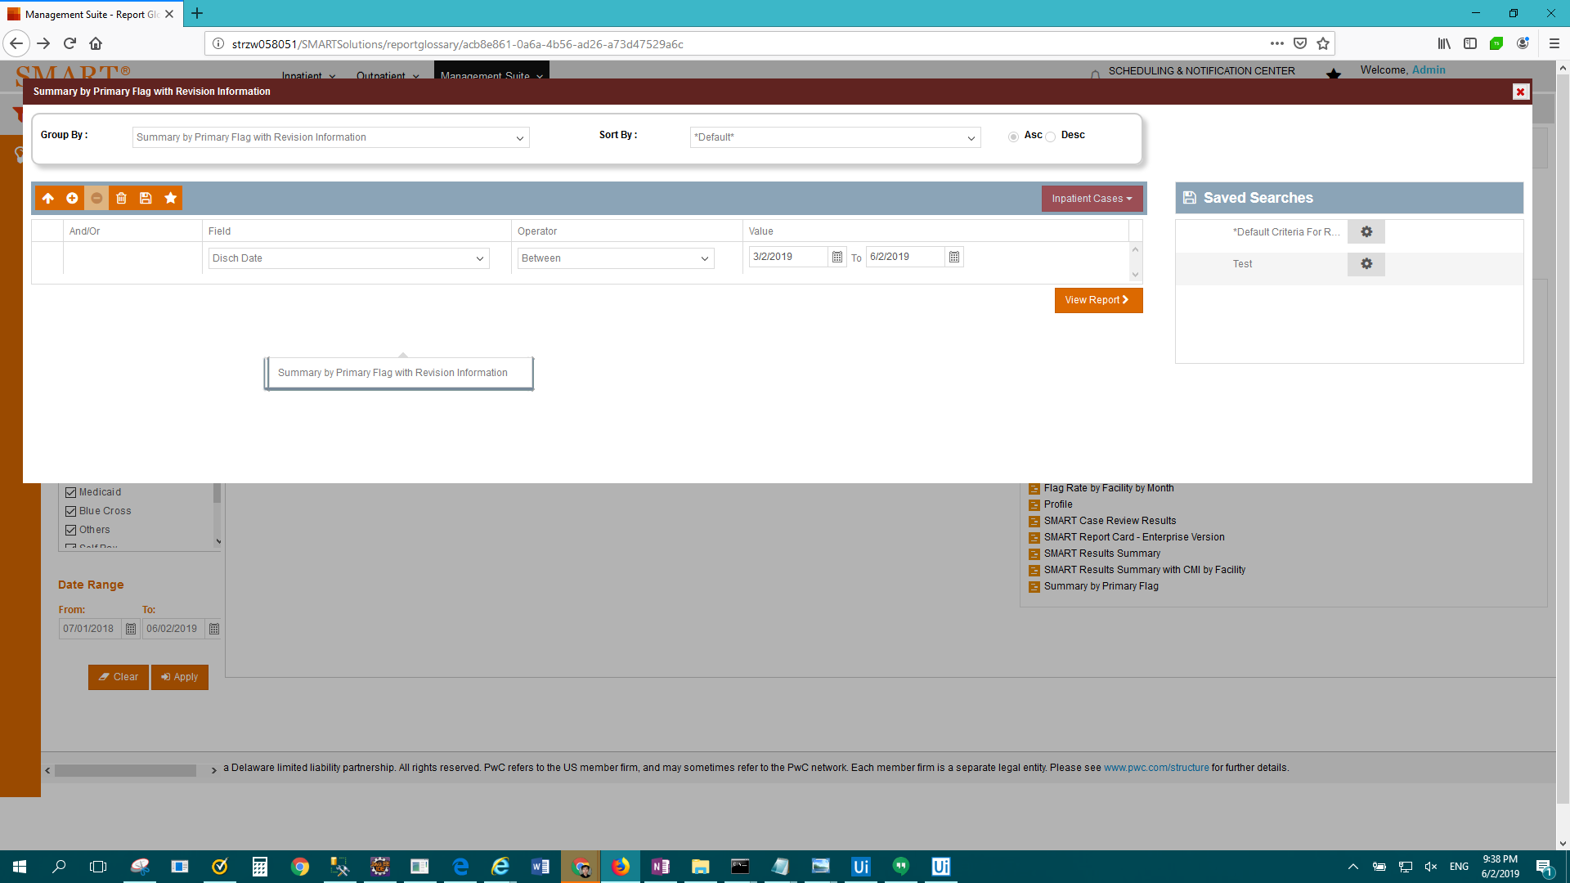

FAIL: Enterprise Report - DRG Contribution to Payer CMI > Result Description: Test Passed for Report: Enterprise Report - DRG Contribution to Payer CMI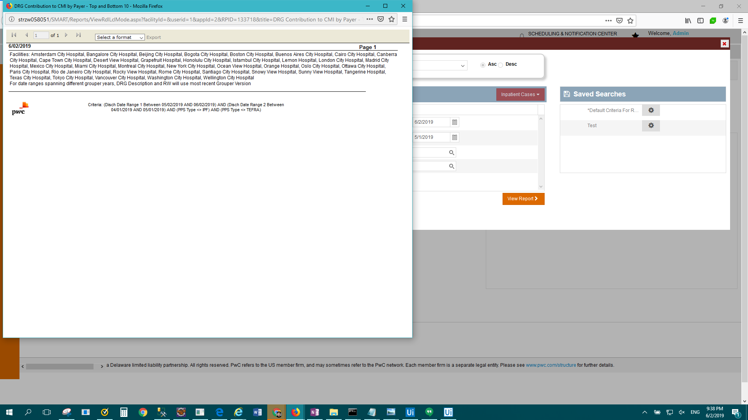

FAIL: Enterprise Report - Top 50 Diagnoses by Present on Admission(POA) > Result Description: Test Passed for Report: Enterprise Report - Top 50 Diagnoses by Present on Admission(POA)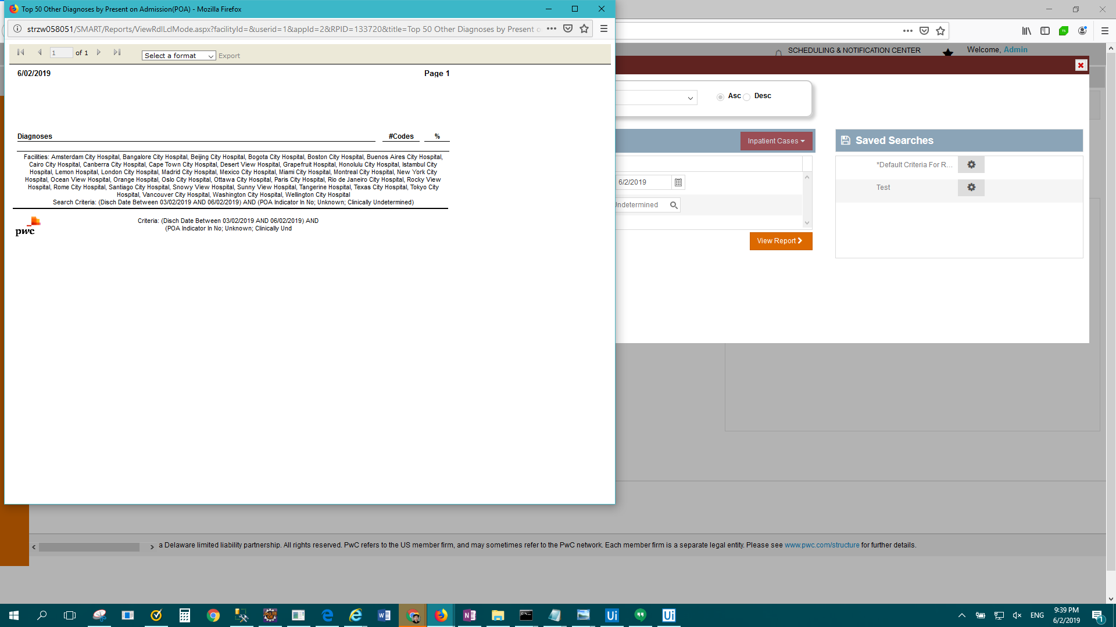

FAIL: Enterprise Report - Flag Rate by Facility by Month > Result Description: Test Passed for Report: Enterprise Report - Flag Rate by Facility by Month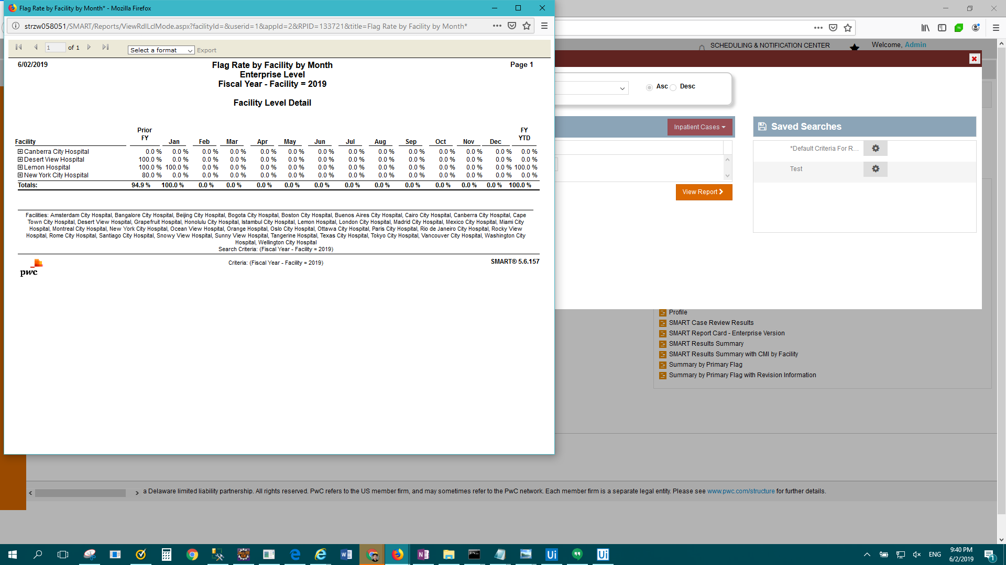

FAIL: Enterprise Report - Reimbursement Change Summary > Result Description: Test Passed for Report: Enterprise Report - Reimbursement Change Summary

FAIL: Enterprise Report - SMART Report Card - Enterprise Version > Result Description: Test Failed For: Enterprise Report - SMART Report Card - Enterprise Version